**E-CONFINEMENT SERVICE SYSTEM**

By

CHIA KAI YI

A REPORT

SUBMITTED TO

Universiti Tunku Abdul Rahman

in partial fulfillment of the requirements

for the degree of

BACHELOR OF COMPUTER SCIENCE (HONOURS)

Faculty of Information and Communication Technology

(Kampar Campus)

MAY 2021

**UNIVERSITI TUNKU ABDUL RAHMAN**

|  |
| --- |
| REPORT STATUS DECLARATION FORM **Title**: E-Confinement Service System_________________________________  **Academic Session**: 2022/01  I ___________CHIA KAI YI_________________________  **(CAPITAL LETTER)**  declare that I allow this Final Year Project Report to be kept in  Universiti Tunku Abdul Rahman Library subject to the regulations as follows:   1. The dissertation is a property of the Library. 2. The Library is allowed to make copies of this dissertation for academic purposes.   Verified by,  _________________________  (Author’s signature) (Supervisor’s signature)  **Address**:  No 59A, Lorong Intan 14,  ­Taman Intan Mas, 36000 Ts. Yeck Yin Ping  Teluk Intan, Perak Supervisor’s name  **Date**: 18/4/2022 **Date**: ____________________ |

|  |  |  |  |
| --- | --- | --- | --- |
| **Universiti Tunku Abdul Rahman** | | | |
| Form Title : **Sample of Submission Sheet for FYP/Dissertation/Thesis** | | | |
| Form Number: **FM-IAD-004** | Rev No.: **0** | Effective Date: **21 JUNE 2011** | Page No.: **1 of 1** |

**FACULTY/INSTITUTE* OF INFORMATION COMMUNICATION AND TECHNOLOGY**

**UNIVERSITI TUNKU ABDUL RAHMAN**

Date: __18/4/2022_____

**SUBMISSION OF FINAL YEAR PROJECT /DISSERTATION/THESIS**

It is hereby certified that _CHIA KAI YI*_* (ID No: __***18ACB01343***) has completed this final year project entitled “____*E-CONFINEMENT SERVICE SYSTEM _ _*” under the supervision of __Ts. Yeck Yin Ping__(Supervisor) from the Department of ____________________,

Faculty of ___ Information Communication And Technology___.

I understand that University will upload softcopy of my final year project / dissertation/ thesis* in pdf format into UTAR Institutional Repository, which may be made accessible to UTAR community and public.

Yours truly,

__

CHIA KAI YI

# DECLARATION OF ORIGINALITY

I declare that this report entitled “**E-CONFINEMENT SERVICE SYSTEM**” is my own work except as cited in the references. The report has not been accepted for any degree and is not being submitted concurrently in candidature for any degree or other award.

Signature : 

Name : CHIA KAI YI

Date : 18/4/2022

# ACKNOWLEDGEMENTS

I would like to express my sincere thanks and appreciation to my supervisor, Ts. Yeck Yin Ping and my moderator, Ts. Tan Teik Boon who have given me this bright opportunity to engage in a mobile application development project. Besides that, they have given me a lot of guidance in order to complete this project. When I was facing problems in this project, the advice from them always assists me in overcoming the problems. It is my first step to establish a career in mobile application field. A million thanks to my supervisor and moderator.

Finally, I must say thanks to my family and my friends for their love, support and continuous encouragement throughout the course.

**ABSTRACT**

This project details an attempt to create a mobile application to provide a platform for the buyers and Confinement Lady to find and sell for the confinement service. This application is targeted to work on Android device. In this project will develop an enhancement of existing application. The core function of this is to help the new mother to search for the available confinement lady around the them. This function is implemented by using the GPS tracking system. Other than that, there would be additional features which can make the users more convenient while using the application.

Developing this project involves the usage of Visual Studio Code as its integrated development environment. The framework used to develop this mobile application is Flutter. Flutter is an open-source UI software development kit created by Google. It is used to develop cross platform applications for Android, iOS, Linux, macOS, Windows, Google Fuchsia, and the web from a single codebase. The interface and most of features would be utilize much of Dart programming. An android device is used for testing.

The methodology of used to develop this project is Agile Development approach. This approach includes Planning, Design, Development, Testing, Deployment which helps to provide deploy the final application that minimize bug after few iterations of the Planning, Design, Development, and Testing phases.

# TABLE OF CONTENTS

REPORT STATUS DECLARATION FORM ii

DECLARATION OF ORIGINALITY iv

ACKNOWLEDGEMENTS v

ABSTRACT vi

TABLE OF CONTENTS vii

LIST OF TABLES xiii

LIST OF FIGURES xiv

LIST OF ABBREVIATIONS xviii

Chapter 1 Introduction 1

1.1 Problem Statement & Motivation 1

1.2 Project Objectives 3

1.3 Project Scope 5

1.4 Contribution 7

1.5 Report Organization 8

Chapter 2 Literature Review 9

2.1 Review of the Technologies 9

2.1.1 Hardware Platform 9

2.1.1 Database 9

2.1.2 Programming Language 10

2.1.3 Algorithm 10

2.1.3.1 Haversine Algorithm 10

2.1.3.2 Vincenty Algorithm 11

2.1.4 Comparison between Haversine algorithm and Vincenty algorithm 13

2.2 Review of Existing Systems/Applications 14

2.2.1 28Days 14

2.2.2 Confinement Care Malaysia PLT 17

2.2.3 NannySOS Confinement Nanny Agency 20

2.2.4 Star Confinement Nanny 22

2.2.5 PEM Confinement Nanny Agency 25

2.2.6 Comparison between the similar application with the proposal system 28

2.3 Discussion 29

Chapter 3 System Methodology/Approach 31

3.1 System Design Diagram/Equation 32

3.1.1 System Architecture Diagram 32

3.1.1.1 Buyer Interface Flow 32

3.1.1.2 Service Provider Interface Flow 33

3.1.1.3 Admin Interface Flow 33

3.1.1.4 Database Management Flow 33

3.1.2 Use Case Diagram and Description 34

3.1.2.1 Use Case Diagram 34

3.1.2.2 Use Case Description 36

3.1.2.2.1 Sign Up 36

3.1.2.2.2 Sign In 37

3.1.2.2.3 Sign out 37

3.1.2.2.4 Manage profile 38

3.1.2.2.5 View Progress Order 38

3.1.2.2.6 View History Order 39

3.1.2.2.7 View Pending Order 39

3.1.2.2.8 View Nearby Confinement Lady 40

3.1.2.2.9 Make Order 41

3.1.2.2.10 Select Default Confinement Service Package 42

3.1.2.2.11 Select Customize Confinement Service Package 42

3.1.2.2.12 Cancel Order 43

3.1.2.2.13 View Cancel Order Status 44

3.1.2.2.14 Extend Order 45

3.1.2.2.15 Rate the Service Provider 46

3.1.2.2.16 Add Service Package 47

3.1.2.2.17 Delete Service Package 47

3.1.2.2.18 View Service Package 48

3.1.2.2.19 Accept Order 48

3.1.2.2.20 Decline Order 49

3.1.2.2.21 Navigate to Buyer’s Location 49

3.1.2.2.22 Manage Cancel Request 50

3.1.2.2.23 View Pending Order Detail 51

3.1.2.2.24 View On-Going Order Detail 51

3.1.2.2.25 View Completed Order Detail 52

3.1.2.2.26 View Declined Order Detail 52

3.1.2.2.27 Reset Password 53

3.1.3 Activity Diagram 54

3.1.3.1 Sign up 54

3.1.3.2 Sign in 55

3.1.3.3 Sign out 56

3.1.3.4 Manage Profile 57

3.1.3.5 View Progress Order 58

3.1.3.6 View History Order 59

3.1.3.7 View Pending Order 60

3.1.3.8 View Nearby Confinement Lady 61

3.1.3.9 Make Order 62

3.1.3.10 Cancel Order 63

3.1.3.11 View Cancel Order Status 64

3.1.3.12 Extend Order 65

3.1.3.13 Rate Service Provider 66

3.1.3.14 Add Service Package 67

3.1.3.15 Delete Service Package 68

3.1.3.16 View Service Package 69

3.1.3.17 Accept Order 70

3.1.3.18 Decline Order 71

3.1.3.19 Navigate to Buyer’s Location 72

3.1.3.20 Manage Cancel Request 73

3.1.3.21 View Pending Order Detail 74

3.1.3.22 View On-Going Order Detail 75

3.1.3.23 View Completed Order Detail 76

3.1.3.24 View Declined Order Detail 77

3.1.3.25 Reset Password 78

Chapter 4 System Design 79

4.1 System Block Diagram 79

4.1.1 Buyer log into system 80

4.1.2 Get buyer and service providers location data from database 80

4.1.3 Compute the distance between the buyer and every service provider using Haversine algorithm 80

4.1.4 Save the distance result to service provider database 80

4.1.5 Display the service provider’s profile based on the distance in ascending order 80

4.2 System Components Specifications 81

4.2.1 Sign Up 81

4.2.2 Fill in Profile Detail 82

4.2.3 Sign In 84

4.2.4 User Roles Identification 85

4.2.5 Manage Profile 86

4.2.5.1 Display Profile Detail 86

4.2.5.2 Update Profile Detail 87

4.2.5.3 Upload Profile Image 88

4.2.5.4 Get User Address 89

4.2.6 Reset Password 90

4.2.7 View Nearby Confinement Lady 91

4.2.8 Display Service Provider Detail 93

4.2.9 Make Order 94

4.2.9.1 Select Service Provider 94

4.2.9.2 Select Confinement Date 95

4.2.9.3 Select Confinement Package 96

4.2.9.3.1 Customize Confinement Package 97

4.2.9.4 Checkout 99

4.2.10 Extend Order 100

4.2.11 Rate Service Provider 101

4.2.12 Add Service Package 102

4.2.13 Delete Service Package 102

4.2.14 Accept Order 103

4.2.15 Decline Order 103

4.2.16 Navigate to Buyer’s Location 104

Chapter 5 System Implementation 105

5.1 Hardware Setup 105

5.1.1 PC Model 105

5.1.2 Mobile Phone 105

5.2 Software Setup 106

5.2.1 Flutter SDK 106

5.2.2 Visual Studio Code 106

5.2.3 Firebase 106

5.3 Setting Configuration 107

5.3.1 Firebase Configuration 107

5.3.2 Project Configuration 108

5.4 System Operation 109

5.4.1 Start-up 109

5.4.2 Sign In 110

5.4.3 Sign Up 111

5.4.4 Reset Password 112

5.4.5 Profile Detail 113

5.4.6 Service Provider Homepage 114

5.4.7 Add service 115

5.4.8 Delete Service 116

5.4.8 Profile 117

5.4.9 View Orders 118

5.4.10 Accept/Decline Order 119

5.4.11 Navigate the Buyer’s Location 120

5.4.12 View History Order Detail 121

5.4.13 About Us 122

5.4.14 Buyer Homepage 123

5.4.15 Service Provider Detail 124

5.4.16 Place Order 126

Chapter 6 Conclusion 134

BIBLIOGRAPHY 135

Appendix A Biweekly Report 138

Appendix B Poster 144

Appendix C Plagiarism Check Result 145

Appendix D FYP 1 Checklist 149

# LIST OF TABLES

|  |  |  |
| --- | --- | --- |
| **Table Number** | **Title** | **Page** |
| Table 2.6.1 | Table of Comparison n Between Reviewed System and Proposed System | 18 |
| Table 3.2.1.1 | Software Tools for Development | 24 |
| Table 3.4.3.1 | Use Case description for Customer Sign Up Module | 29 |
| Table 3.4.3.2 | Use Case description for Customer Sign in Module | 29 |
| Table 3.4.3.3 | Use Case description for Select Confinement Service Module | 30 |
| Table 3.4.3.4 | Use Case description for Choose Default Confinement Service Package module | 30 |
| Table 3.4.3.5 | Use Case description for Customize Confinement Service Package | 31 |
| Table 3.4.3.6 | Use Case description for View Order Summary Module | 31 |
| Table 3.4.3.7 | Use Case description for Rate Confinement Lady Module | 32 |
| Table 3.4.3.8 | Use Case description for Report Problem Module | 32 |
| Table 3.4.3.9 | Use Case description for Confinement Lady Sign Up Module | 33 |
| Table 3.4.3.10 | Use Case description for Confinement Lady Sign in Module | 33 |
| Table 3.4.3.11 | Use Case description for View Rating Module | 34 |
| Table 3.4.3.12 | Use Case description for Navigate to Customer’s house | 34 |

# LIST OF FIGURES

|  |  |  |
| --- | --- | --- |
| **Figure Number** | **Title** | **Page** |
| Figure 2.1.1.1 | Main interface of 28Days | 4 |
| Figure 2.1.1.2 | Main interface of 28Days | 5 |
| Figure 2.1.1.3 | E-commerce platform on 28Days | 5 |
| Figure 2.2.1.1 | Main Interface of Confinement Care Malaysia PLT | 7 |
| Figure 2.2.2.1 | Guidance for customers to book confinement lady | 8 |
| Figure 2.2.2.2 | Services listed with graphical visual | 8 |
| Figure 2.3.1.1 | Main interface of NannySOS | 10 |
| Figure 2.3.2.1 | Contact Interface of NannySOS | 11 |
| Figure 2.4.1.1 | Main Interface of Star Confinement Nanny | 12 |
| Figure 2.4.2.1 | Reservation System of Star Confinement Nanny | 13 |
| Figure 2.5.1.1 | Main Interface of PEM Confinement Nanny Agency | 15 |
| Figure 2.5.2.1 | Services listed in Graphical View | 16 |
| Figure 2.5.2.2 | Review from Customers of PEM Confinement Nanny Agency | 16 |
| Figure 3.1.1 | Agile Software Development Phases | 23 |
| Figure 3.4.1.1 | System Framework of E-confinement Service System | 27 |
| Figure 3.4.2.1 | Use Case Diagram of E-Confinement Service System | 28 |
| Figure 3.4.4.1 | Activity Diagram for Sign Up Module | 35 |
| Figure 3.4.4.3 | Activity Diagram for Select Confinement Service Module | 36 |
| Figure 3.4.4.4 | Activity Diagram for Select Default Confinement Service Package Module | 38 |
| Figure 3.4.4.5 | Activity Diagram for Select Customize Confinement Service Package Module | 39 |
| Figure 3.4.4.6 | Activity Diagram for View Order Summary Module | 39 |
| Figure 3.4.4.7 | Activity Diagram for Rate Confinement Lady Module | 40 |
| Figure 3.4.4.8 | Activity Diagram for Report Problem Module | 41 |
| Figure 3.4.4.9 | Activity Diagram for Confinement Lady Sign Up Module | 42 |
| Figure 3.4.4.10 | Activity Diagram for Confinement Lady Sign in Module | 42 |
| Figure 3.4.4.11 | Activity Diagram for Navigate to Customer’s House | 43 |
| Figure 3.4.4.12 | Activity Diagram for View Rating Module | 44 |
| Figure 3.4.5.1 | Sequence Diagram for Sign Up Module | 45 |
| Figure 3.4.5.2 | Sequence Diagram for Sign in Module | 46 |
| Figure 3.4.5.3 | Sequence Diagram for Select Confinement Service Module | 47 |
| Figure 3.4.5.4 | Sequence Diagram for View Order Summary Module | 48 |
| Figure 3.4.5.5 | Sequence Diagram for Rating Confinement Lady Module | 49 |
| Figure 3.4.5.6 | Sequence Diagram for Report Problem Module | 50 |
| Figure 3.4.5.7 | Sequence Diagram for Navigate to Customer House module | 51 |
| Figure 3.4.5.8 | Sequence Diagram for View Rating Module | 52 |
| Figure 3.5.1 | Login Verification | 53 |
| Figure 3.5.2 | Sign Up Verification | 54 |
| Figure 3.5.3 | Password Verification in Sign in and Sign Up | 54 |
| Figure 3.5.4 | Email Verification in Sign in and Sign Up | 55 |
| Figure 3.7.1 | Timeline for FYP 1 | 57 |
| Figure 3.7.2 | Timeline for FYP 2 | 58 |
| Figure 4.1.1 | Firebase Setup (1) | 59 |
| Figure 4.1.2 | Firebase Setup (2) | 59 |
| Figure 4.2.1 | Splash Screen | 60 |
| Figure 4.2.2 | Welcome Page | 60 |
| Figure 4.3.1 | Sign in User Interface | 61 |
| Figure 4.3.2 | Source code of Sign in Function | 62 |
| Figure 4.4.1 | Sign-up user interface | 62 |
| Figure 4.4.2 | Source code for Sign up Function | 63 |
| Figure 4.5.1 | Profile Detail User Interface (1) | 63 |
| Figure 4.5.2 | Profile Detail User Interface (2) | 63 |
| Figure 4.5.3 | Source code for add the data into Firebase | 64 |
| Figure 4.5.4 | Data that stored in Firebase | 64 |
| Figure 4.6.1 | Homepage (Customer) | 65 |
| Figure 4.6.2 | Source code of the Buttons | 66 |
| Figure 4.7.1 | Profile Interface (1) | 67 |
| Figure 4.7.2 | Profile Interface (2) | 67 |
| Figure 4.7.3 | Source code for update profile data | 68 |
| Figure 4.8.1 | Order Now User Interface (1) | 68 |
| Figure 4.8.2 | Order Now User Interface (2) | 68 |
| Figure 4.8.3 | Date Picker | 69 |
| Figure 4.8.4 | Source code for date picker | 69 |
| Figure 4.9.1 | Confinement Lady Selection Page | 70 |
| Figure 4.10.1 | Service Type User Interface | 71 |
| Figure 4.11.1 | Default Confinement Service User Interface | 72 |
| Figure 4.11.2 | Dialog Box | 72 |
| Figure 4.11.3 | Source code of the dialog box | 73 |
| Figure 4.11.4 | Source code of add the default service package | 73 |
| Figure 4.12.1 | Customize Confinement Service User Interface | 74 |
| Figure 4.12.2 | Source code of add the customize service package | 75 |
| Figure 4.13.1 | Pending Order Page | 75 |
| Figure 4.13.2 | Pending Order Page Detail | 75 |
| Figure 4.14.1 | Progress Order Page | 76 |
| Figure 4.14.2 | Progress Order Page Detail | 76 |
| Figure 4.14.3 | Source code to delete the order | 76 |
| Figure 4.14.4 | Rating dialog | 77 |
| Figure 4.14.5 | Source code of the Submit button | 78 |
| Figure 4.15.1 | History Page | 78 |
| Figure 4.15.2 | History Page Detail | 78 |
| Figure 4.16.1 | Homepage (Confinement Lady) | 79 |
| Figure 4.17.1 | Profile Interface (3) | 80 |
| Figure 4.17.2 | Profile Interface (4) | 80 |
| Figure 4.18.1 | Pending Order Page | 81 |
| Figure 4.18.2 | Pending Order Detail Page | 81 |
| Figure 4.19.1 | Progress Order Page | 82 |
| Figure 4.19.1 | Progress Order Detail Page | 82 |
| Figure 4.20.1 | History Page | 83 |
| Figure 4.20.2 | History Detail Page | 83 |

# LIST OF ABBREVIATIONS

GUI – Graphical User Interface

GPS – Global Positioning System

API – Application Program Interface

IDE – Integrated Development Tools

a.k.a. – also known as

# Introduction

## 1.1 Problem Statement & Motivation

* + 1. **Dissatisfaction of the provided reservation system in the web-based application.**

The dissatisfaction of the reservation system provided by the system due to the automatically assign confinement services to the buyer without letting them to customize the confinement services. Most of the reservation system provide the default confinement service packages to the buyer to make sure they can maximize their revenue. As a result, the buyer unable to customize their preferable confinement service packages when they are using the system. Consequently, buyer will have bad impression and experience on the provide confinement service that might affect the reputation of the service provided.

* + 1. **Poor Quality of the confinement lady’s service.**

The challenge of implementing a confinement lady rating system due to the poor quality of confinement service. The performance of the confinement lady will not be monitored without the rating system. Hence, the Mother are not credibility and accountability of the confinement lady. As a result, the Mother might have the chance to pick a confinement lady with low credibility and accountability which will cause the Mother have a bad experience on the confinement service that might affect the reputation of the service platform.

* + 1. **Unable to find the nearby confinement lady.**

Buyer who find the confinement lady might wish to find a nearby confinement lady since the flavor or taste of the food cooked by the confinement lady might be huge differences and not suit to the buyer’ taste due to the different culture or cooking style based on the states and areas. However, they did not know if there are any nearby confinement lady around them as they cannot browse any confinement lady near them. Thus, it is difficult for them to go search for the nearby confinement lady since they do not have an application or website to browse for the confinement lady.

## 1.2 Project Objectives

1. **To integrate the customize confinement service system in the application for the improve the level of customization in the reservation of confinement service.**

Satisfaction of the customer is important as it is foundation of a successful business. Therefore, a fully customizable on selecting confinement service package system will be implement to the mobile-based application. Buyer able to choose their desired service package or customize their own desired service package and confinement ladies able to set up their own and unique confinement service packages in this mobile application. As a result, this system able to bring convenient and satisfaction to both users.

1. **To implement the rating system for monitoring the rating given to the confinement lady.**

The rating system will be implemented into the system to monitor the performance of the confinement lady consistently. Buyers are allowed to rate their experience with confinement lady at the end of the confinement service. This feature is used to enhance the buyer’s experience in order to ensure a supreme service is provided to the them. As a result, the confinement lady’s performance is improved in order to receive higher rating from the buyer as the rating is reflect to the confinement service experience and the credibility from this confinement lady.

1. **To apply Haversine algorithm for getting the nearest confinement ladies around the buyer**

The Haversine algorithm will be applied into this project in order to search for the nearest confinement ladies around the Mother. This algorithm used to calculate the shortest distance between two coordinate which is useful for this scenario. Buyers can view the list of confinement ladies that around him by using this feature.

## 1.3 Project Scope

The project scopes cover the implementation of the current technology to solve the problems that mentioned at the 1.2 Problem Statements. This application is a mobile-based application that run in Android-platform. This project will be developing with the Flutter framework and using the Dart programming language.

1. **Customizable confinement service system.**

The mobile-based application will implement a customizable service system to let the user customize their confinement service package. After the buyers select his desired confinement lady and the date of confinement, buyers will be directed to the user interface that allow them to select the different confinement service packages provided by the confinement ladies. If the buyers wish to customize their own confinement service package, they are allowed to customize the confinement service by selecting the customize button at the bottom part. This feature allows the buyers to get their desired confinement service without paying extra for the service that unnecessary.

1. **Rating system with photos and videos.**

Rating system feature will be implemented into the system to allow buyers to rate their experiences with the confinement service provided by the confinement lady. It is used to rate the performance of the confinement lady by uploading the videos, photos, comments and the rating about the confinement services they experienced. The videos, photos, comments and the rating uploaded by the buyers will be displayed on the rating section of the particular confinement lady for further references.

1. **GPS Tracking System.**

GPS tracking system is a feature that used the GPS service in the device to help the buyers find the confinement ladies around them by computing the distance between them. The system will access the geolocation of buyers and confinement ladies and calculate the distance between them by applied the Haversine algorithm. Haversine algorithm used to calculate the shortest distance between two points on a sphere using their latitudes and longitudes measured along the surface. It will benefit the buyers who are willing to find confinement lady who is near to them.

## 1.4 Contribution

This mobile application is being develops for the users to use it as a platform for looking for confinement service and the job opportunity for the free-lancing confinement lady.

In this project, the customizable reservation service system will be implemented into system which allow the user to choose for their desired service confinement service package without need to pay any extra money to experience some certain service that they do not want to include in their service package. This feature also allowed the confinement lady to sell their unique confinement service package which can make the service more diversified. The customizable reservation system able to resolve the dissatisfaction of the users about the current provided reservation system.

The GPS tracking system able to provide a lot of job opportunity to the confinement lady. They able to find the customer through the mobile application. This mobile application provides a platform for the confinement lady to find the reliable customer sources. Besides, this mobile application provides a secure way for the user to find the confinement lady. The user that uses this platform only can find the confinement lady that had registered in the E-confinement service system which mean that the data of the confinement lady that registered in the database will be verified before shown in the customers selecting page.

The rating system able to prevent the other customer from experiences some bad confinement service provided by the low credibility and accountability confinement lady. The rating system let the customers to differentiate which confinement lady has the better credibility and better responsibility to handle the confinement service. As a result, the quality of the confinement service able to be increase as the performance of the confinement lady able to monitor directly from the rating system.

## 1.5 Report Organization

This report is organised into 7 chapters**: Chapter 1 Introduction, Chapter 2 Literature Review, Chapter 3 System Methodology/Approach, Chapter 4 System Design, Chapter 5 System Implementation, Chapter 6 System Evaluation and Discussion, and Chapter 7 Conclusion and Recommendation.** The first chapter is the introduction of this project which includes problem statement and motivation, project objectives, project scope, project contribution, and report organisation. The second chapter is the literature review carried out on several existing web applications in the market related to the confinement service provider to evaluate the strengths and weaknesses of each existing system. The strength and weakness of algorithm studied also included in this chapter. The third chapter is the system methodology that include all the system design diagrams like system architecture diagram, use case diagrams, activity diagrams and the sequence diagrams. The fourth chapter is regarding the details on how to implement the design of the system. Furthermore, the fifth chapter reports the about how the system is been implemented and the screenshot of the application interface. Chapter sixth is about the evaluation of the overall system. Lastly, the conclusion and recommendation will be discussed in chapter seventh.

# Literature Review

## 2.1 Review of the Technologies

### 2.1.1 Hardware Platform

**2.1.1.1 Visual Studio Code**

Visual Studio Code, also commonly known as VS Code, is a source code editor made by Microsoft for Windows, Linux and macOS. Visual Studio Code combines the simplicity of a code editor with what the developer needs for their core edit-build-debug cycle. The features included in this IDE support for debugging, syntax highlighting, intelligent code completion, snippets, code refactoring, and embedded Git. Users also can change the appearance, theme and preferences of the IDE by install extensions from the store.

**2.1.1.2 Android Studio**

Android Studio is the official IDE for the Google’s Android operating system. This IDE is available for multiple platform which are Windows, Linux and macOS. The features available in this IDE such as Gradle-based build support, Android-specific refactoring and quick fixed, Lint tools to catch the performance, usability, version compatibility and etc. The main feature of this IDE used in this project is Android emulator. This feature is used as an emulator to debug the source code.

### 2.1.1 Database

**2.1.1.1 Google Firebase**

Google Firebase is a platform developed by Google for creating the backend for mobile and web application. It also provides the feature for web hosting. It was originally an independent company that founded in 2011. Google acquired this Firebase in 2013 and now this is their flagship their offering the backend services for the application development.

### 2.1.2 Programming Language

The programming language used to develop this project is Dart. Dart programming language first released date at 2013. Dart is the programming language used to code Flutter app which is used to build the native application. Google had the first release of the Flutter 1.0 in December 2018, after having it in beta testing mode for more than 18 months. Dart is a programming language as well as a mobile app development platform. Ecma (ECMA-408) approved it as a standard, and it's used to develop just about everything on the web, servers, desktops, and, of course, mobile apps.

### 2.1.3 Algorithm

#### 2.1.3.1 Haversine Algorithm

**2.1.3.1.1 Description**

Haversine algorithm is widely used to compute the shortest distance between two points on a sphere using the latitudes and longitudes along the earth surface. [17] The Haversine algorithm can be expressed in the following formula:



***Figure 2.1.3.1.1.1 Formula of Haversine Algorithm***

r = radius of earth (6371 km)  = latitude of the two points

d = distance between two point  = longitude of the two points

**2.1.3.1.2 Strengths**

Haversine algorithm provide a simpler calculation. The computation time is faster and reduces the battery drainage of the mobile phone.

**2.1.3.1.3 Weaknesses**

However, Haversine algorithm does not provide the high accuracy as Vincenty algorithm offers.

#### 2.1.3.2 Vincenty Algorithm

**2.1.3.2.1 Description**

Vincenty algorithm was developed by Thaddeus Vincenty (1975a) for calculating the geodesic distances between two points (latitudes and longitudes) on an ellipsoidal model of the Earth.

This algorithm includes a direct and an inverse method where:

* Direct Method:

It computes the location of a point that is a given distance and azimuth from another point

* Inverse Method:

It computes the geographical distance and azimuth between two given points.

For example, the Inverse Method outputs λ after assigning several constants including the length of the semi-major axis, length of the semi-minor axis, flattening, latitude coordinates, reduced latitudes, etc. The aim of the method is to minimize the value of the output λ (i.e. when the results converge to a desired degree of accuracy):

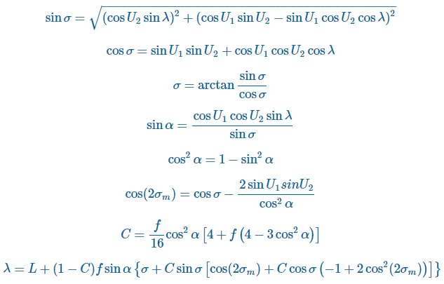

***Figure 2.1.3.2.1.1 Formula of Vincenty Algorithm***

When the difference between the current value of λ and the value of λ from the previous iteration is less than the convergence tolerance then the final stage of the Inverse Method can be executed:

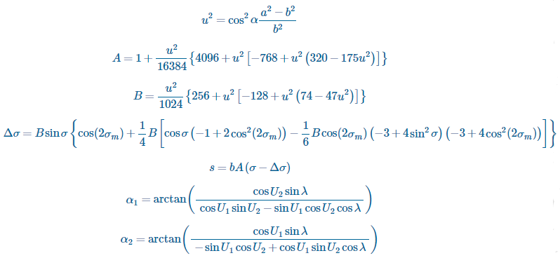

***Figure 2.1.3.2.1.2 Formula of Vincenty Algorithm***

**2.1.3.2.2 Strengths**

The accuracy of the result using Vincenty algorithm is more accurate compared to Haversine algorithm.

**2.1.3.2.3 Weaknesses**

Vincenty algorithm is more computationally intensive, therefore the performance is slower and the battery drain is higher compared to Haversine algorithm

### 2.1.4 Comparison between Haversine algorithm and Vincenty algorithm

|  |  |  |
| --- | --- | --- |
|  | Haversine algorithm | Vincenty algorithm |
| Computation Time | Short | Long |
| Complexity | Low | High |
| Battery consumption | Low | High |
| Accuracy | Low | High |

***Table 2.1.4.1 Table of Comparison Between Haversine Algorithm And Vincenty Algorithm***

## 2.2 Review of Existing Systems/Applications

### 2.2.1 28Days

**2.2.1.1 Description**

The 28Days is the Malaysia 1st Online Postnatal Care Service Platform. It is a trusted online confinement service search tool dedicated to help new moms or mum-to-be find a reliable and the right postnatal care provider or also known as ‘Pui Yuet’. This website is founded by a mother of four children who named Ianie Chong. One of the reasons that urge Ianie to run this system is the bad experience during her pregnancy. During her pregnancy, she had a lot of bad experience of the entire process of hiring a Pui Yuet. So instead of solving this situation, she decides to run a platform that could provide the right Pui Yuet for all of the new mom or mom-to-be. This website mainly helps the moms to find the suitable confinement ladies or nannies in Malaysia. In fact, moms can request to change the confinement lady in the event that the one you paired are not a good match with you.

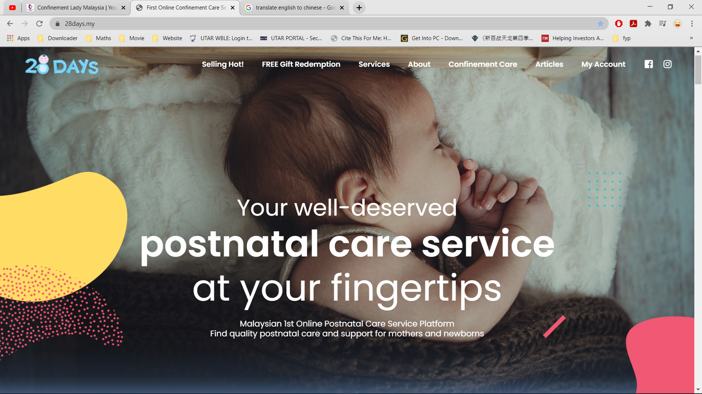

***Figure 2.2.1.1.1 Main interface of 28Days.***

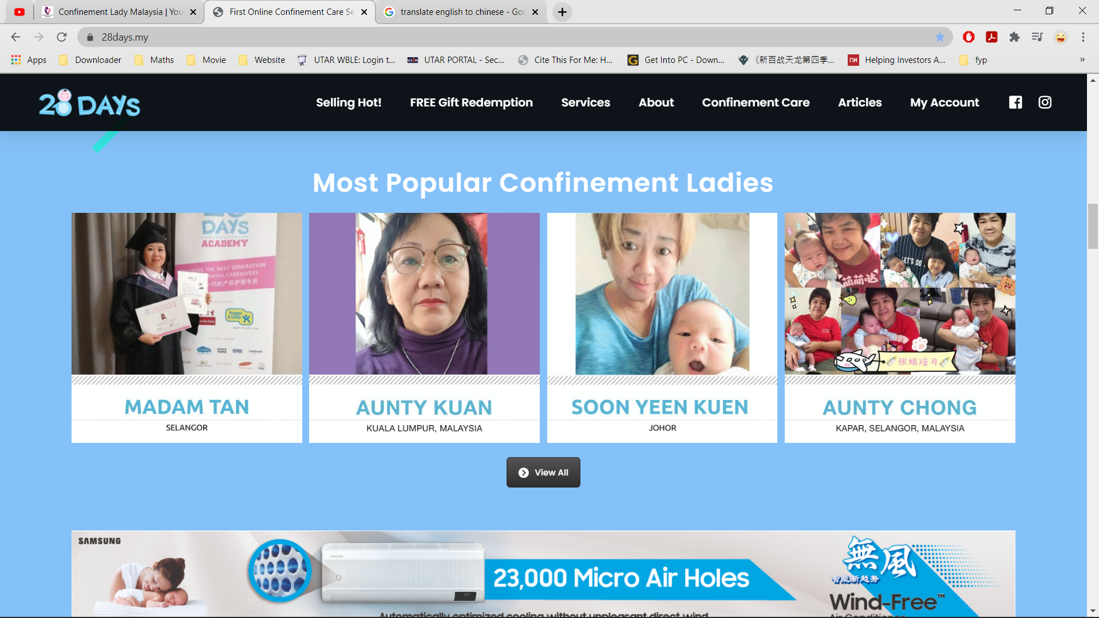

***Figure 2.2.1.1.2 Main interface of 28Days.***

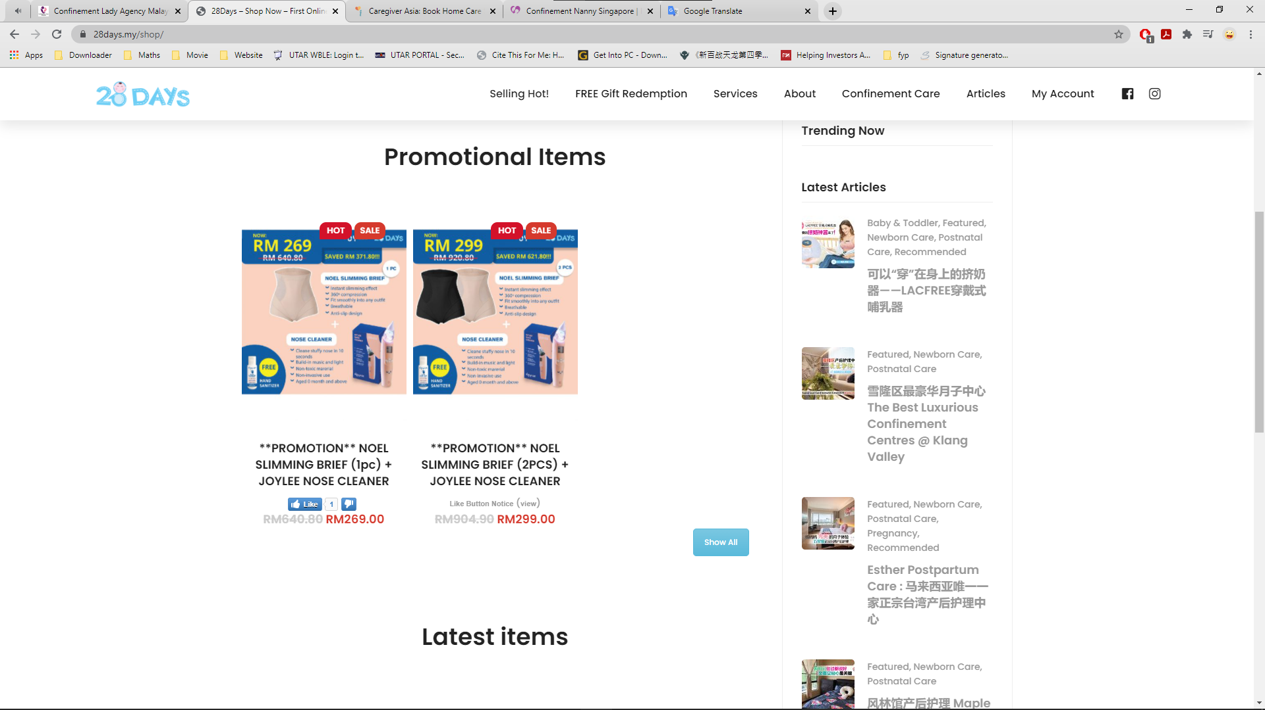

***Figure 2.2.1.1.3 E-commerce platform on 28Days.***

**2.2.1.2 Strengths**

The GUI of this platform is quite simple and easy for the user to use even for those users who does not have very well knowledge about the computer also can handle and operate it. Other than this, the platform has list out the most popular confinement ladies in their main interface. This feature could help the new moms to compare the services between both different confinement ladies and help them to choose out their desired Pui Yuet. Besides, this website also provides an e-commerce platform for the retailer to sell their commodity on the website.

**2.2.1.3 Weaknesses and Limitations**

However, 28Days does not provide some examples of the photo of the confinement lady taking care of the baby and moms. This could be worrying the users since they could not see any evidence that can proof the quality of the confinement service. Another weakness of this platform did not provide the 24/7 standby chat service for the customers. This could cause the office could not instantly receive the feedback or the problem faced by their customers during the confinement service period. Besides, 28Days did not provide review site to let the users write down review. This might cause the potential customers change their mind to hire confinement lady through their platform since they do not have any good review.

**2.2.1.4 Suggestions and Recommendations**

28Days could provide the photo of the confinement lady during the training session or the photo of real scenario that confinement lady taking care of the new moms and baby at their website to proof the professional of their workers. Besides, 28Days can implement the live chat system into their website so they could receive the message from their customers and reply them in real time. Next, the developer can build in a section to display all the review and rating of the service from the customers on their page to proof the quality of their service so that the confinement service center can attract more customers.

### 2.2.2 Confinement Care Malaysia PLT

**2.2.2.1 Description**

Confinement Care Malaysia PLT is an Online Clients-to-Confinement Care Services Provider in Malaysia. Their vision is to help every new mother in achieving a stress-free confinement, by providing Quality Customer Service at affordable fees, all in one organized portal. Confinement Care Malaysia PLT mainly providing the following service which is: coordinating the prompt arrival of a confinement lady to your home when your newborn arrives, providing professional massage services to help new mothers recover and rejuvenate after pregnancy and childbirth and providing professional consultant advice to the first-time. Their confinement service coverage area mainly located at Klang Valley, Penang, and Singapore. The design of this website is quite simple and clearly for those elder people to understand.

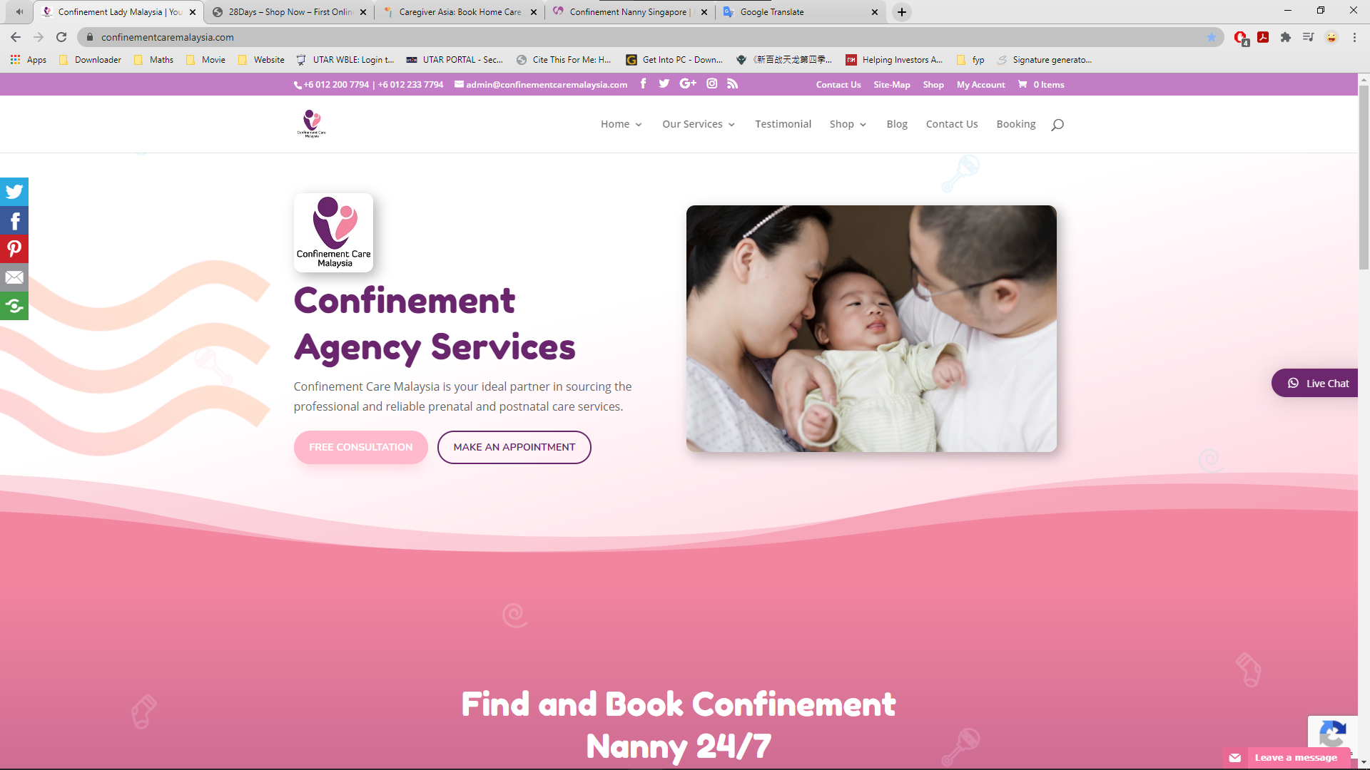

***Figure 2.2.2.1.1 Main Interface of Confinement Care Malaysia PLT.***

**2.2.2.2 Strengths**

The guidance to find and book confinement lady in this website is stated clearly with short and simple in the main page, which made other people easy to understand. Besides, this website also provides the e-platform to sell the confinement product on the website. Another strength that needs to mention is this website has listed out all of that service graphically on their page to emphasize the service they provide.

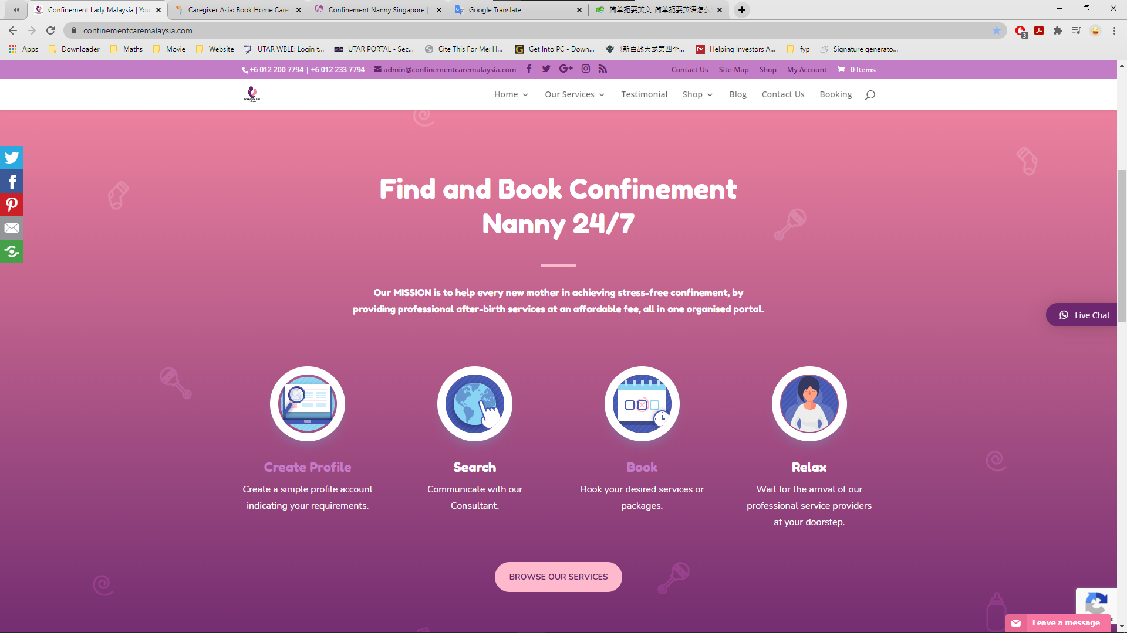

***Figure 2.2.2.2.1 Guidance for customers to book confinement lady.***

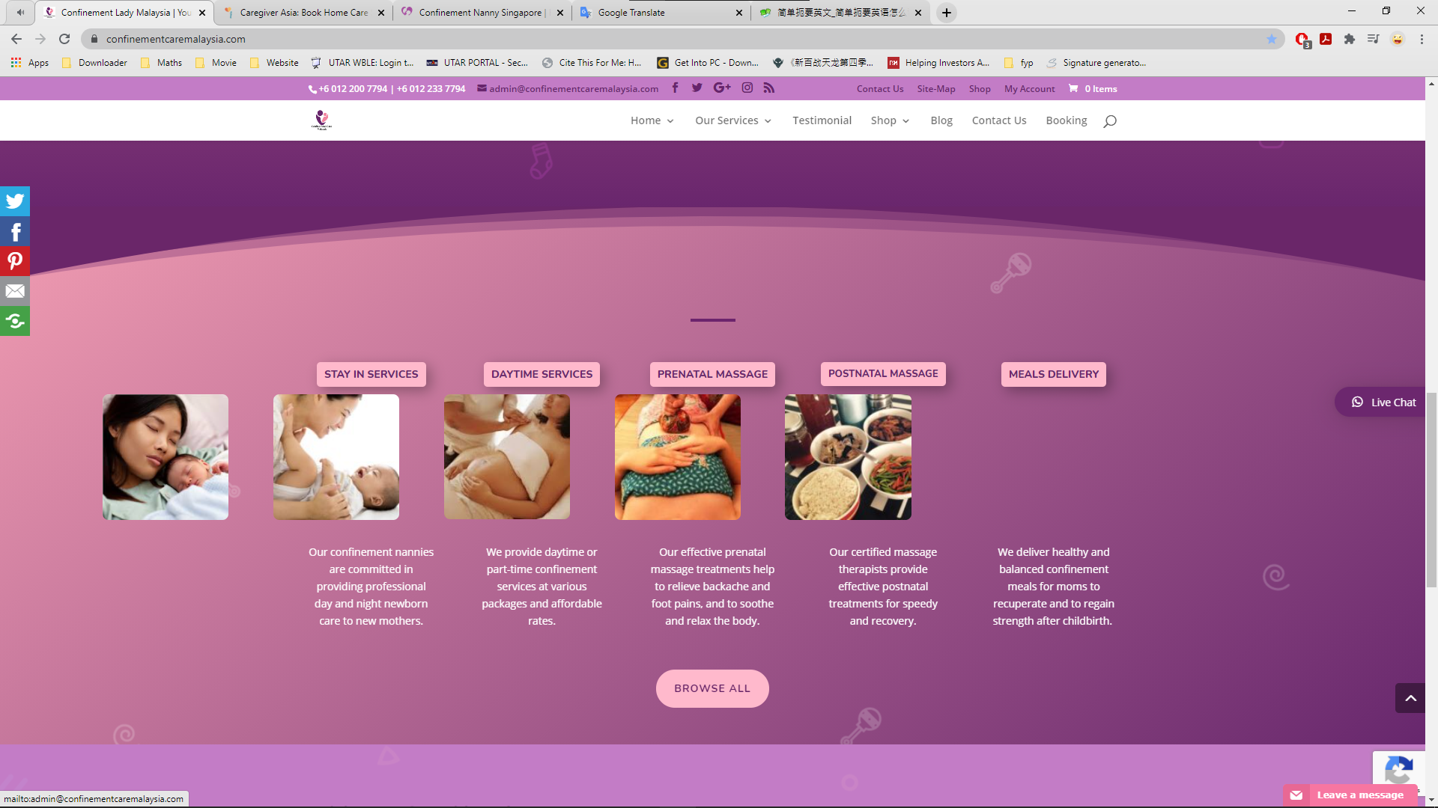

***Figure 2.2.2.2.2 Services listed with graphical visual.***

**2.2.2.3 Weaknesses and Limitations**

This website does not have the pop out notification features on the device. The customers have to self-check the email to for the confirmation of the booking instead of straightly pop out the confirmation notification on their device. Next, this system does not provide detail of the confinement nanny for the user but just random assigning a nanny to the customers.

**2.2.2.4 Suggestions and Recommendations**

The website could apply the pop out notification feature into the website so in the future customers could instantly being notify from the portal once their application is being accepted. Next, the website can add in the detail of confinement lady like name, case handled, experiences into the portal for the customers to have a better view or recognition about the confinement lady they going to hire.

### 2.2.3 NannySOS Confinement Nanny Agency

**2.2.3.1 Description**

NannySOS is a professional confinement nanny agency in Singapore that established since 2011. It registered and approved by the Ministry of Manpower (MOM) to help facilitate the employment such as applying confinement nanny work permit for Malaysian confinement nanny. NannySOS provides confinement services to help mothers with full recovery after childbirth and taking good care of the baby. All nannies from NannySOS confinement nanny agency are professionally trained with at least 3 years of experience (Confinement Nanny Singapore, 2021).

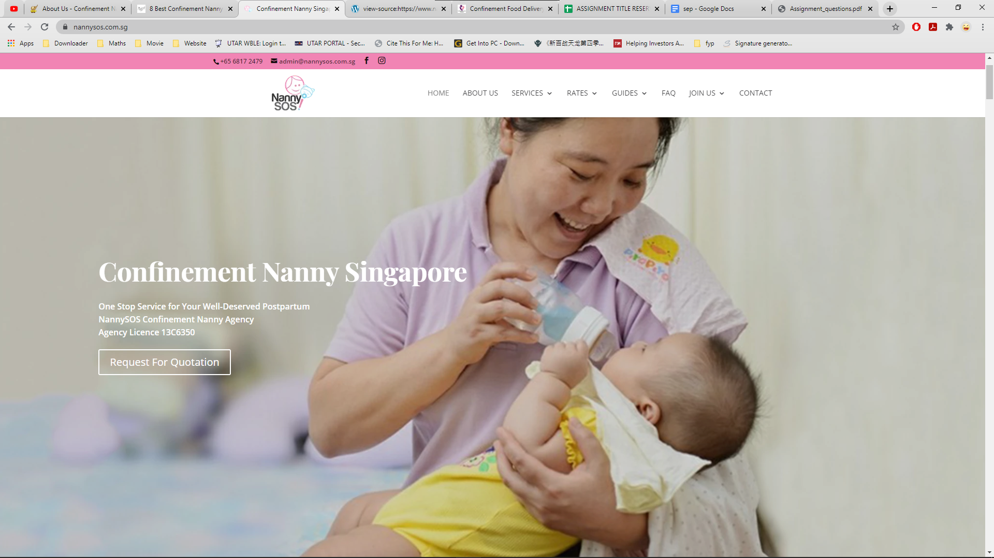

***Figure 2.2.3.1.1 Main interface of NannySOS.***

**2.2.3.2 Strengths**

In the main interface of this website, the agency will provide the provide platform for the recruitment for confinement nanny whereas other websites do not have this feature. The detail of the food menu like the number of meals provided and the price of the meals is clearly stated and align orderliness in the table. Besides, NannySOS also provide the graphical view of its agency location which supported by Google Maps.

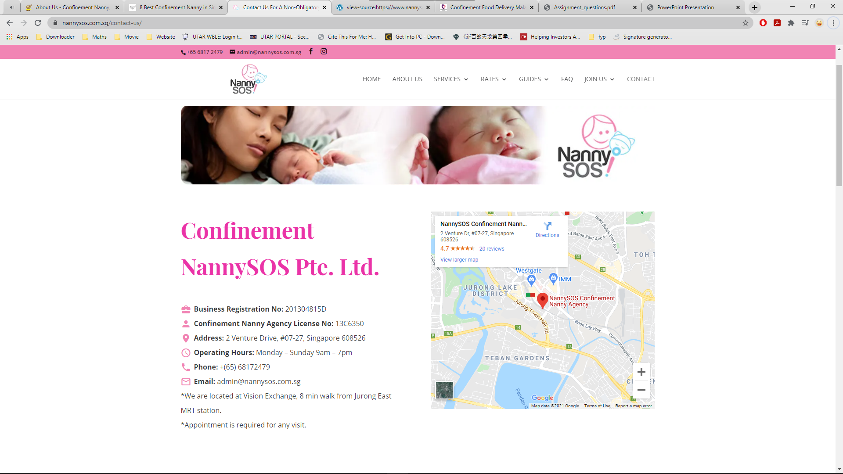

***Figure 2.2.3.2.1 Contact Interface of NannySOS.***

**2.2.3.3 Weaknesses and Limitations**

However, NannySOS did not provide the feature that shown the available confinement lady for the customers to choose. This could not provide the satisfying choice for the customers to choose for their desired confinement lady. NannySOS did not provide the e-commerce platform to sell the relevant confinement items which also cause them lost one of the ways to gain the profit. Besides, live chat system did not implement in the system.

**2.2.3.4 Suggestions and Recommendations**

NannySOS could implement a section that consist all of the available confinement ladies on their website for the customers to choose. Besides, NannySOS can implement a platform to let the seller sell their item on their website. Lastly, NannySOS could build the live chat system or insert a link to direct their customer to their own chat system so they could communicate with their customer instantly.

### 2.2.4 Star Confinement Nanny

**2.2.4.1 Description**

Star Confinement Nanny is specialized in providing quality confinement nannies to post-natal moms and newborns which established since 2013. Their confinement nannies are the modern nannies who are had at least 5-1- years set and full experiences. As such, they are excellent in doing both traditional confinement practices and modern confinement practices for moms and caring for newborns. All of their nannies are selected based on good working record, cleared reference check and a MUST too possess good attitude. Especially one of their nannies had earn an award for the Best Service Confinement Nannies in year 2018. Confinement Nanny seek to become a one of the best confinement agencies in Singapore. They grow from a solid foundation and constantly seek opportunities to grow & expand.

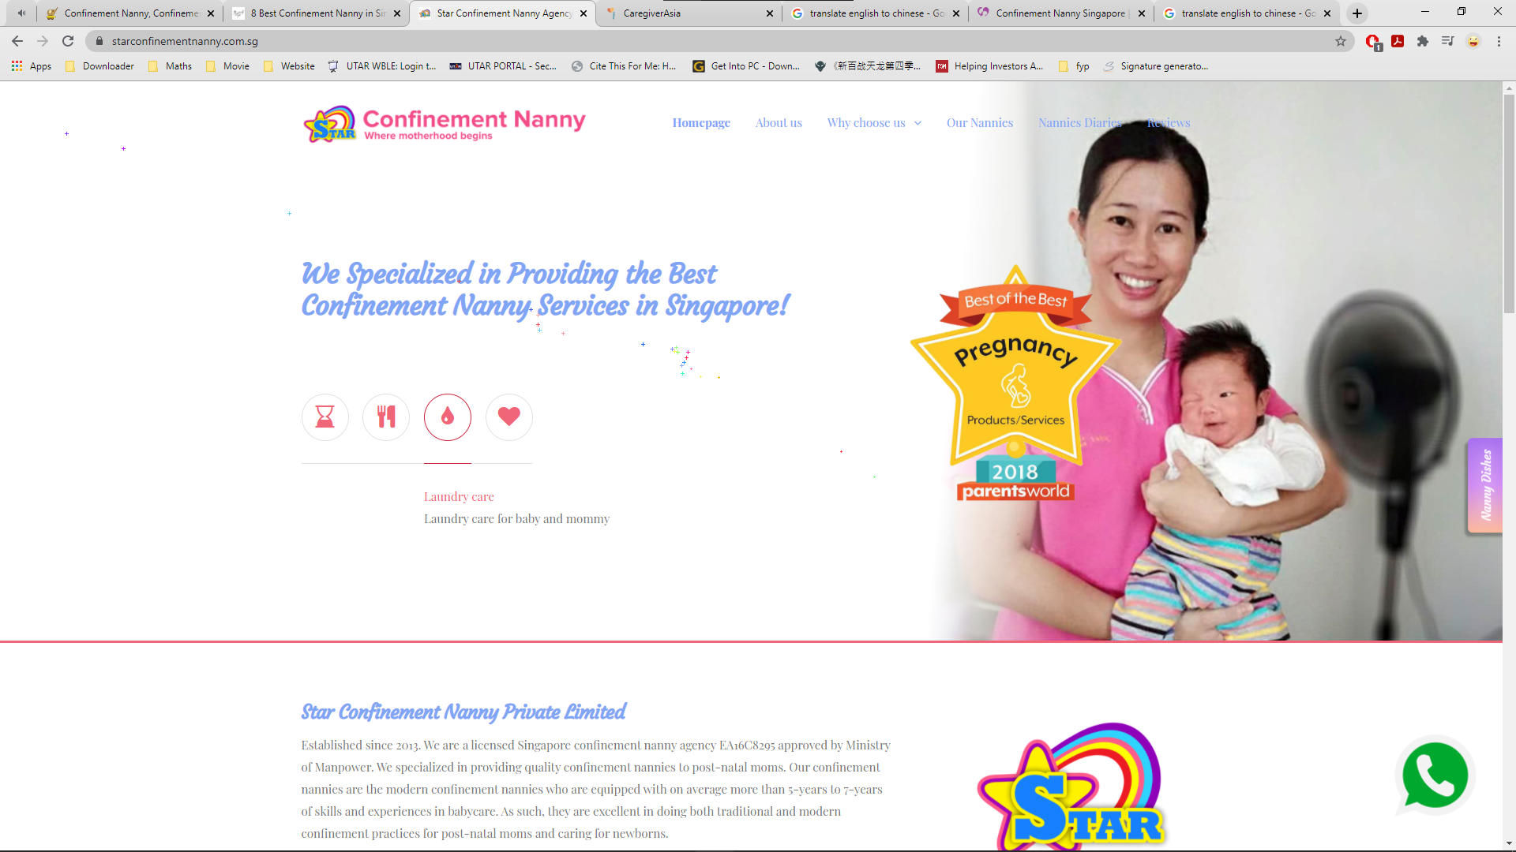

***Figure 2.2.4.1.1 Main Interface of Star Confinement Nanny.***

**2.2.4.2 Strengths**

Star Confinement Nanny had an interesting feature in its reservation system. It allows user or customer to make the reservations with agency through the calendar on their website. Besides, Star Confinement Nanny also provide different kind photo of their confinement meals on their website to attract the customers to order the meals from their agency. Besides, Star Confinement Nanny had posted the nanny diaries on their webpage to let the new moms and their family to understand what actual the confinement lady does to take care the mummy and baby during whole of the confinement period.

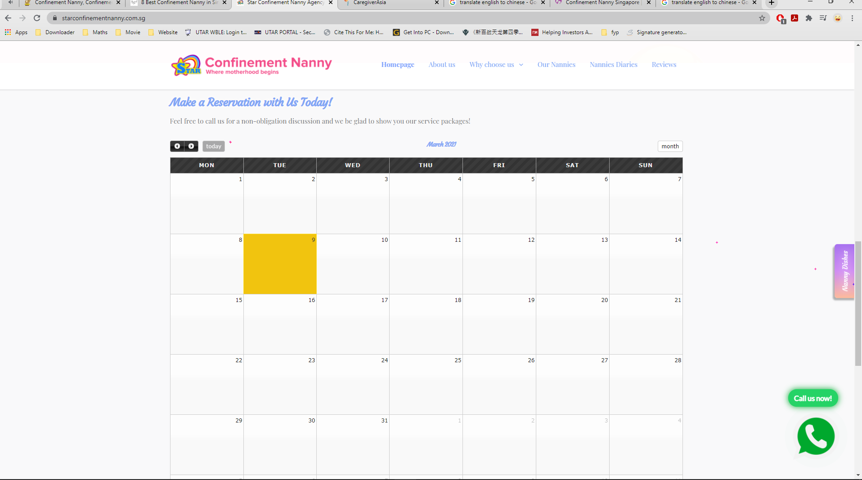

***Figure 2.2.4.2.1 Reservation System of Star Confinement Nanny.***

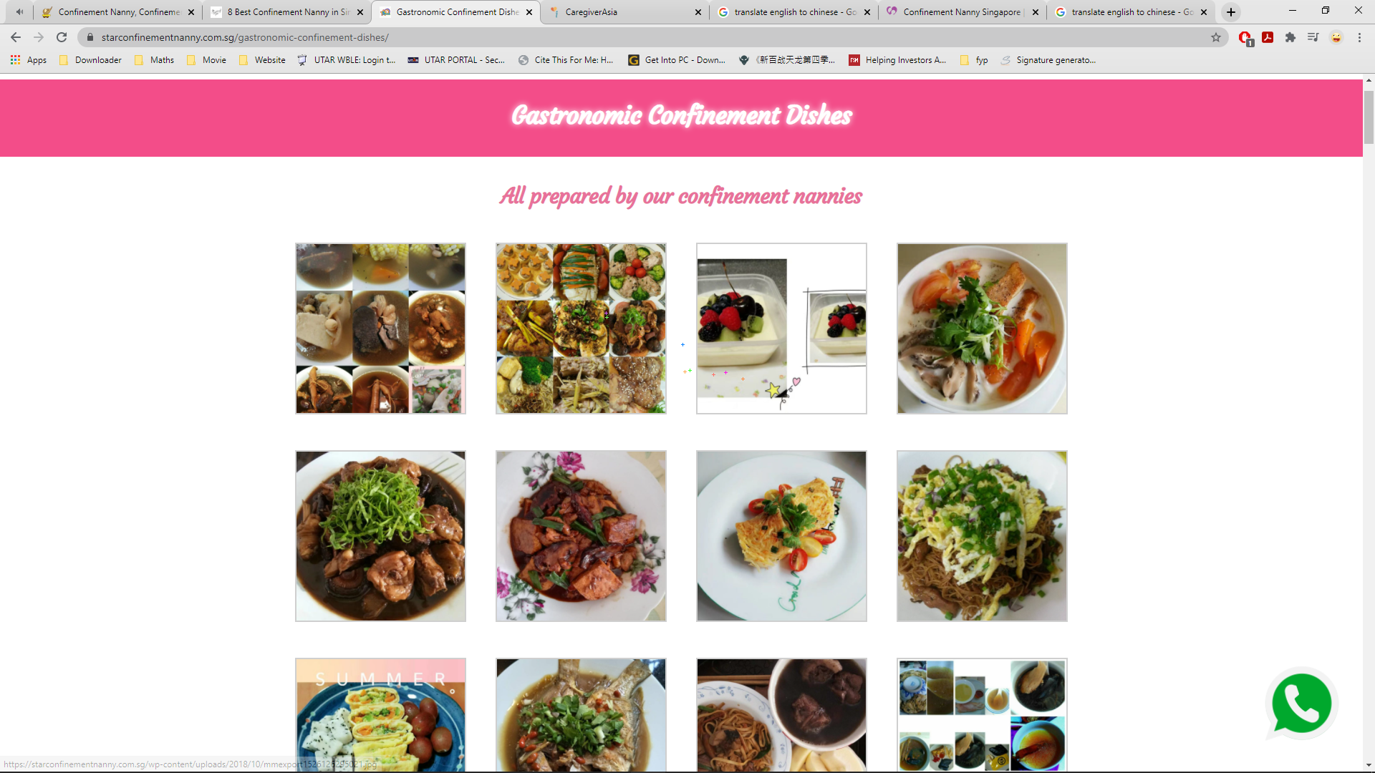

***Figure 2.2.4.2.2 Confinement Dishes of Star Confinement Nanny.***

**2.2.4.3 Weaknesses and Limitations**

However, Star Confinement Nanny does not provide e-commerce platform for the seller to sell the item on their website. The location provided by the agency is written by word form instead of displaying the location via graphical view.

**2.2.4.4 Suggestions and Recommendations**

Star Confinement Nanny could ask their IT team to setup a platform on their site to let the intention seller to sell their product on the platform. Next, the IT team could also implement the Google API in the webpage to show out the location of the Star Confinement Nanny on their page.

### 2.2.5 PEM Confinement Nanny Agency

**2.2.5.1 Description**

PEM Confinement Nanny Agency was established in 1987 and has been in the industry for 30 years. PEM Confinement Nanny Agency is the largest Confinement Centre in Singapore with over 400 nannies and is the first confinement nanny agency to be licensed by Ministry of Manpower (MOM) (PEM Confinement Nanny Agency, 2021). PEM Confinement Nanny Agency provide the following services which is baby care, laundry work for mother and baby, confinement bath, confinement herbal tonics, confinement food, domestic chores, guidance for mother in breastfeeding and advices in an affordable price.

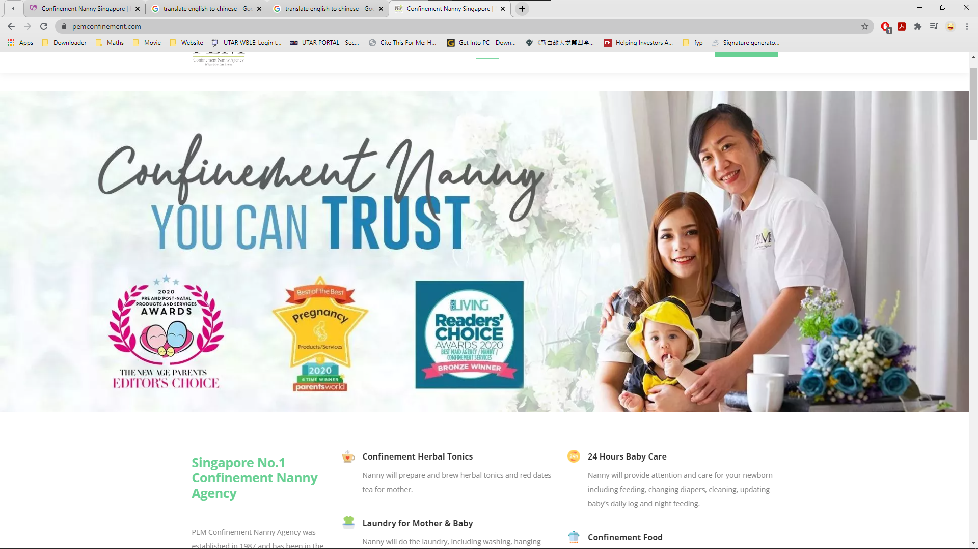

***Figure 2.2.5.1.1 Main Interface of PEM Confinement Nanny Agency***

**2.2.5.2 Strengths**

PEM Confinement Nanny Agency had listed out all of its services in graphical way at the main interface which make its interface more attractive. Besides, PEM Confinement Nanny Agency display its rating and review from customers in a more interesting method which is swiper slide to attract the attention of the customers while visiting the webpage.

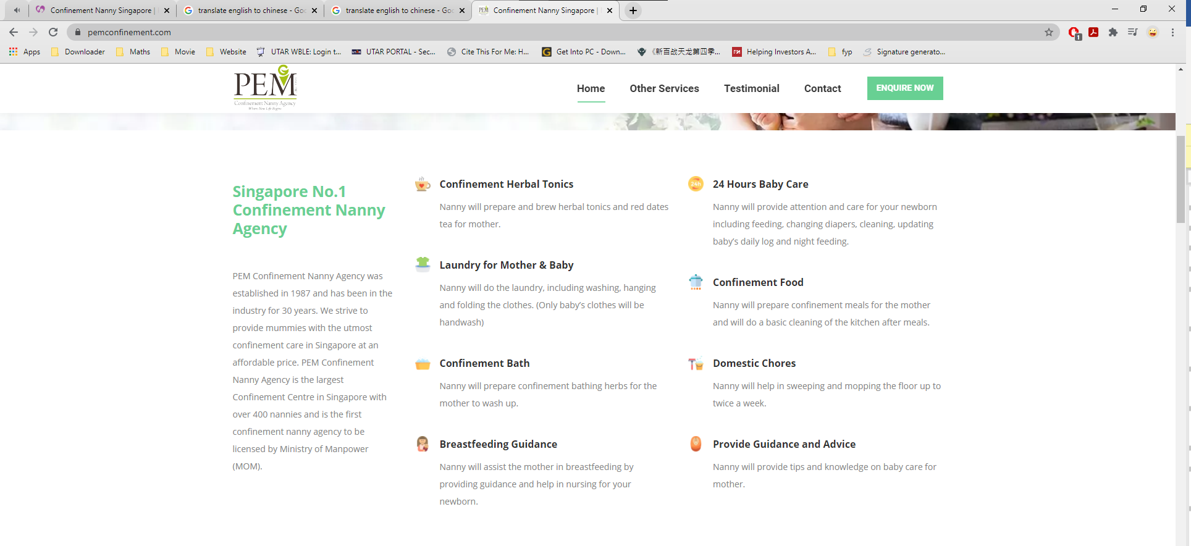

***Figure 2.2.5.2.1 Services listed in Graphical View.***

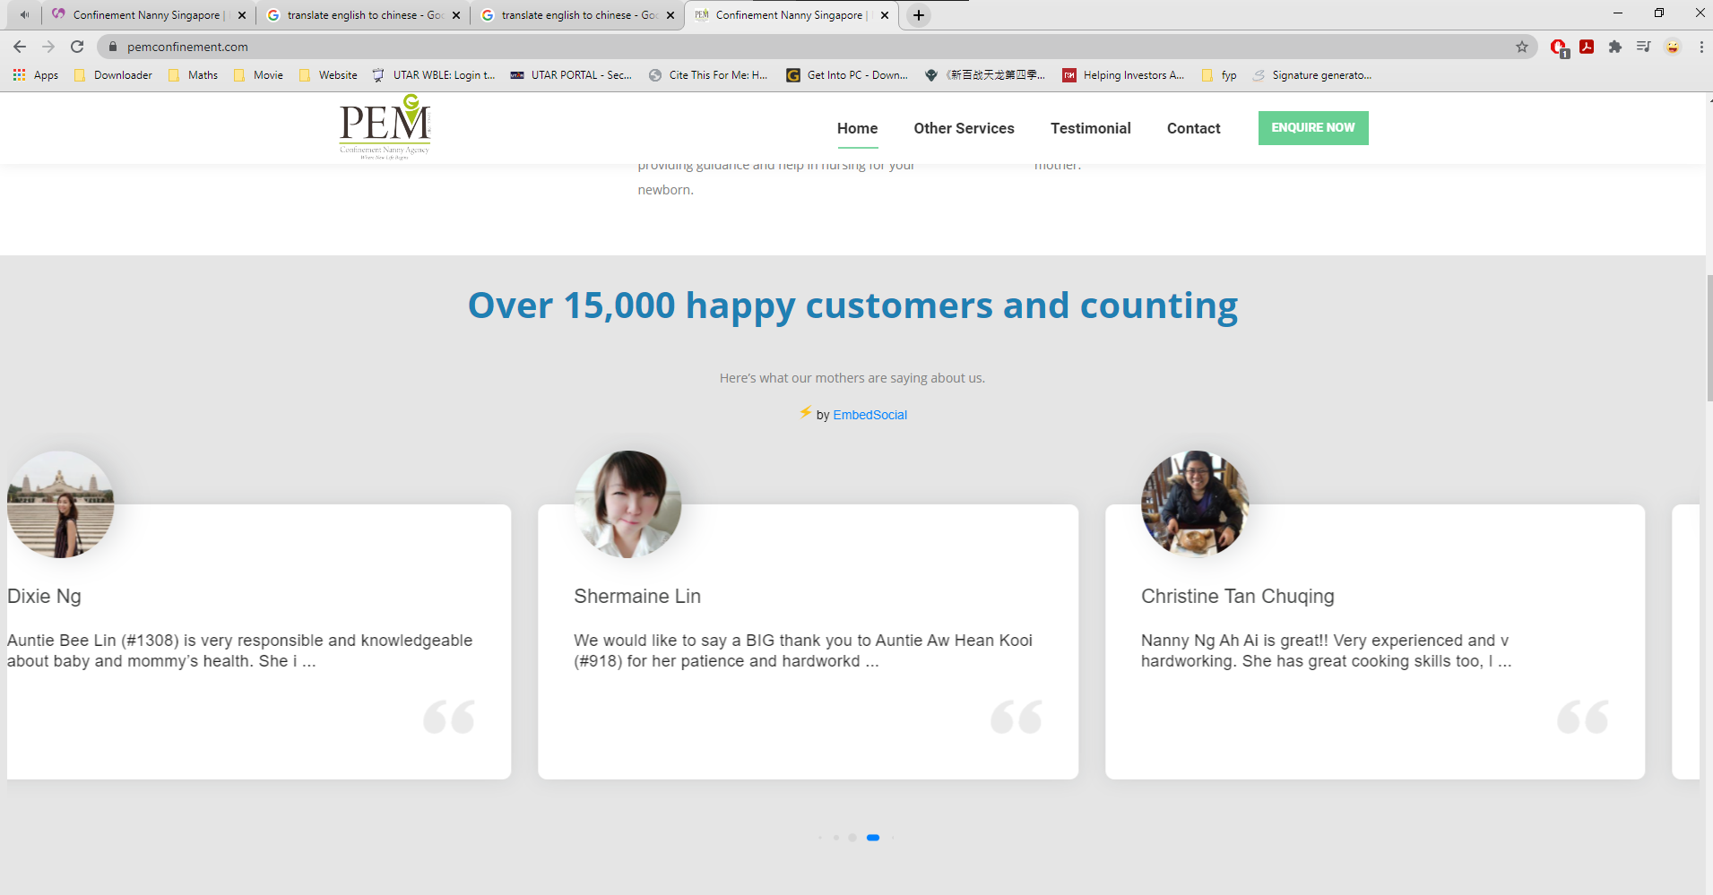

***Figure 2.2.5.2.2 Review from Customers of PEM Confinement Nanny Agency.***

**2.2.5.3 Weaknesses and Limitations**

First of all, PEM Confinement Nanny Agency does not have the live chat system which make a lot of trouble to customer who wish to get some consultation from PEM Confinement Nanny Agency. Next, customers cannot make reservation with PEM Confinement Nanny Agency through calendar which might make both sides could not came out an appropriate time to meet each other. Lastly, the location of PEM Confinement Nanny Agency had been stated unclearly since it did not provide a detail address which might cause the customer unable to find confinement center.

**2.2.5.4 Suggestions and Recommendations**

PEM Confinement Nanny Agency could implement a chat API into the system for the staff to contact with the customers. Next, PEM Confinement Nanny Agency can set up the reservation system with associated with calendar system so that the customer can reserve an available time for themselves. PEM Confinement Nanny Agency could implement Google Maps API into the webpage to show the location of the confinement center for the customers to have a more detail graphical location view.

### 2.2.6 Comparison between the similar application with the proposal system

The following table show the comparison between the similar application with the proposed system:

|  |  |  |  |  |  |  |
| --- | --- | --- | --- | --- | --- | --- |
| Features | 28days(website) | Confinement Care Malaysia PLT (website) | NannySOS | Star Confinement Nanny | PEM Confinement Nanny Agency | Proposed system |
| Rating system | Close with solid fill | Close with solid fill |  | Close with solid fill | Close with solid fill | Checkmark with solid fill |
| Customizable service package | Close with solid fill | Close with solid fill | Close with solid fill | Checkmark with solid fill | Close with solid fill | Checkmark with solid fill |
| Nearby Tracking System | Close with solid fill | Close with solid fill | Close with solid fill | Close with solid fill | Close with solid fill | Checkmark with solid fill |
| GPS navigation | Close with solid fill | Close with solid fill | Close with solid fill | Close with solid fill | Close with solid fill | Checkmark with solid fill |
| Notification alert | Close with solid fill | Close with solid fill | Close with solid fill | Close with solid fill | Close with solid fill | Close with solid fill |

***Table 2.2.6.1 Table of Comparison Between Reviewed System and Proposed System***

## 2.3 Discussion

From the Table 2.2.6.1, the author has chosen few features to compare with the existing web application. First of all, is the rating system. The table show that most of the application in the market does not have the rating system to visualize the quality of the confinement service provided by the confinement lady. The confinement lady might not give as much effort as they can to provide the confinement service if there is no any system that can monitor or rate their service which might cause the reputation of the agency become worse.

Besides, the customizable service package is chosen to be implement into system. The reason for choose this feature is the author would like to provide the Mothers have more selection of the choice during the confinement service selection stage compared to other web application in the market which only allow user to choose for the confinement service package that they provided. However, users might only need some part of the confinement service in the package which will cause the user extra spend the money for the service that no necessary. Besides, confinement ladies also able to customize their own unique confinement service package for sale to attract more customer.

Navigation system is chosen to apply in this module to navigate the confinement lady to reach the Mother’s house and avoid unnecessary time wastage by the confinement lady during travel to the Mother’s house.

The GPS tracking system will be added into the system also to allow Mothers look for the confinement ladies that stay near around them. The main reason to add this feature into the system is because this can allow Mothers to find the confinement lady that stay near them so that the food or beverages prepared by the confinement lady able to suit the Mother’s taste.

In Table 2.1.5.1, it shows that the comparison between Haversine algorithm and Vincenty algorithm. Haversine algorithm have a faster computation time and a lower brain consumption compared to the Vincenty algorithm. However, the Vincenty algorithm have a higher accuracy of the result compared to Haversine. For this application, the distance computed between two users does not need a high precision on the result. Therefore, the Haversine algorithm is applied in this case due to the computation time and brain consumption is better than Vincenty algorithm.

# System Methodology/Approach

The Agile software development methodology was applied in the development process for this project. The purpose to choose this method for this project is that it able to develop software that is both high quality and low-cost.

At the brainstorm a.k.a. planning stage, the developer will analysis the problems faced by the users and came out the solutions based on the requirement of the users. Then, in the design stage, developer will design the framework of the system, design the documents needed, prototype of the application, and the function and algorithm that need to be implemented into the system. At the development stage, the function and algorithm will be implemented into the system by developer one by one until the expected output is achieved. The developer will test the system again and again in the quality assure stage a.k.a. testing stage to identify and solve the potential bug in the system. If all of the functionally of the system is develop completely, the system will be delivered to the users. Otherwise, the developers will continue to fix the system until it error-free.

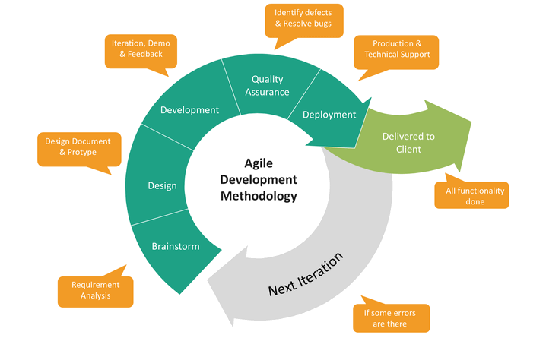

***Figure 3.1 Agile Software Development Phases***

## 3.1 System Design Diagram/Equation

### 3.1.1 System Architecture Diagram

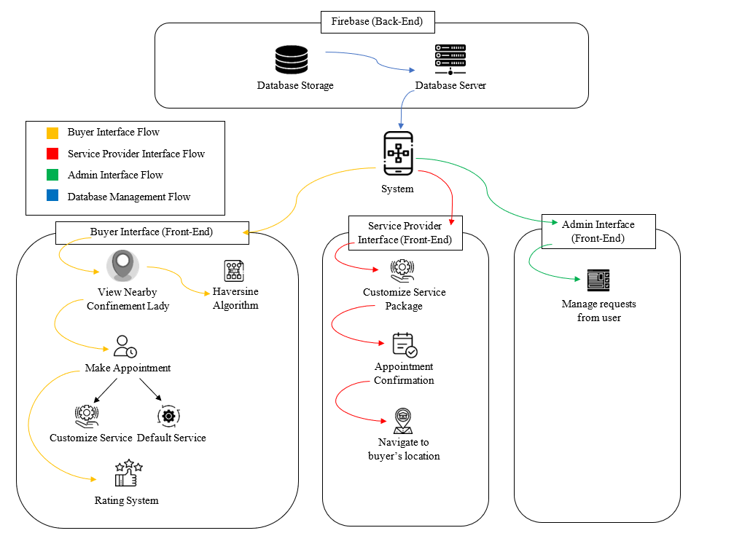

***Figure 3.1.1.1 System Architecture Diagram of E-confinement Service System***

This is the system architecture diagram of the e-confinement service system. The system is split into two part which is front-end and back-end. There are 4 different flow in this system architecture diagram which is buyer interface flow, service provider interface, admin interface flow, database management flow. Each flow is represented by their own unique color.

#### 3.1.1.1 Buyer Interface Flow

Buyer interface flow starts when the buyer login the user log into their account. Haversine algorithm will start computing the distance between the buyer and the service provider a.k.a. confinement lady. The nearer confinement lady will be displayed first followed by the further as a list at the homepage of the buyer. Buyer can start make order after they choose the confinement lady. Buyer can either select the provided package by the confinement lady or customize the service package based on the provided package. After make the order with the confinement lady, the buyer needs to wait for the confirmation from the confinement lady. At the end of the service, buyer can rate the performance of the confinement lady.

#### 3.1.1.2 Service Provider Interface Flow

Service provider interface flow starts when the service provider a.k.a. confinement lady log into their account. Confinement lady can start to set up their confinement service package. There are 3 different type of packages to let the confinement lady customize the service that they want to include into the package. Besides, after they confirm the order made by the buyer, they can press the navigation button to navigate to the buyer’s house.

#### 3.1.1.3 Admin Interface Flow

Admin interface flow starts when there is cancel order request raised by the buyer. Admin need to manage the requests raised by the buyer by approve or decline the request based on their reason.

#### 3.1.1.4 Database Management Flow

Database management flow starts when the user registers an account in the system. The users must use their email to register an account and provide all the required information to be stored in the database. The service information provided by the service provider will be stored in the database. Moreover, the order details made by the users will also be stored in the database for the order tracing in the future. The location of the users also will be stored in the database to be used as parameter to compute the distance between the buyer and confinement lady. In addition, the rating review given by the buyer will also store in the database to be displayed as an information for the service provider. All the data will be stored in the Firebase so that the data can be tracked in the future.

### 3.1.2 Use Case Diagram and Description

A use case is a written description of how the users will interact and perform tasks in the system. In this section, there had two sub-section which is use case diagram and use case description. Use case diagram summarize the relationship between the use cases, actors and the system. Besides, the use case description also described the sequences of the users from beginning until ending to achieve the goal.

#### 3.1.2.1 Use Case Diagram

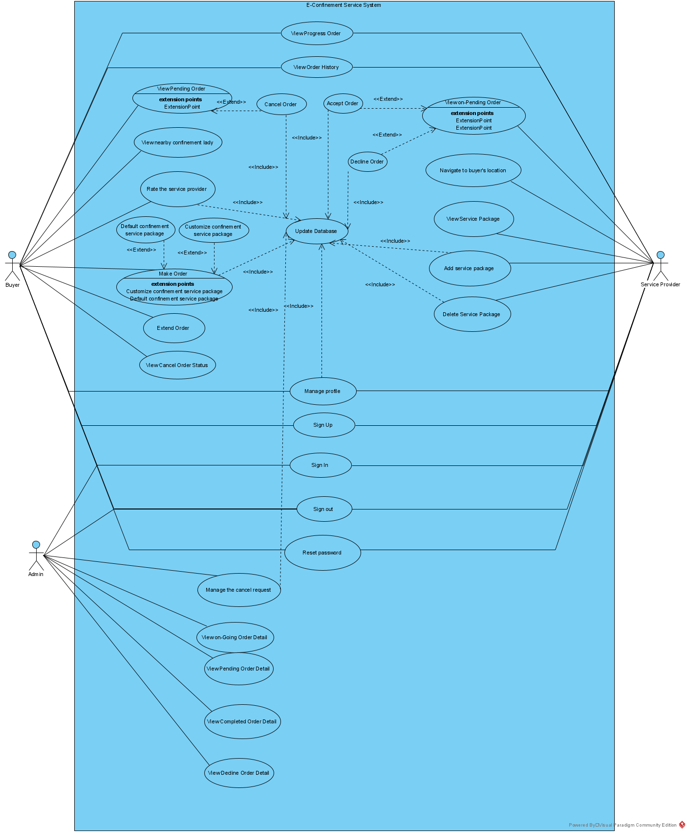

***Figure 3.1.2.1.1 Use Case Diagram***

Figure 3.1.2.1.1 has shown the use case diagram of the e-confinement service system. There are three type of user in the system which is buyer, service provider and admin. Buyer and service provider able to sign up, sign in, sign out and reset password in the application. They also able to manage their profile by editing the name, phone number, address and other personal information. Admin only able sign into the account for administration purpose.

Admin user only able to be assigned at the backend by the administrator. Admin able to view all the order information that made between the buyer and service provider. They also able to manage the cancel order request raised by the buyer.

For buyer, they are able to view the nearby service provider a.k.a. confinement lady from the nearest to the furthest as a list at the home page. After select the confinement lady, they are able to make the order offered by the confinement lady. If they wish to remove some of the service offered by the confinement lady, they also able to remove the particular service. Buyer also able to cancel the order request and refund the money before the confinement lady confirm the order at the pending order page. They also can view the status of the cancel order. Buyer also able to check the progress order detail at the progress order page. Buyer can choose to extend the date of confinement service if they wish to extend the confinement service after discuss with the confinement lady. After all the services ended, buyer able to rate their confinement lady, by providing the photo, videos and comment about their experience at the page provided. All the rating detail and the order detail will be updated to the database. Buyer also able to view their order history to see their previous order detail.

Next, service provider able to add and delete their own service package. Service provider also able to view the service packages added by them. Besides, service provider able to view all the order detail that make with them. They can choose either to accept or to decline the order. If decline the order, the system will remove the order. Once accept the order, the system will add the order detail at the progress order page as a further reference for service provider. Service provider can navigate to the buyer house by using the google map with click the button provided in the order detail page.

#### 3.1.2.2 Use Case Description

##### 3.1.2.2.1 Sign Up

|  |  |  |
| --- | --- | --- |
| Use case name: Sign up | ID: 001 | Important level: High |
| Primary Actor: Buyer, Service Provider | | |
| Stakeholders and Interests:  Buyer, Service Provider – want to sign up a user account to access the system. | | |
| Trigger: User clicks on the “Sign Up” button at the sign-up page. | | |
| Normal Flow of Events:   1. User fill the email and password in the provided column. 2. User click the “Sign Up” button. 3. System will authenticate the information of user. 4. System will direct the user to Personal Detail page. 5. User fill up the profile information. 6. User click the “Complete” button. 7. System will show Terms & Condition for the user. 8. User click “Agree” to proceed. 9. System will save the data into database. 10. System will direct user to their homepage. 11. System display “Successfully Sign Up” message to user. | | |
| Sub Flows:  S-2.1 If email or password is not complete, system will display the error message.  S-3.1 If the email of the customer duplicate with the database, system will ask customer to retype a new email.  S-6.1 If the profile information is not complete, system will toast the message for the user.  S-8.1 If user did not agree the Terms & Condition, system will stop at the profile information filling stage. | | |

***Table 3.1.2.2.1.1 Sign Up Use Case Description***

* + - * 1. 3.1.2.2.2 Sign In

|  |  |  |
| --- | --- | --- |
| Use case name: Sign In | ID: 002 | Important level: High |
| Primary Actor: Buyer, Service Provider, Admin | | |
| Stakeholders and Interests:  Buyer, Service Provider, Admin – want to sign into the system. | | |
| Trigger: User clicks on the “Sign In” button at the sign in page. | | |
| Normal Flow of Events:   1. User fill the email and password in the provided column. 2. User click the “Sign In” button. 3. System will authenticate the information of user. 4. System will direct the user to their homepage page. 5. User fill up the profile information. 6. System display “Successfully Sign In” message to user. | | |
| Sub Flows:  S-2.1 If email or password is incorrect, system will display the error message. | | |

***Table 3.1.2.2.2.1Sign in Use Case Description***

* + - * 1. 3.1.2.2.3 Sign out

|  |  |  |
| --- | --- | --- |
| Use case name: Sign Out | ID: 003 | Important level: High |
| Primary Actor: Buyer, Service Provider, Admin | | |
| Stakeholders and Interests:  Buyer, Service Provider, Admin – want to sign out from the system. | | |
| Trigger: User clicks the “Logout” button at the side drawer menu. | | |
| Normal Flow of Events:   1. User clicks the “Logout” button. 2. System will authenticate the login status of user. 3. System will direct the user to the welcome page. 4. System display “Successfully Signed out” message to user. | | |

***Table 3.1.2.2.3.1 Sign out Use Case Description***

* + - * 1. 3.1.2.2.4 Manage profile

|  |  |  |
| --- | --- | --- |
| Use case name: Manage profile | ID: 004 | Important level: Medium |
| Primary Actor: Buyer, Service Provider | | |
| Stakeholders and Interests:  Buyer, Service Provider – want to edit the profile information. | | |
| Trigger: User clicks the “Profile” button at the side drawer menu. | | |
| Normal Flow of Events:   1. User clicks the “Profile” button. 2. System will direct user to the profile information page. 3. User starts to edit the information 4. Users clicks the “Save” button on the top right corner of the page. 5. System update the data into the database. | | |
| Sub Flows:  S-4.1 System will display the error message if the information does not meet the requirements. | | |

***Table 3.1.2.2.4.1 Manage Profile Use Case Description***

* + - * 1. 3.1.2.2.5 View Progress Order

|  |  |  |
| --- | --- | --- |
| Use case name: View Progress Order | ID: 005 | Important level: Low |
| Primary Actor: Buyer, Service Provider | | |
| Stakeholders and Interests:  Buyer, Service Provider – want to view the progress order information. | | |
| Trigger: User clicks the “Orders” button at the side drawer menu. | | |
| Normal Flow of Events:   1. User clicks the “Orders” button. 2. System will direct user to the order tabs page. 3. User selects the “Progress Order” tab. 4. System display the progress orders in a list. 5. Users clicks on the order list to view the details.   6. System will display the order information in a new page. | | |

***Table 3.1.2.2.5.1 View Progress Order Use Case Description***

* + - * 1. 3.1.2.2.6 View History Order

|  |  |  |
| --- | --- | --- |
| Use case name: View History Order | ID: 006 | Important level: Low |
| Primary Actor: Buyer, Service Provider | | |
| Stakeholders and Interests:  Buyer, Service Provider – want to view the history order information. | | |
| Trigger: User clicks the “Orders” button at the side drawer menu. | | |
| Normal Flow of Events:   1. User clicks the “Orders” button. 2. System will direct user to the order tabs page. 3. User selects the “History Order” tab. 4. System display the history orders in a list. 5. Users clicks on the order list to view the details. 6. System will display the order information in a new page. | | |

***Table 3.1.2.2.6.1 View History Order Use Case Description***

* + - * 1. 3.1.2.2.7 View Pending Order

|  |  |  |
| --- | --- | --- |
| Use case name: View Pending Order | ID: 007 | Important level: Low |
| Primary Actor: Buyer, Service Provider | | |
| Stakeholders and Interests:  Buyer, Service Provider – want to view the pending order information. | | |
| Trigger: User clicks the “Orders” button at the side drawer menu. | | |
| Normal Flow of Events:   1. User clicks the “Orders” button. 2. System will direct user to the order tabs page. 3. User selects the “Pending Order” tab. 4. System display the pending orders in a list. 5. Users clicks on the order list to view the details.   6. System will display the order information in a new page. | | |

***Table 3.1.2.2.7.1 View Pending Order Use Case Description***

* + - * 1. 3.1.2.2.8 View Nearby Confinement Lady

|  |  |  |
| --- | --- | --- |
| Use case name: View Nearby Confinement Lady | ID: 008 | Important level: High |
| Primary Actor: Buyer | | |
| Stakeholders and Interests:  Buyer – wants to search nearby confinement lady around them. | | |
| Trigger: Users sign into the system. | | |
| Normal Flow of Events:   1. User sign into system. 2. System get the location data of all the service provider from database. 3. System apply Haversine algorithm to compute the distance between the buyer and service provider. 4. System will display the confinement lady list from nearest to furthest at the homepage. 5. User clicks the confinement lady. 6. System will direct user to the confinement lady profile information page. 7. Users view the detail information of the confinement lady. | | |

***Table 3.1.2.2.8.1 View Nearby Confinement Lady Use Case Description***

* + - * 1. 3.1.2.2.9 Make Order

|  |  |  |
| --- | --- | --- |
| Use case name: Make Order | ID: 009 | Important level: High |
| Primary Actor: Buyer | | |
| Stakeholders and Interests:  Buyer – wants to order the confinement service. | | |
| Trigger: User clicks the “Order Now” button at the bottom-right corner of the homepage. | | |
| Normal Flow of Events:   1. User clicks the “Order Now” button. 2. System direct the user to the “Place Your Order” page. 3. User click the “Press Here” button at the “Select Confinement Lady” step. 4. System will show the available confinement lady in a list for user. 5. User select the confinement lady. 6. System will direct user to the confinement lady profile information page that they selected. 7. User clicks the “Hire Me” button. 8. System will update the confinement lady information at the “Place Your Order” page. 9. User clicks the “Continue” button proceed to the “Select Confinement Date” step. 10. User click the “Press Here” button at the “Select Confinement Date” step. 11. System will display calendar for user. 12. User picks the date of the confinement service. 13. System will update the confinement date information at the “Place Your Order” page. 14. User clicks the “Continue” button proceed to the “Select Confinement Package” step. 15. User click the “Press Here” button at the “Select Confinement Package” step. 16. System will display the service package for user. 17. User selects the confinement service package. 18. System will update the confinement service package information at the “Place Your Order” page. 19. User clicks the “Continue” button. 20. System will display the payment method. 21. User fill in the payment information. 22. System will verify the payment information. 23. System will display the order success information to the user. | | |
| Sub Flows:  S-19.1 If user did not select the confinement lady or confinement date or confinement service, system will display the message to inform user.  S-21.1 If user did not make payment, system will display the message to inform the user. | | |

***Table 3.1.2.2.9.1 Make Order Use Case Description***

* + - * 1. 3.1.2.2.10 Select Default Confinement Service Package

|  |  |  |
| --- | --- | --- |
| Use case name: Select Default Confinement Service Package | ID: 010 | Important level: High |
| Primary Actor: Buyer | | |
| Stakeholders and Interests:  Buyer – wants to order the default confinement service package. | | |
| Trigger: User clicks on the service package at the “Service Selecting” page. | | |
| Normal Flow of Events:   1. User selects confinement service packages. 2. System display the detail of the confinement service package. 3. User click “Order” button. 4. System direct user back to “Place Your Order” page and update the confinement service package information. | | |

***Table 3.1.2.2.10.1*** ***Select Default Confinement Service Package Use Case Description***

* + - * 1. 3.1.2.2.11 Select Customize Confinement Service Package

|  |  |  |
| --- | --- | --- |
| Use case name: Select Customize Confinement Service Package | ID: 011 | Important level: High |
| Primary Actor: Buyer | | |
| Stakeholders and Interests:  Buyer – wants to order the customize confinement service package. | | |
| Trigger: User clicks on the service package at the “Service Selecting” page. | | |
| Normal Flow of Events:   1. User selects confinement service packages. 2. System display the detail of the confinement service package. 3. User click “Customize” button. 4. System direct user back to “Customize Order” page and display all the service available in the previous default package. 5. User select the services that they want to remain. 6. User clicks “Add To Cart” button to add the package. 7. System direct user back to “Place Your Order” page and update the confinement service package information. | | |
| Sub Flows:  S-6.1 If user did not pick any service, system will display message to notify user. | | |

***Table 3.1.2.2.11.1*** ***Select Customize Confinement Service Package Use Case Description***

* + - * 1. 3.1.2.2.12 Cancel Order

|  |  |  |
| --- | --- | --- |
| Use case name: Cancel Order | ID: 012 | Important level: High |
| Primary Actor: Buyer | | |
| Stakeholders and Interests:  Buyer – wants to cancel the order that made before. | | |
| Trigger: User clicks the “Orders” button at the side drawer menu. | | |
| Normal Flow of Events:   1. User clicks the “Orders” button. 2. System will direct user to the order tabs page. 3. User selects the “Pending Order” tab. 4. System display the pending orders in a list. 5. Users clicks on the “Cancel” button at the order they wish to cancel. 6. System will direct user to the Cancel Order Page. 7. User fill in the cancel reason at the provided space. 8. User click to “Submit” button. 9. System will update the data into database. | | |
| Sub Flows:  S-7.1 If the user did not fill out the cancel reason and clicks the “Submit” button, system will display a message to inform user. | | |

***Table 3.1.2.2.12.1 Cancel Order Use Case Description***

* + - * 1. 3.1.2.2.13 View Cancel Order Status

|  |  |  |
| --- | --- | --- |
| Use case name: View Cancel Order Status | ID: 013 | Important level: High |
| Primary Actor: Buyer | | |
| Stakeholders and Interests:  Buyer – wants to view cancel order status information | | |
| Trigger: User clicks the “Refund” button at the side drawer menu. | | |
| Normal Flow of Events:   1. User clicks the “Refund” button. 2. System will direct user to the Refund page. 3. System display the cancel orders status in a list. 4. Users clicks on the order list to view the details. 5. System will display the order information in a new page. | | |

***Table 3.1.2.2.13.1 View Cancel Order Status Use Case Description***

* + - * 1. 3.1.2.2.14 Extend Order

|  |  |  |
| --- | --- | --- |
| Use case name: Extend Order | ID: 014 | Important level: High |
| Primary Actor: Buyer | | |
| Stakeholders and Interests:  Buyer – wants to extend the confinement service date. | | |
| Trigger: User clicks the “Extend” button at the “Progress Order” tab. | | |
| Normal Flow of Events:   1. User clicks the “Orders” button. 2. System will direct user to the order tabs page. 3. User selects the “Progress Order” tab. 4. System display the progress orders in a list. 5. User clicks on the “Extend” button. 6. System will direct user to the “Extend Order” page. 7. User clicks the “Extend” button. 8. System display the calendar. 9. User select the date they want to extend. 10. System return to “Extend Order” page and update the date of confinement in the page. 11. User clicks the “Submit” button. | | |
| Sub Flows:  S-11.1 If the user did not select the extend date, system will display the message to inform the user. | | |

***Table 3.1.2.2.14.1 Extend Order Use Case Description***

* + - * 1. 3.1.2.2.15 Rate the Service Provider

|  |  |  |
| --- | --- | --- |
| Use case name: Rate the Service Provider | ID: 015 | Important level: High |
| Primary Actor: Buyer | | |
| Stakeholders and Interests:  Buyer – wants to extend the confinement service date. | | |
| Trigger: User clicks the “Complete” button at the “Progress Order” tab. | | |
| Normal Flow of Events:   1. User clicks the “Orders” button. 2. System will direct user to the order tabs page. 3. User selects the “Progress Order” tab. 4. System display the progress orders in a list. 5. User clicks on the “Complete” button. 6. System will direct user to the “Rate The Service” page. 7. User give the star rating to the service provider. 8. User upload the photos or videos if any in the provided space. 9. User fill in the comment in the provided space. 10. User clicks “Submit” button. | | |
| Sub Flows:  S-11.1 If user did not fill any comment, system will display message to inform user. | | |

***Table 3.1.2.2.15.1*** ***Rate the Service Provider Use Case Description***

* + - * 1. 3.1.2.2.16 Add Service Package

|  |  |  |
| --- | --- | --- |
| Use case name: Add Service Package | ID: 016 | Important level: High |
| Primary Actor: Service Provider | | |
| Stakeholders and Interests:  Service provider – wants to add the service into the service package. | | |
| Trigger: User clicks “Add” button in the “Add Service” page. | | |
| Normal Flow of Events:   1. User clicks the “Setup Packages” button. 2. System will direct user to the “Add Service” page. 3. User fill in the service name and the price at the provided space. 4. User clicks the “Add” button. 5. System will update the data to database. 6. System will display the message when the user successfully added the service. | | |
| Sub Flows:  S-11.1 If service name or price is incomplete, system will display message to inform user. | | |

***Table 3.1.2.2.16.1*** ***Add Service Package Use Case Description***

* + - * 1. 3.1.2.2.17 Delete Service Package

|  |  |  |
| --- | --- | --- |
| Use case name: Delete Service Package | ID: 017 | Important level: High |
| Primary Actor: Service Provider | | |
| Stakeholders and Interests:  Service provider – wants to delete the service from the service package. | | |
| Trigger: User swipe left the service at the service package display list. | | |
| Normal Flow of Events:   1. User clicks the “Setup Packages” button. 2. System will direct user to the “Add Service” page. 3. System will display the list of added service. 4. User swipe left the unwanted service at the service package display list. 5. System will update the data to database. 6. System will display the message when the user successfully removes the service. | | |

***Table 3.1.2.2.17.1*** ***Delete Service Package Use Case Description***

* + - * 1. 3.1.2.2.18 View Service Package

|  |  |  |
| --- | --- | --- |
| Use case name: View Service Package | ID: 018 | Important level: High |
| Primary Actor: Service Provider | | |
| Stakeholders and Interests:  Service provider – wants to view the service in the service package. | | |
| Trigger: User clicks the “Setup Packages” button at the homepage. | | |
| Normal Flow of Events:   1. User clicks the “Setup Packages” button. 2. System will direct user to the “Add Service” page. 3. System display the service added in the service package in a list. | | |

***Table 3.1.2.2.18.1*** ***View Service Package Use Case Description***

* + - * 1. 3.1.2.2.19 Accept Order

|  |  |  |
| --- | --- | --- |
| Use case name: Accept Order | ID: 019 | Important level: High |
| Primary Actor: Service Provider | | |
| Stakeholders and Interests:  Service provider – wants to accept the order. | | |
| Trigger: User clicks “Accept Order” button in the order detail page. | | |
| Normal Flow of Events:   1. User clicks the “Orders” button. 2. System will direct user to the order tabs page. 3. User selects the “Pending Order” tab. 4. System display the pending orders in a list. 5. Users clicks on the order list to view the details. 6. System will display the order information in order detail page. 7. User clicks “Accept Order” button. 8. System update the database and move the order to “Progress Order” page. | | |

***Table 3.1.2.2.19.1*** ***Accept Order Use Case Description***

* + - * 1. 3.1.2.2.20 Decline Order

|  |  |  |
| --- | --- | --- |
| Use case name: Decline Order | ID: 020 | Important level: High |
| Primary Actor: Service Provider | | |
| Stakeholders and Interests:  Service provider – wants to decline the order. | | |
| Trigger: User clicks “Decline Order” button in the order detail page. | | |
| Normal Flow of Events:   1. User clicks the “Orders” button. 2. System will direct user to the order tabs page. 3. User selects the “Pending Order” tab. 4. System display the pending orders in a list. 5. Users clicks on the order list to view the details. 6. System will display the order information in order detail page. 7. User clicks “Decline Order” button. 8. System update the database and remove the order. | | |

***Table 3.1.2.2.20.1*** ***Decline Order Use Case Description***

* + - * 1. 3.1.2.2.21 Navigate to Buyer’s Location

|  |  |  |
| --- | --- | --- |
| Use case name: Navigate to Buyer’s location | ID: 021 | Important level: High |
| Primary Actor: Service Provider | | |
| Stakeholders and Interests:  Service provider – wants use map to go to buyer’s house. | | |
| Trigger: User clicks “Decline Order” button in the order detail page. | | |
| Normal Flow of Events:   1. User clicks the “Orders” button. 2. System will direct user to the order tabs page. 3. User selects the “Progress Order” tab. 4. System display the progress orders in a list. 5. Users clicks on the order list to view the details. 6. System will display the order information in order detail page. 7. User clicks “Open Maps” button. 8. System pass the buyer and service provider’s geolocation to the Google Maps App. 9. Google Maps App will generate the fastest route for service provider to go to buyer’s house. | | |

***Table 3.1.2.2.21.1*** ***Navigate to Buyer’s Location Use Case Description***

* + - * 1. 3.1.2.2.22 Manage Cancel Request

|  |  |  |
| --- | --- | --- |
| Use case name: Manage Cancel Request | ID: 022 | Important level: High |
| Primary Actor: Admin | | |
| Stakeholders and Interests:  Admin – wants to manage the cancel request. | | |
| Trigger: User clicks “Cancel Order” button in the “Add Service” page. | | |
| Normal Flow of Events:   1. User clicks the “Cancel Order” button at the list of title. 2. System will display all the cancel order requests in a list. 3. User click tick icon button to approve the cancel request. 4. System will update the status and refund the money to the buyer. | | |
| Sub Flows:  S-3.1 If user clicks cross icon button, system will decline the cancel request and the money won’t be refund to the buyer. | | |

***Table 3.1.2.2.22.1*** ***Manage Cancel Request Use Case Description***

* + - * 1. 3.1.2.2.23 View Pending Order Detail

|  |  |  |
| --- | --- | --- |
| Use case name: View Pending Order Detail | ID: 023 | Important level: Medium |
| Primary Actor: Admin | | |
| Stakeholders and Interests:  Admin – wants to view the pending order detail. | | |
| Trigger: User clicks “Pending Order” button in the “Add Service” page. | | |
| Normal Flow of Events:   1. User clicks the “Pending Order” button at the list of title. 2. System will display all the pending orders in a list. 3. User click the order. 4. System will display the order detail information in a new page. | | |

***Table 3.1.2.2.23.1*** ***View Pending Order Detail Use Case Description***

* + - * 1. 3.1.2.2.24 View On-Going Order Detail

|  |  |  |
| --- | --- | --- |
| Use case name: View On-Going Order Detail | ID: 024 | Important level: Medium |
| Primary Actor: Admin | | |
| Stakeholders and Interests:  Admin – wants to view the on-going order detail. | | |
| Trigger: User clicks “On-Going Order” button in the “Add Service” page. | | |
| Normal Flow of Events:   1. User clicks the “On-Going Order” button at the list of title. 2. System will display all the on-going orders in a list. 3. User click the order. 4. System will display the order detail information in a new page. | | |

***Table 3.1.2.2.24.1*** ***View On-Going Order Detail Use Case Description***

* + - * 1. 3.1.2.2.25 View Completed Order Detail

|  |  |  |
| --- | --- | --- |
| Use case name: View Completed Order Detail | ID: 025 | Important level: Medium |
| Primary Actor: Admin | | |
| Stakeholders and Interests:  Admin – wants to view the completed order detail. | | |
| Trigger: User clicks “Completed Order” button in the “Add Service” page. | | |
| Normal Flow of Events:   1. User clicks the “Completed Order” button at the list of title. 2. System will display all the completed orders in a list. 3. User click the order. 4. System will display the order detail information in a new page. | | |

***Table 3.1.2.2.25.1*** ***View Completed Order Detail Use Case Description***

* + - * 1. 3.1.2.2.26 View Declined Order Detail

|  |  |  |
| --- | --- | --- |
| Use case name: View Declined Order Detail | ID: 026 | Important level: Medium |
| Primary Actor: Admin | | |
| Stakeholders and Interests:  Admin – wants to view the completed order detail. | | |
| Trigger: User clicks “Declined Order” button in the “Add Service” page. | | |
| Normal Flow of Events:   1. User clicks the “Declined Order” button at the list of title. 2. System will display all the declined orders in a list. 3. User click the order. 4. System will display the order detail information in a new page. | | |

***Table 3.1.2.2.26.1*** ***View Declined Order Detail Use Case Description***

* + - * 1. 3.1.2.2.27 Reset Password

|  |  |  |
| --- | --- | --- |
| Use case name: Reset Password | ID: 027 | Important level: Medium |
| Primary Actor: Buyer, Service Provider | | |
| Stakeholders and Interests:  Buyer, Service Provider – wants to reset their password. | | |
| Trigger: User clicks “Forget Password” button in the “Sign In” page. | | |
| Normal Flow of Events:   1. User clicks the “Forget Password” button at the sign in page. 2. System will direct user to the reset password page. 3. User fill in the email in the provided space. 4. User clicks “Send” button. 5. System will display “InEmail link has been sent to your mail” message. 6. System will send an email for the user to key in new password. 7. User key in the new password at the provided space. 8. User clicks “Submit” button. | | |
| Sub Flow:  S-4.1 If email input field did not complete, system will display message to inform user | | |

***Table 3.1.2.2.27.1*** ***View Declined Order Detail Use Case Description***

### 3.1.3 Activity Diagram

#### 3.1.3.1 Sign up

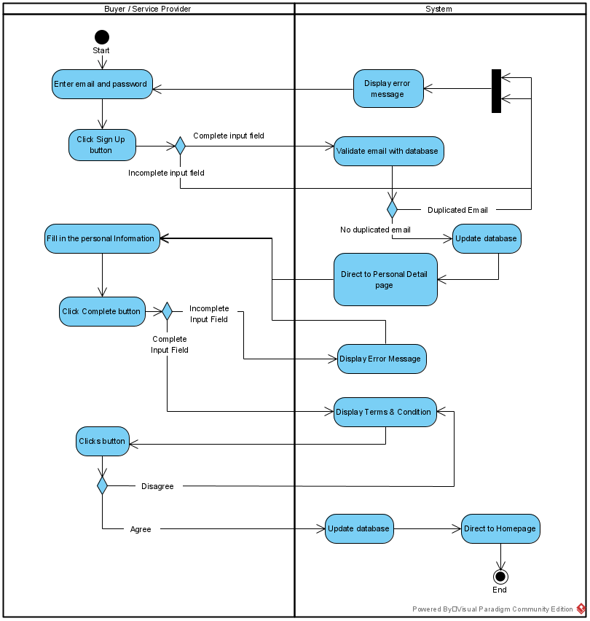

***Figure 3.1.3.1.1 Sign Up Activity Diagram***

#### 3.1.3.2 Sign in

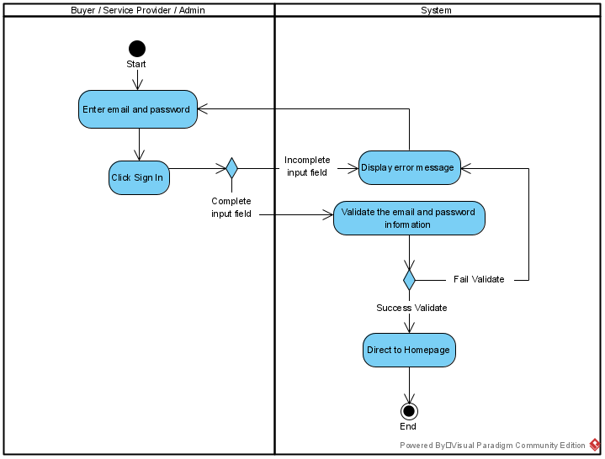

***Figure 3.1.3.2.1 Sign In Activity Diagram***

#### 3.1.3.3 Sign out

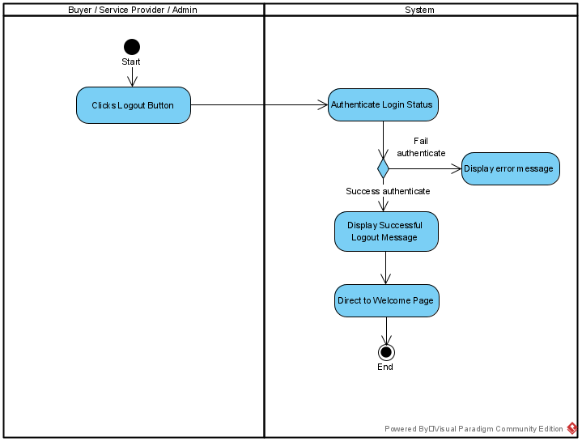

***Figure 3.1.3.3.1 Sign Out Activity Diagram***

#### 3.1.3.4 Manage Profile

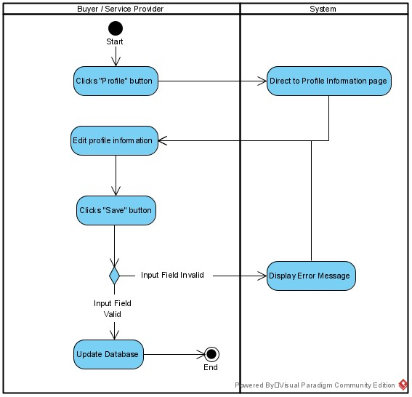

***Figure 3.1.3.4.1 Manage Profile Activity Diagram***

#### 3.1.3.5 View Progress Order

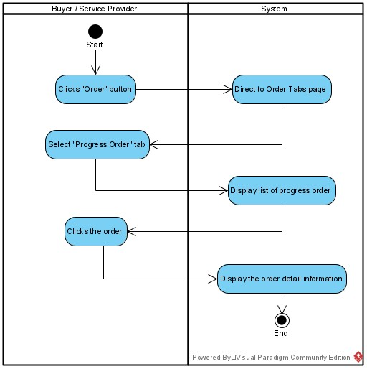

***Figure 3.1.3.5.1 View Progress Order Activity Diagram***

#### 3.1.3.6 View History Order

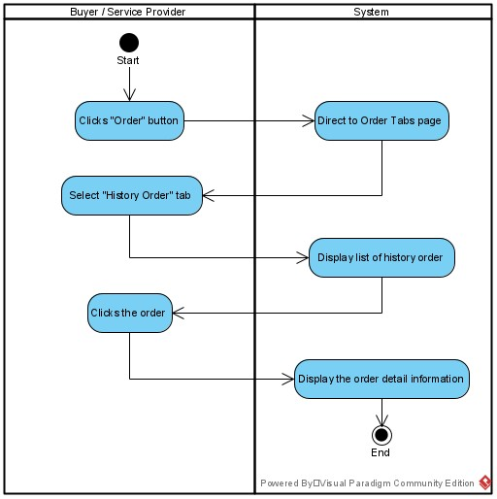

***Figure 3.1.3.6.1 View History Order Activity Diagram***

#### 3.1.3.7 View Pending Order

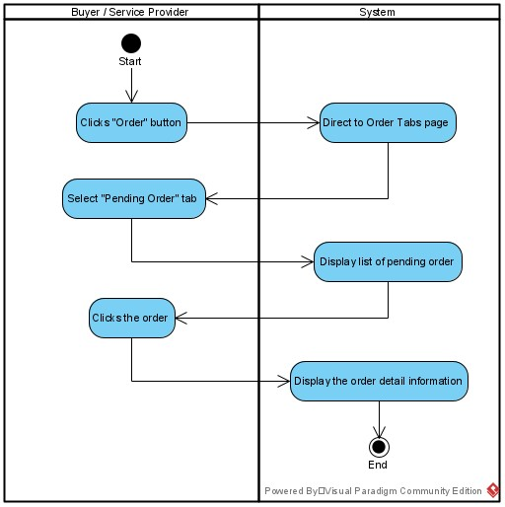

***Figure 3.1.3.7.1 View Pending Order Activity Diagram***

#### 3.1.3.8 View Nearby Confinement Lady

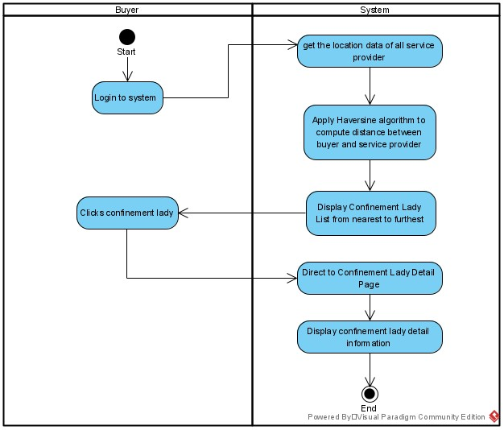

***Figure 3.1.3.8.1 View Nearby Confinement Lady Activity Diagram***

#### 3.1.3.9 Make Order

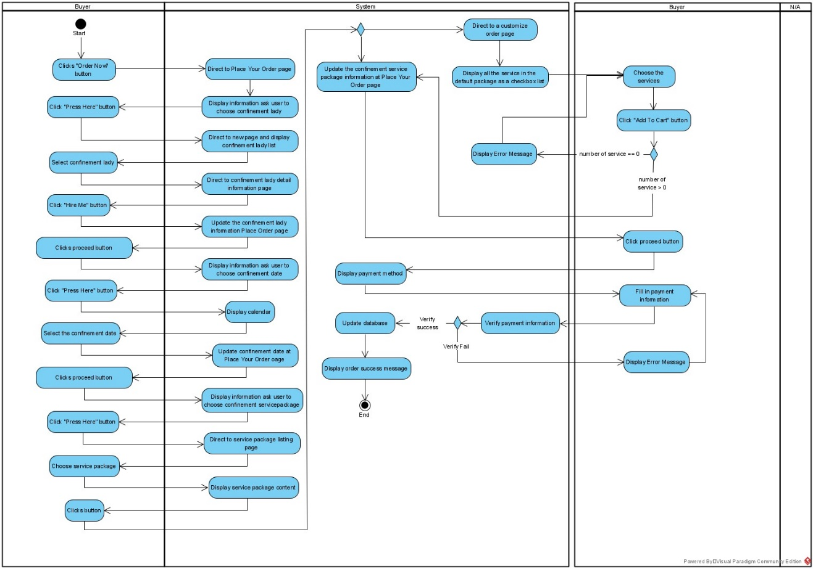

***Figure 3.1.3.9.1 Make Order Activity Diagram***

#### 3.1.3.10 Cancel Order

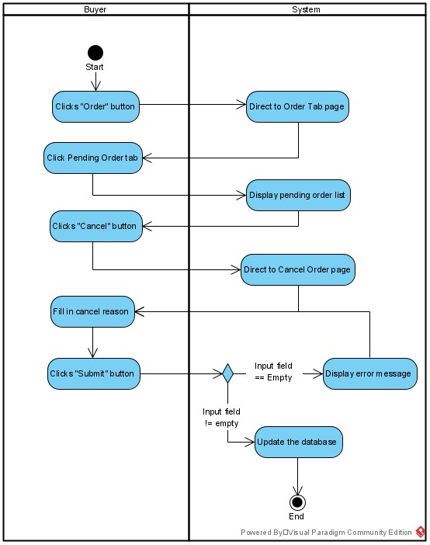

***Figure 3.1.3.10.1 Cancel Order Activity Diagram***

#### 3.1.3.11 View Cancel Order Status

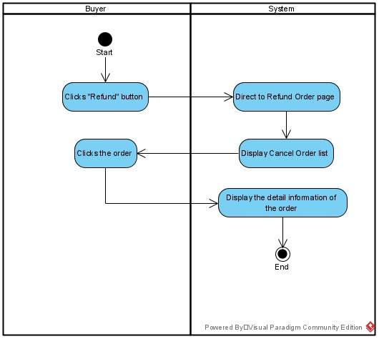

***Figure 3.1.3.11.1 View Cancel Order Status Activity Diagram***

#### 3.1.3.12 Extend Order

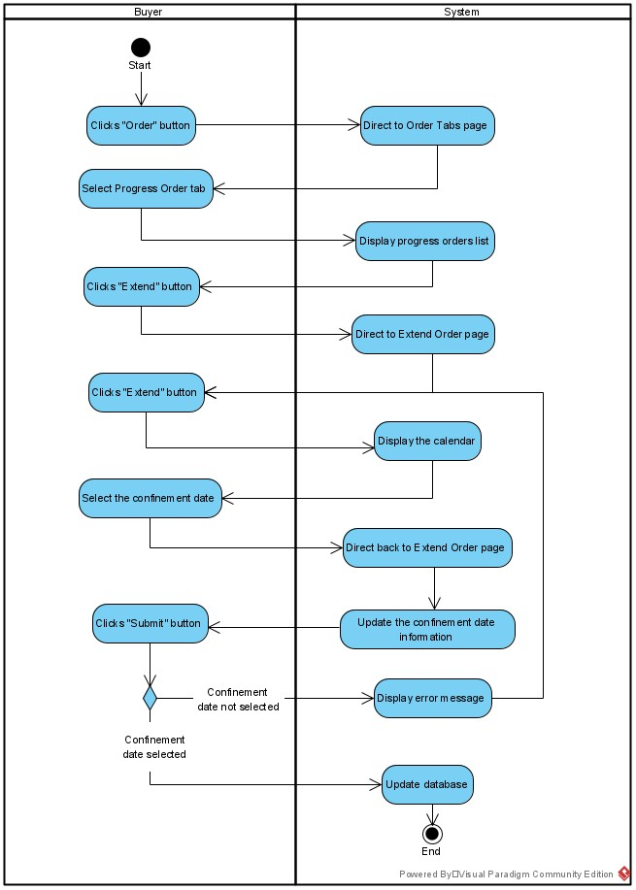

***Figure 3.1.3.12.1 Extend Order Activity Diagram***

#### 3.1.3.13 Rate Service Provider

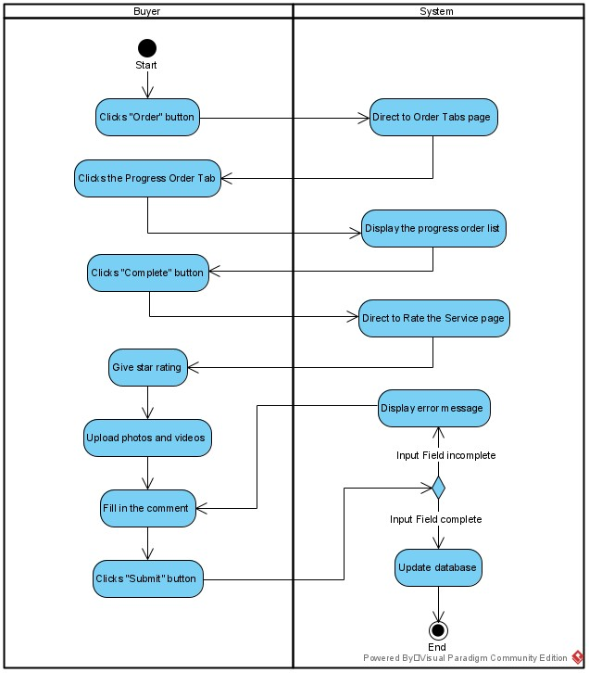

***Figure 3.1.3.13.1 Rate Service Provider Activity Diagram***

#### 3.1.3.14 Add Service Package

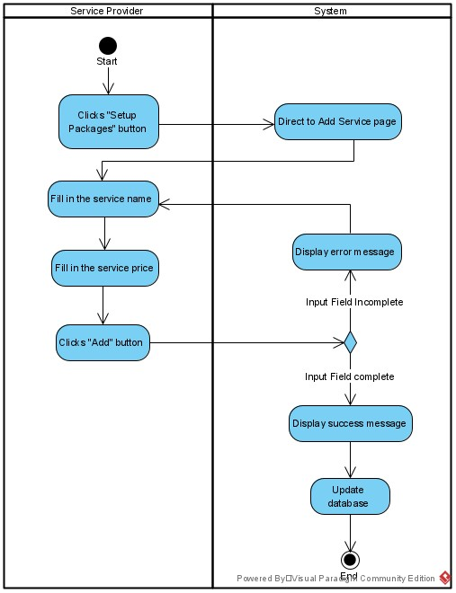

***Figure 3.1.3.14.1 Add Service Package Activity Diagram***

#### 3.1.3.15 Delete Service Package

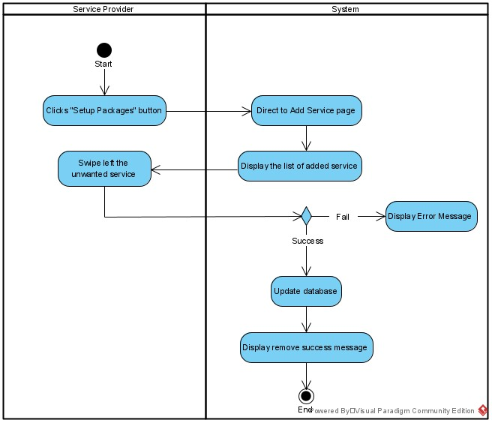 ***Figure 3.1.3.15.1 Delete Service Package Activity Diagram***

#### 3.1.3.16 View Service Package

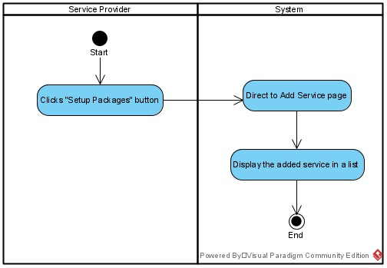

***Figure 3.1.3.16.1 View Service Package Activity Diagram***

#### 3.1.3.17 Accept Order

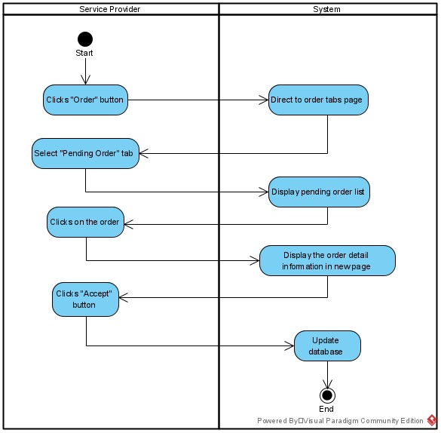

***Figure 3.1.3.17.1 Accept Order Activity Diagram***

#### 3.1.3.18 Decline Order

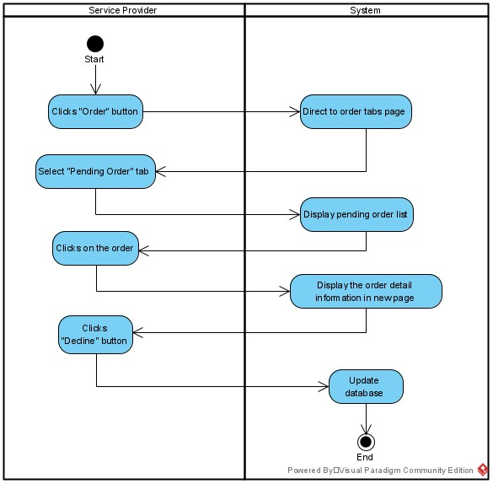

***Figure 3.1.3.18.1 Decline Order Activity Diagram***

#### 3.1.3.19 Navigate to Buyer’s Location

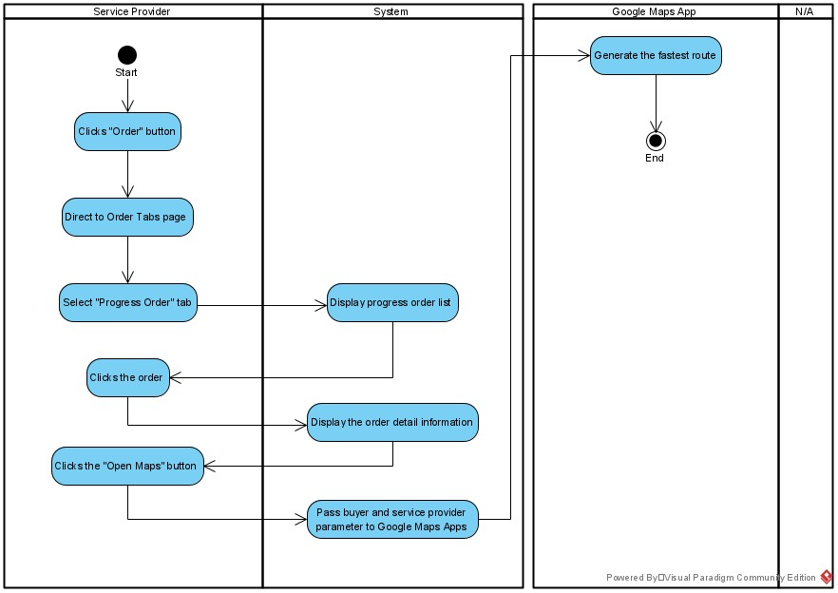

***Figure 3.1.3.19.1 Navigate to Buyer’s Location Activity Diagram***

#### 3.1.3.20 Manage Cancel Request

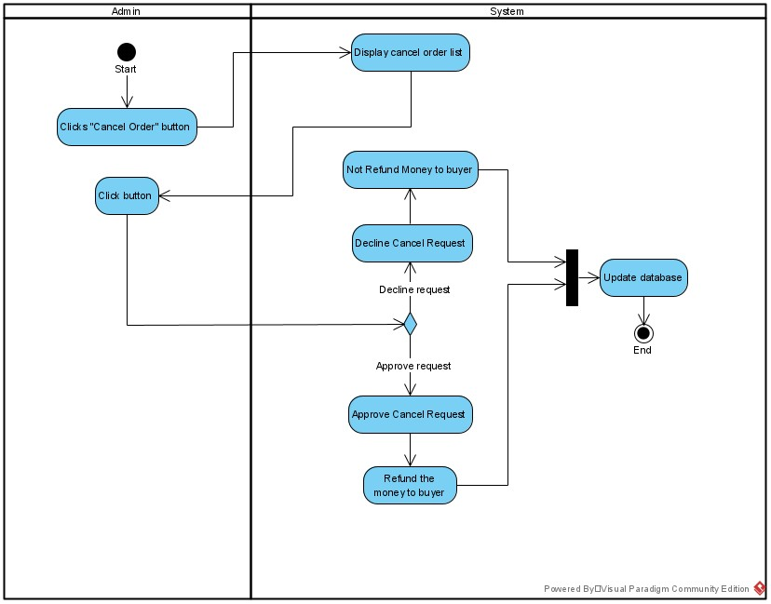

***Figure 3.1.3.20.1 Manage Cancel Request Activity Diagram***

#### 3.1.3.21 View Pending Order Detail

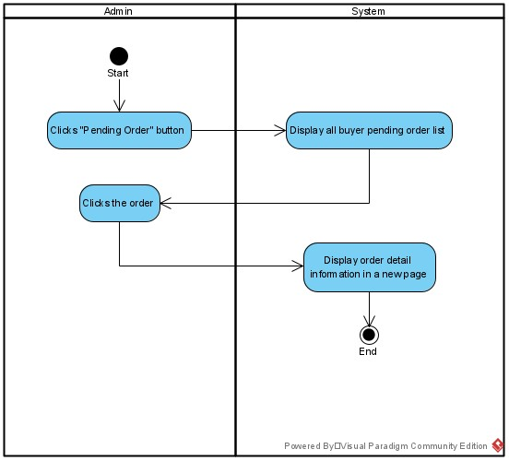

***Figure 3.1.3.21.1 View Pending Order Detail Activity Diagram***

#### 3.1.3.22 View On-Going Order Detail

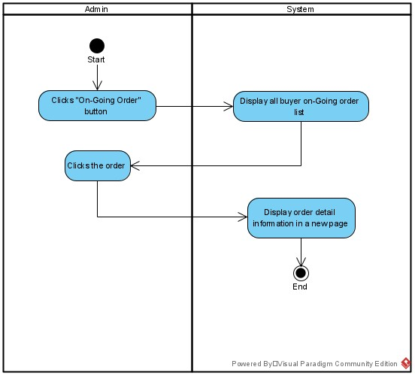

***Figure 3.1.3.22.1 View On-Going Order Detail Activity Diagram***

#### 3.1.3.23 View Completed Order Detail

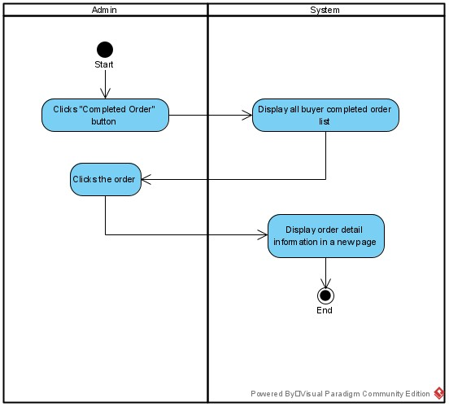

***Figure 3.1.3.23.1 View Completed Order Detail Activity Diagram***

#### 3.1.3.24 View Declined Order Detail

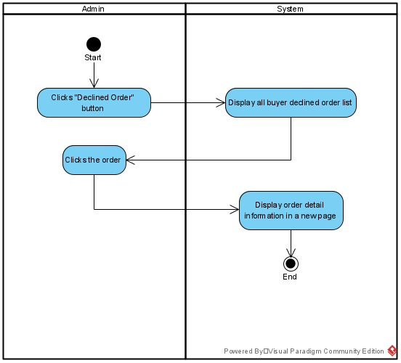

***Figure 3.1.3.24.1 View Declined Order Detail Activity Diagram***

#### 3.1.3.25 Reset Password

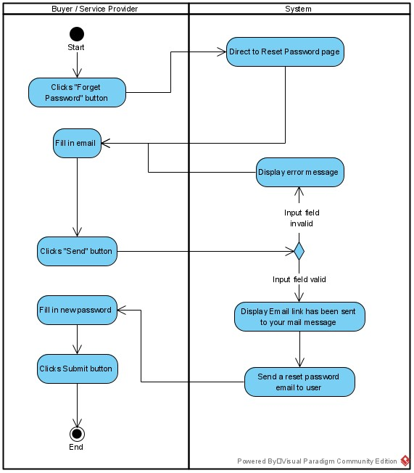

***Figure 3.1.3.25.1 Reset Password Activity Diagram***

# System Design

## 4.1 System Block Diagram

E-confinement service system had used Haversine algorithm to calculate the distance between the users. This algorithm is used to compute the distance between the buyer and the service providers. The result of the computation will be updated to the data of the service provider and display as a list on the buyer’s homepage. Figure 4.1.1 shows the block diagram of the Haversine algorithm works in e-confinement service system.

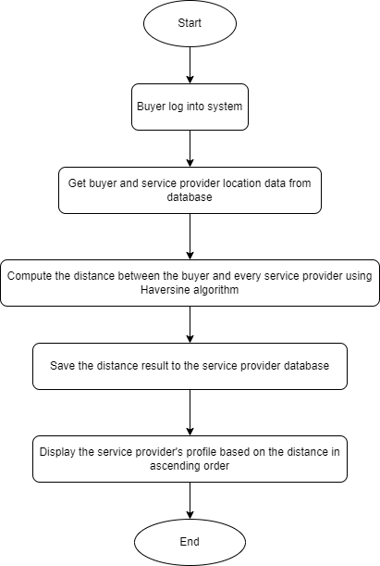

***Figure 4.1.1 Block Diagram of Haversine Algorithm***

### 4.1.1 Buyer log into system

User has to login to system as a buyer to trigger this feature.

### 4.1.2 Get buyer and service providers location data from database

System will retrieve the location data of the users that stored in the database that get when the users is register their personal information in the registration stage.

### 4.1.3 Compute the distance between the buyer and every service provider using Haversine algorithm

System will calculate the distance between the buyer and every service provider one by one by passing in the geocoordinate of the user and the service provider into the Haversine algorithm. The algorithm will compute the distance and return the result in kilometer unit.

### 4.1.4 Save the distance result to service provider database

The result of the distance between user and each service provider will be stored into the service provider’s user database.

### 4.1.5 Display the service provider’s profile based on the distance in ascending order

The nearest service provider will be displayed at the first one with her profile picture, followed by her name and distance with the buyer until the last service provider.

## 4.2 System Components Specifications

To start a project, a new Flutter project is created in Visual Studio Code and a project in Firebase is needed. After that, the project is need to connect to the Firebase to access the authentication. Firebase Storage and the Firestore features available in the Firebase. The required google-services.json file is added into the project folder and the dependency also added into the build-gradle file in the project.

### 4.2.1 Sign Up

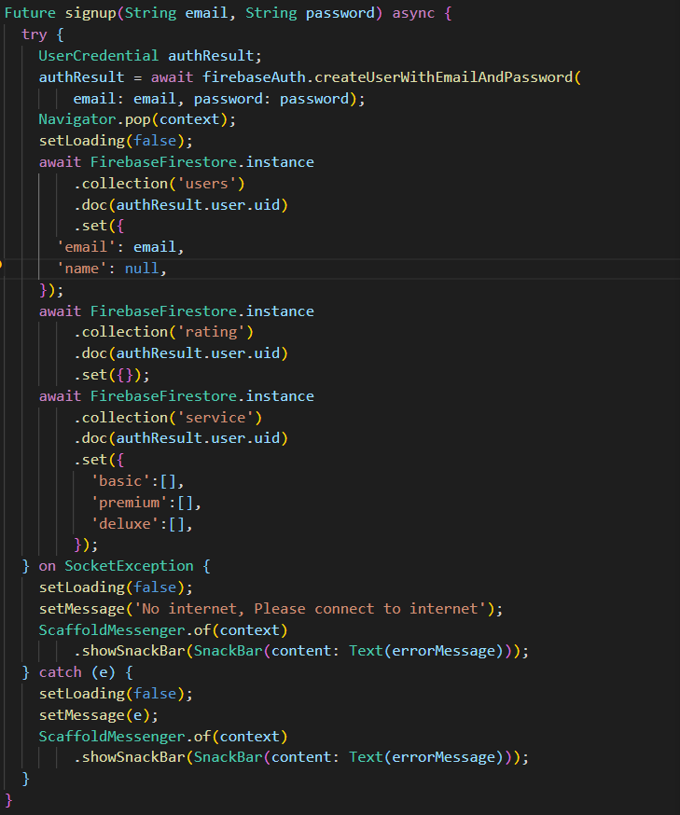

***Figure 4.2.1.1 Sign up***

Figure 4.2.1.1 shows the code used to sign up an account for the user. First, when the sign-up button is pressed, input fields like the email and password will be retrieved by the system. If there are any missing inputs, system will display the error message at the missing input field. If the email is an invalid format, system will display the error and require the user to key in again. If the password length is less than 8-character, system will display the error message and require the user to key in again. If there is not any problem exist with the input field, the system will create the user using the createUserWithEmailAndPassword() function and then direct to the fill profile detail page.

### 4.2.2 Fill in Profile Detail

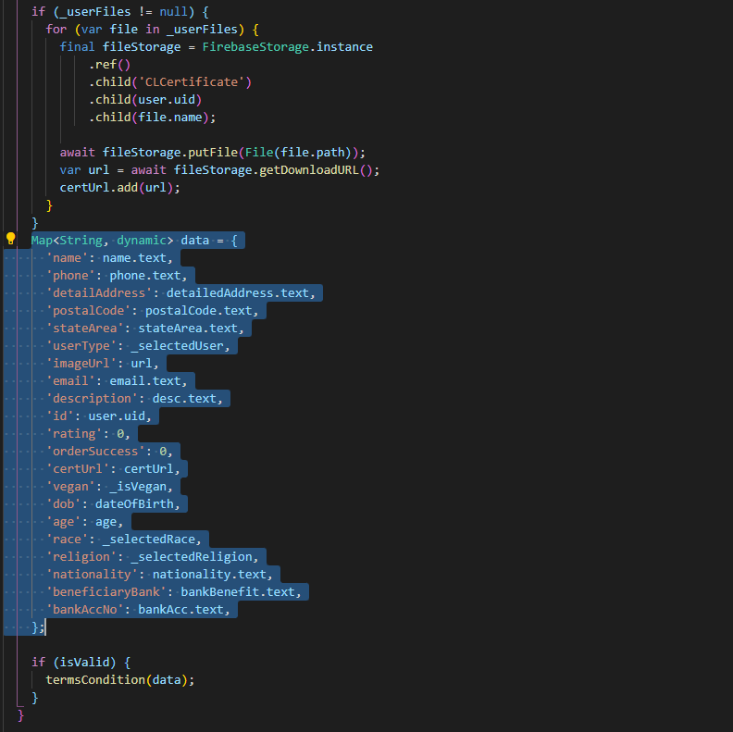

***Figure 4.2.2.1 Fill in Profile Detail***

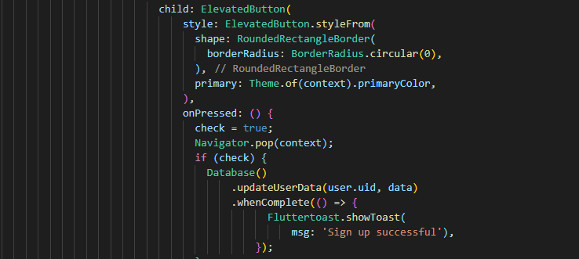

***Figure 4.2.2.2 Update user profile detail Function***

The data that required the user to fill is shown in the Figure 4.2.2.1. All the data of the user will be updated into the database after they done filling the data click the “Done” button.

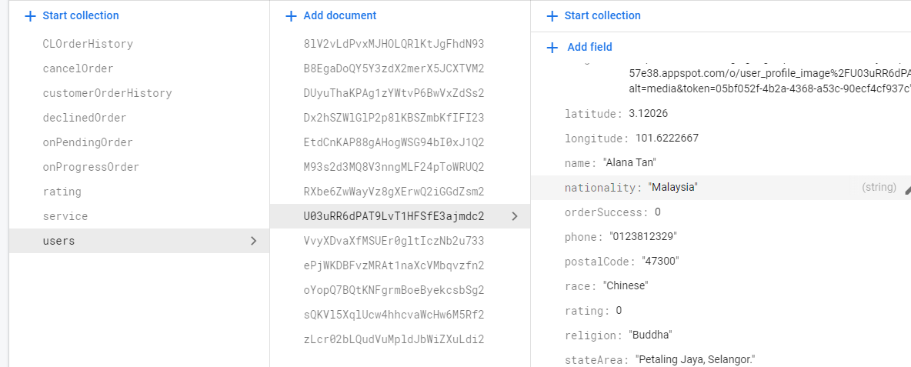

***Figure 4.2.2.3 User data stored in Firestore***

Figure 4.2.2.3 shows that the “users” collection in Cloud Firestore. All the data of the users will be stored in this collection after the done filled the data in the profile detail page.

### 4.2.3 Sign In

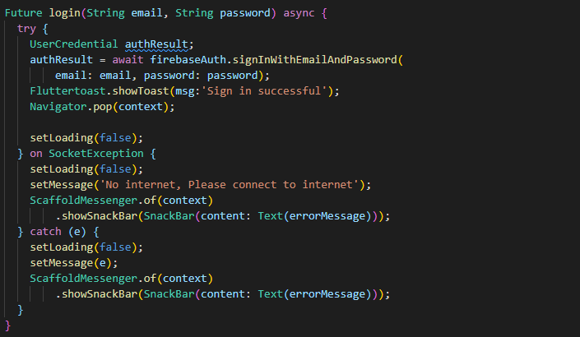

***Figure 4.2.3.1 Sign in***

Figure 4.2.3.1 shows the coding of the sign in function. This function is executed when the user clicks the sign in button in the login page. System will check the input field whether there is any missing input field. If got, system will display the error message at the missing field. If there is any invalid format in the input field, the system will also display the error message at the particular field. System will call the signInWithEmailAndPassword function to authenticate the information of the user. If user successfully signed in, user will be directed to the homepage.

### 4.2.4 User Roles Identification

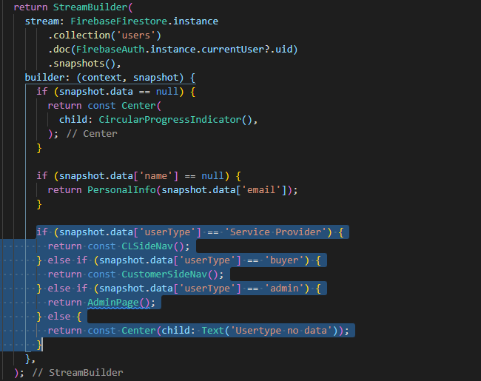

***Figure 4.2.4.1 User Roles Identification***

Figure 4.2.4.1 shows the coding of the user roles identification. When the user successfully login to system, system will check the user type of the user. If the user is “Service Provider”, the user will be directed to service provider page. If the user is “Buyer”, user will be directed to buyer page. If user is “admin”, user will be directed to admin page.

### 4.2.5 Manage Profile

#### 4.2.5.1 Display Profile Detail

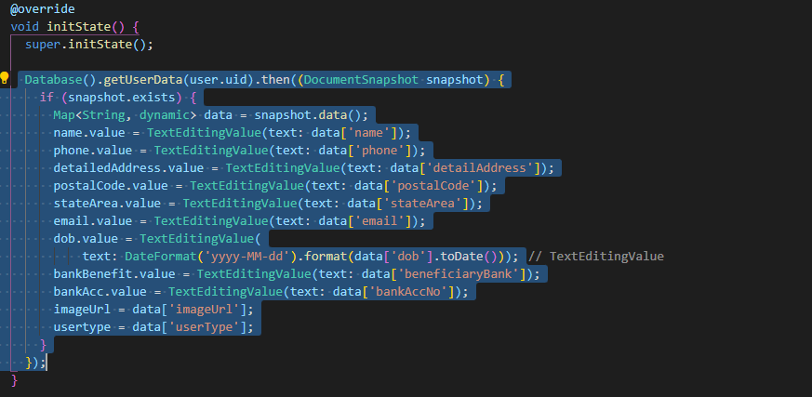

***Figure 4.2.5.1.1 Display Profile Detail***

Figure 4.2.5.1.1 has shown the coding of the data retrieved from Firebase to display the profile detail. The data retrieved will be stored to variables and used to display into the profile page when the page is successfully built. The user profile image used the user ID as its filename and stored in the user-profile-image folder in the Firebase Storage.

#### 4.2.5.2 Update Profile Detail

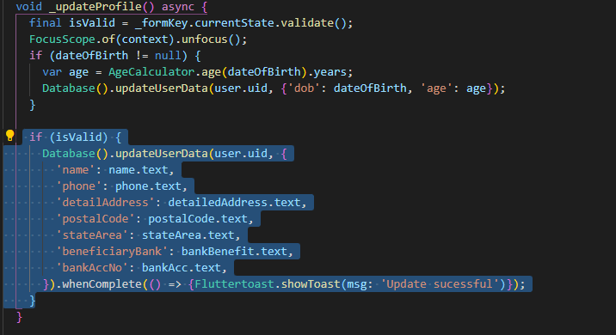

***Figure 4.2.5.2.1 Update Profile Detail***

Figure 4.2.5.2.1 shows the coding of update profile detail. When the user clicks Save button after edits the information in the profile page, this function will be executed. The system will get all the input field and stored it as a Map data. The data will be updated into the Firebase and display the success message once its success.

#### 4.2.5.3 Upload Profile Image

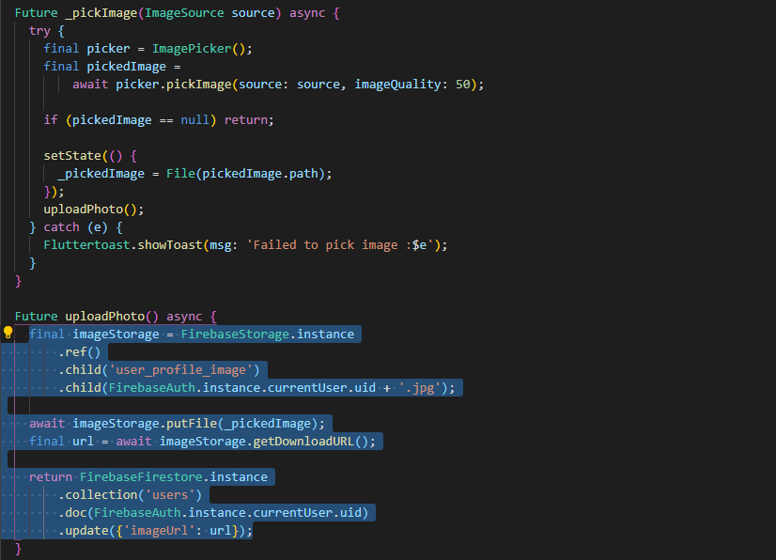

***Figure 4.2.5.3.1 Upload Profile Image***

Figure 4.2.5.3.1 shows the coding of the upload profile image function. When the user clicks the upload photo icon, system will pop up bottom sheet, let user to choose either camera or gallery. If user choose camera, system will call out camera app and let user to take a photo. If user choose gallery, system will call out gallery and let user choose the photo from gallery. After user click the tick icon, upload photo function will be executed and the photo will store in the Firebase Storage.

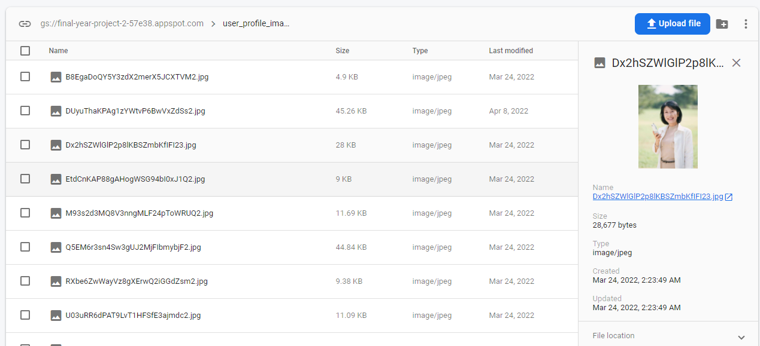

***Figure 4.2.5.3.2 Uploaded Profile Image In Firebase Storage***

#### 4.2.5.4 Get User Address

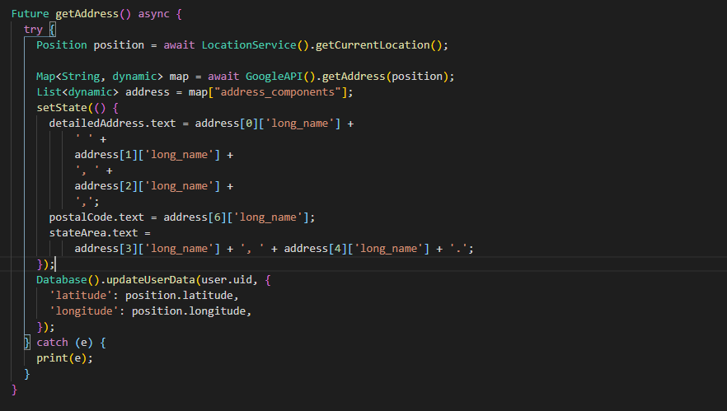***Figure 4.2.5.4.1 Get User Address***

Figure 4.2.5.4.1 shows the coding of the get user address function. When the user clicks the GPS icon at the profile page, system will retrieve the geolocation of the user. After that system will pass the location data to the Google Map API to retrieve the address of the user. The result returned by the Google Maps API will auto-fill to the address column in the profile detail page.

### 4.2.6 Reset Password

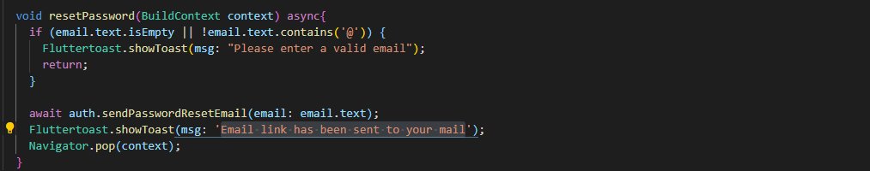

***Figure 4.2.6.1 Reset Password***

Figure 4.2.6.1 shows the coding function of the reset password module. If the input field is in invalid format, system will display the message to notify the user. If there is no problem in the input field, system will call the sendPasswordResetEmail() function to reset the user password using an email.

### 4.2.7 View Nearby Confinement Lady

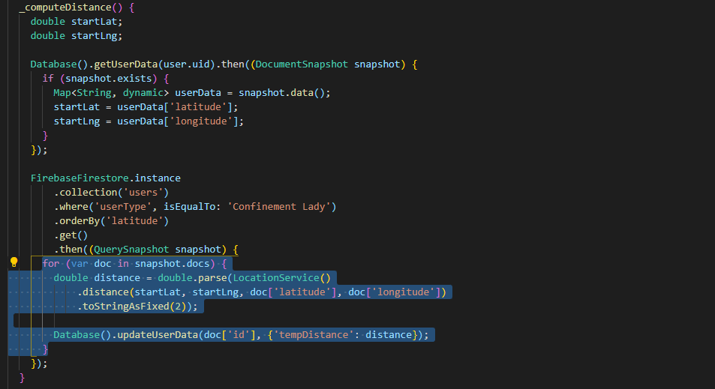

***Figure 4.2.7.1 View Nearby Confinement Lady (1)***

Figure 4.2.7.1 shows the coding used to compute the distance between buyer and service provider using Haversine algorithm. The result returned in the algorithm is updated to the service provider database every time the buyer login to the system.

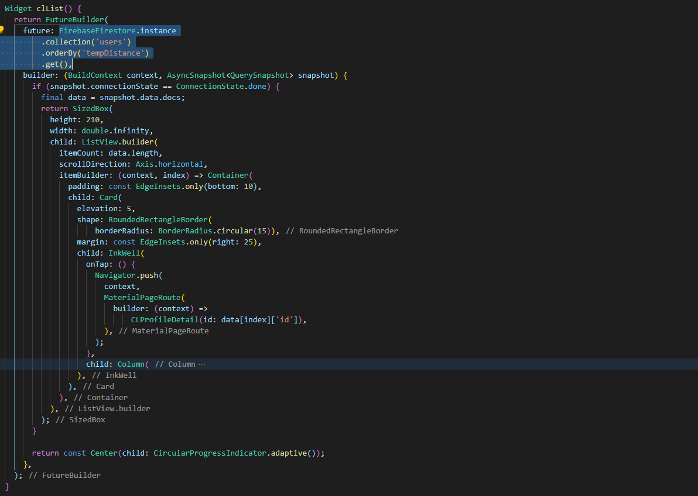

***Figure 4.2.7.2 View Nearby Confinement Lady (2)***

Figure 4.2.7.2 shows the coding to display the nearby service provider in a list view. The system retrieved the service provider data from database by using the FutureBuilder method. The system will get the data from the “users” collection in the Firebase and display the data of the service provider based on the distance value in ascending order.

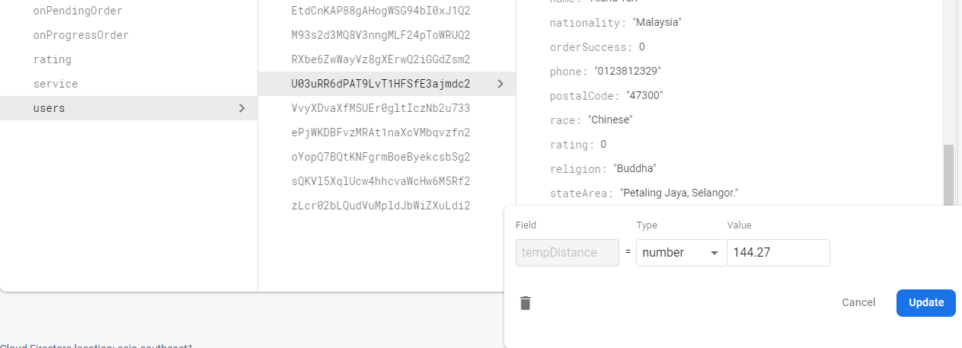

***Figure 4.2.7.3 Distance data in Firebase Storage***

### 4.2.8 Display Service Provider Detail

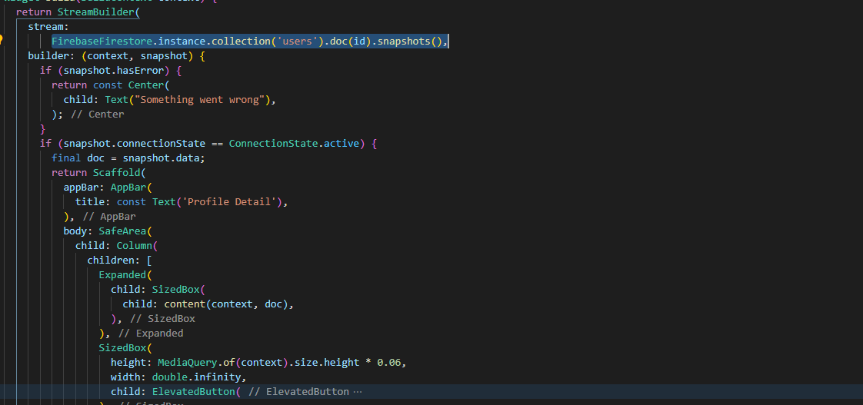

***Figure 4.2.8.1 Display Service Provider Detail (1)***

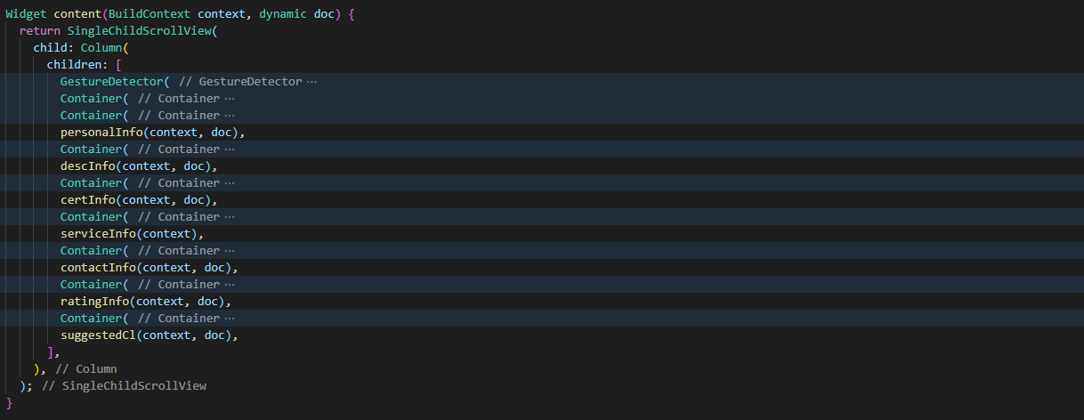

***Figure 4.2.8.2 Display Service Provider Detail (2)***

Figure 4.2.8.1 and Figure 4.2.8.2 show that the coding to display service provider detail function. After the user clicks on the image or list of the service provider, system will direct the buyer to this page and display all the information of the service provider. The information included profile image, personal information, confinement service provided, certificates of they obtained, contact information, rating information, and other similar service provider.

### 4.2.9 Make Order

#### 4.2.9.1 Select Service Provider

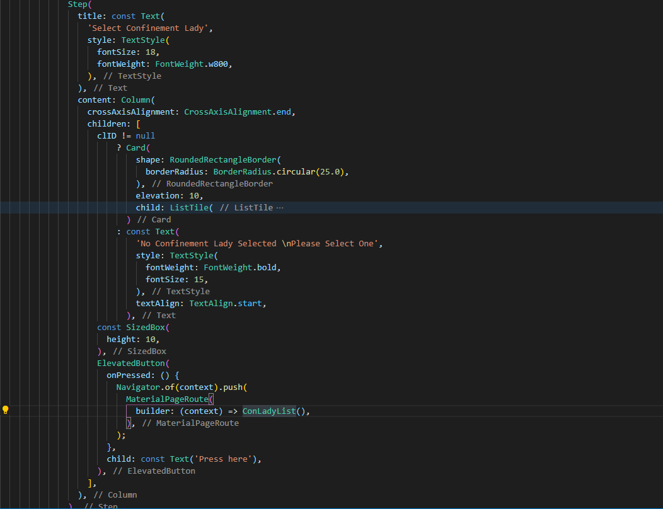

***Figure 4.2.9.1.1 Select Service Provider***

Figure 4.2.9.1.1 shows that the coding for the select service provider. After user clicks Press Here button, system will show display a list of service providers to let buyer choose. Buyer can click on the service provider to view more detail of the service provider. After buyer clicks the Hire Me button, the system will update the service provider data at the order process page. Figure 4.2.9.1.2 shows the coding function of the update service provider information. If the buyer did not choose service provider and proceed to next step the message will be displayed by the system to inform buyer to choose a service provider.

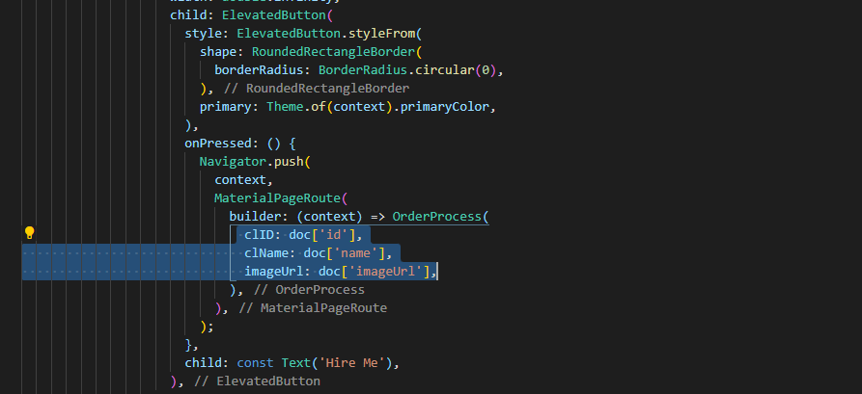

***Figure 4.2.9.1.2 Update Service Provider Information***

#### 4.2.9.2 Select Confinement Date

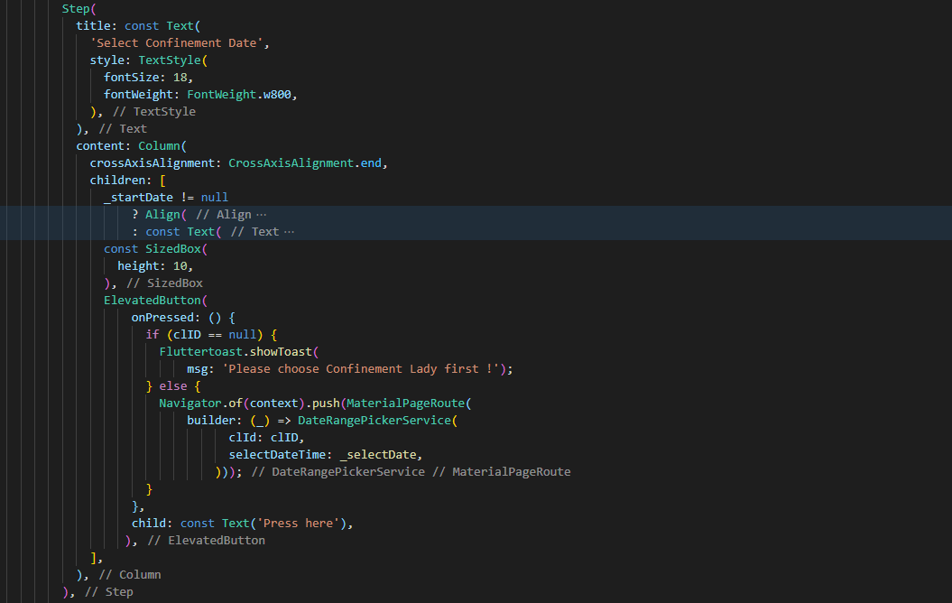

***Figure 4.2.9.2.1 Select Confinement Date (1)***

Figure 4.2.9.2.1 shows that the coding to required buyer choose the confinement date. After buyer clicks the Press Here button, system will ask the buyer to select the confinement date. Once buyer done complete select the confinement date and press Ok button, system will update the confinement date and calculate the total days of confinement service and update the information in the order process page.

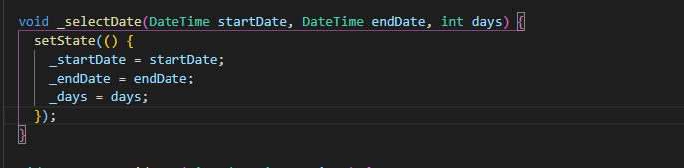

***Figure 4.2.9.2.2 Select Confinement Date (2)***

#### 4.2.9.3 Select Confinement Package

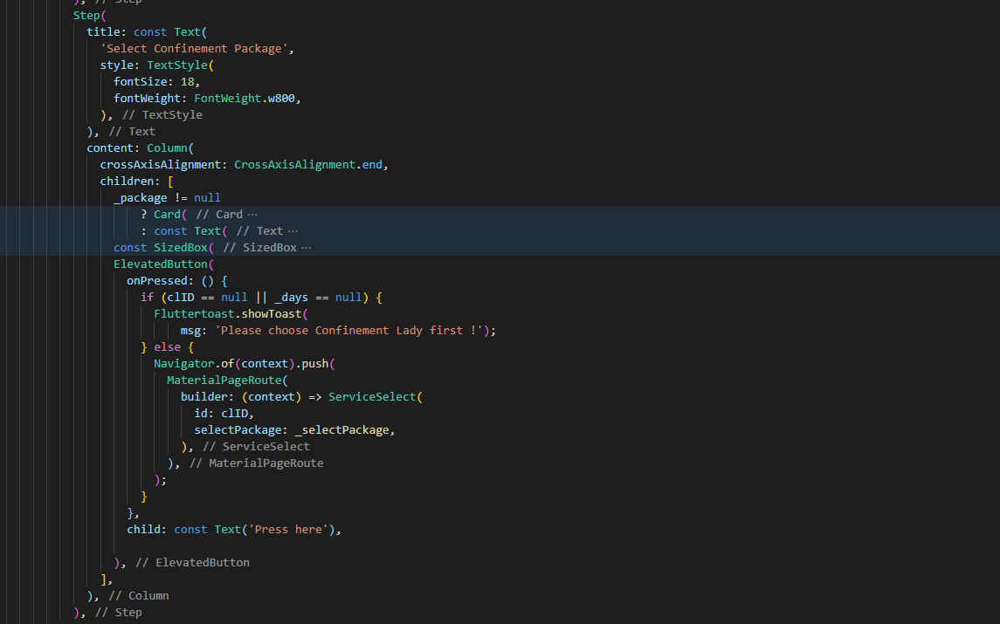

***Figure 4.2.9.3.1 Select Confinement Package (1)***

Figure 4.2.9.3.1 shows the coding to required buyer to choose the confinement service package. After buyer clicks Press Here button, buyer is directed to the service selected page to select the service package. Once buyer clicks the package, system will show the services included in the package in a dialog. Buyer can choose to customize the order or just select the default package. Figure 4.2.9.3.2 shows the coding of the dialog button.

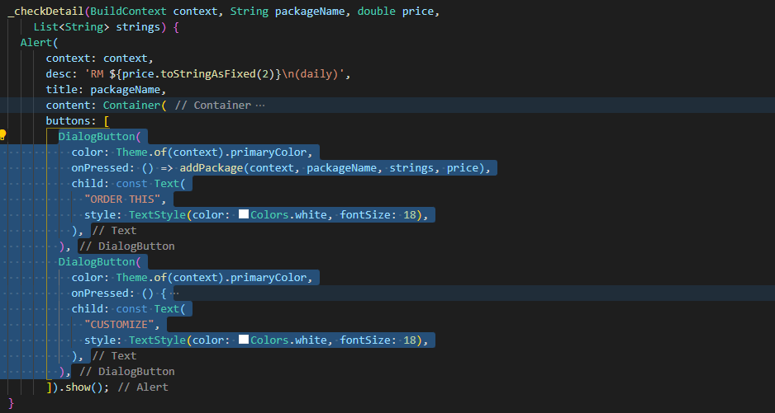

***Figure 4.2.9.3.2 Dialog of the Order Detail***

##### 4.2.9.3.1 Customize Confinement Package

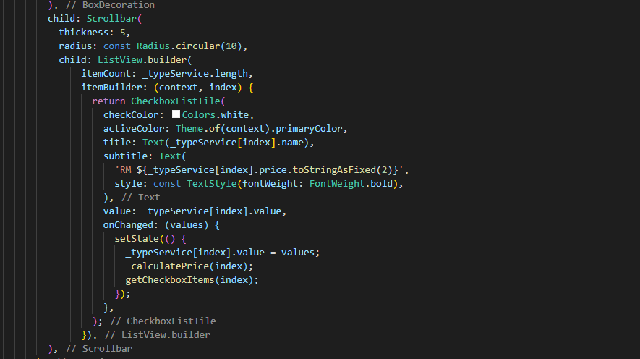

***Figure 4.2.9.3.1.1 Customize Confinement Service Package (1)***

Figure 4.2.9.3.1.1 shows the coding to customize the confinement service package. System will retrieve the service data that the buyer selects and display at the new page. Buyer are allowed to select the service they want and remove the service they dislike. System will automatically calculate the total price after buyer selects the services. If the buyer removes all the service the system will display message and ask the buyer to select at least one service to proceed to next step. Buyer clicks “Add to Cart” button to update the service selected into the system. Figure 4.2.9.3.1.2 shows the coding to update the service package.

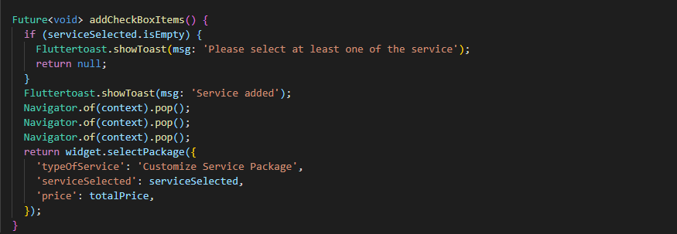

***Figure 4.2.9.3.1.1 Customize Confinement Service Package.***

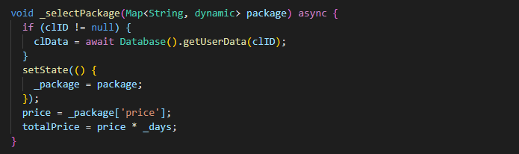

***Figure 4.2.9.3.3 Select Confinement Package (2)***

Figure 4.2.9.3.3 shows the coding for select confinement package function. After buyer done selecting the package, system will return back to order process page and update the service information. The price and total days of confinement will be used to calculate the total price of the confinement service.

#### 4.2.9.4 Checkout

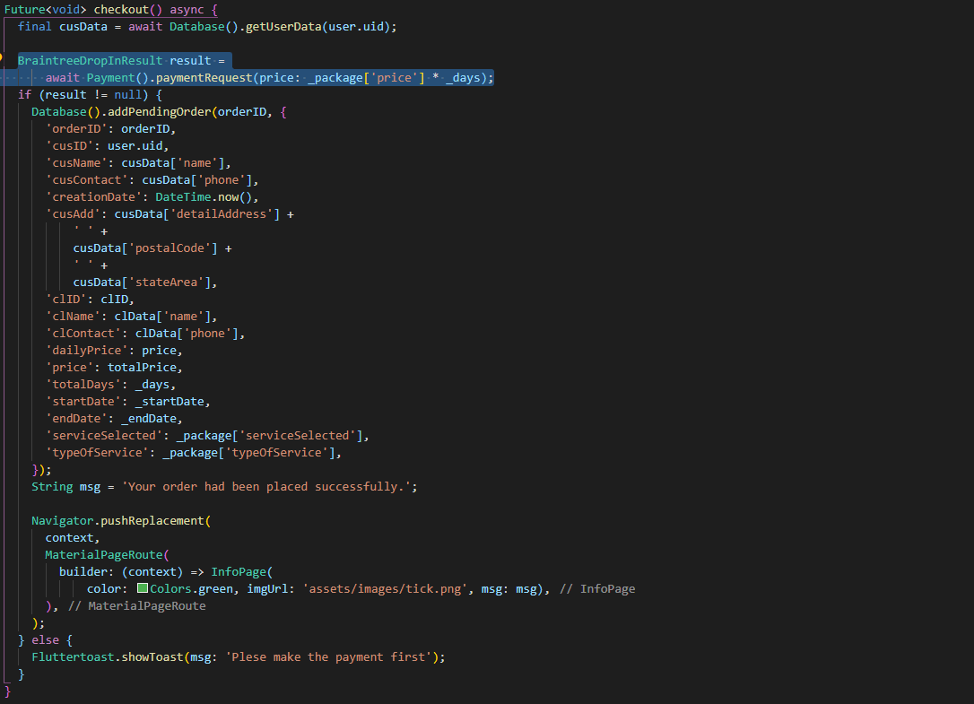

***Figure 4.2.9.4.1 Checkout***

Figure 4.2.9.4.1 shows that the coding of the for the checkout function. After the buyer complete all the steps to choose service provider, confinement date, and confinement package, buyer Clicks the Press Here button will trigger the checkout function. System will show two options for user to make payment either using PayPal or credit card. After buyer make the payment, system will show a notice to alert them that the order has been successfully made. The order data will be stored in the Firebase like the Figure 4.2.9.4.2. If the buyer has miss any one of the previous steps, system will display the message to inform buyer. If buyer did not make the payment successful, system will also display the message to notify the buyer.

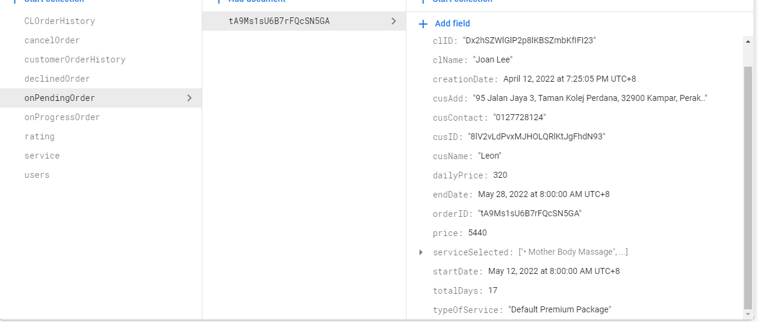

***Figure 4.2.9.4.2 Order Stored in Firebase***

### 4.2.10 Extend Order

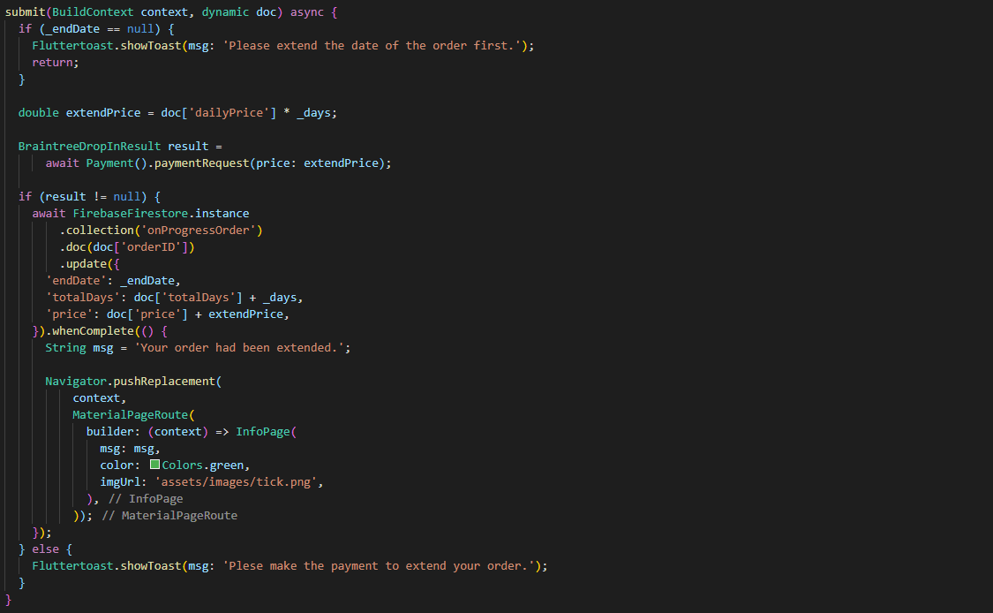

***Figure 4.2.10.1 Extend Order***

Figure 4.2.10.1 shows the coding for the extend order function. If buyer wishes to extend the confinement service, buyer can click the Extend button at the progress order page. System will direct buyer to the extend order page. System will display the calendar to let buyer select the extended date. The previous confinement date will be outlined to prevent buyer duplicating the confinement date. The price for the extended confinement service will be calculated and ask the buyer to make the payment. The extended date will be update to the Firebase.

### 4.2.11 Rate Service Provider

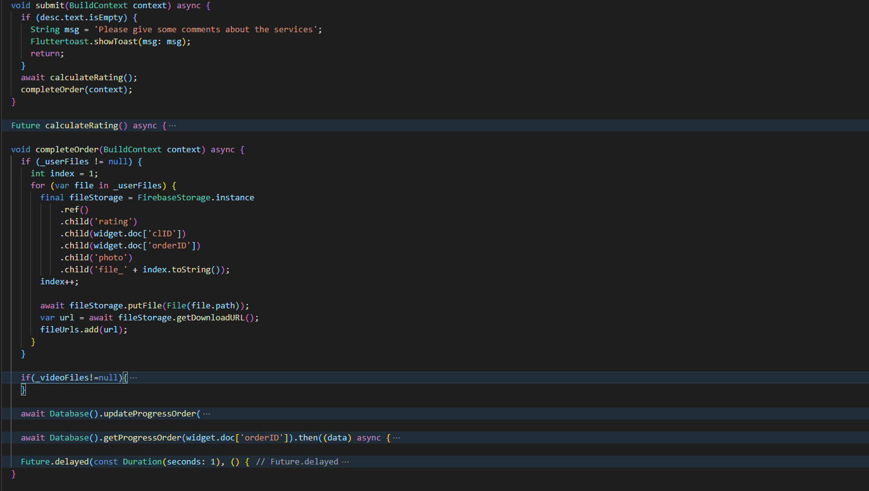

***Figure 4.2.11.1 Rate Service Provider***

Figure 4.2.11.1 shown that the coding for the rate service provider function. After the service provider completed their confinement service, buyer can click the Complete button to rate the confinement service they experienced. Buyer is allowed to upload their photos and videos to the rating and add comment about the service they experienced. The rating provided by buyer will be uploaded to database and shown in the rating section in the service provider detail page.

### 4.2.12 Add Service Package

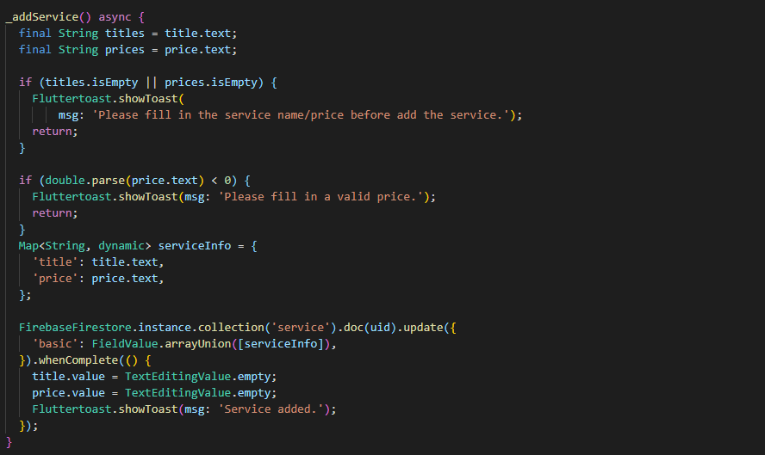

***Figure 4.2.12.1 Add Service Package***

Figure 4.2.12.1 shown the coding function of the add service package. Service provider key in the service name and service price they want to included into the service package and press Add button. System will then add the service into the service package and display the message to inform service provider. If the input field is invalid, system will display error message to inform service provider.

### 4.2.13 Delete Service Package

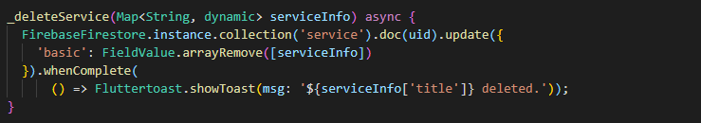

***Figure 4.2.13.1 Delete Service Package***

Figure 4.2.13.1 shown the coding function to delete the service package. Service provider can swipe left on the list of added service. System will display the message to inform service provider once they success remove it.

### 4.2.14 Accept Order

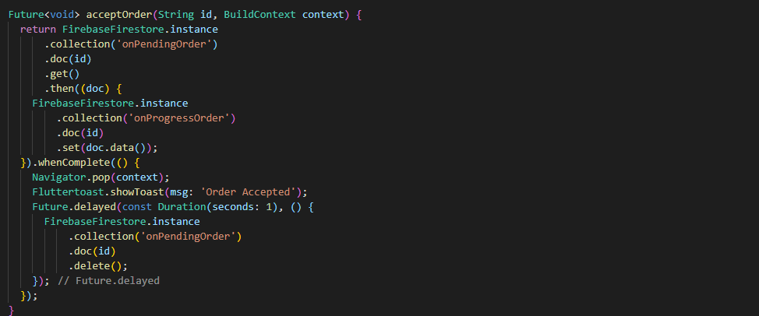

***Figure 4.2.14.1 Accept Order***

Figure 4.2.14.1 shows that the function for the service provider to accept the order. After the buyer made the order, the order detail will display in the pending order page. Service provider can check the buyer detail through the order information. Service provider clicks the Accept Order button and the system will update the order status and display the order at progress order page.

### 4.2.15 Decline Order

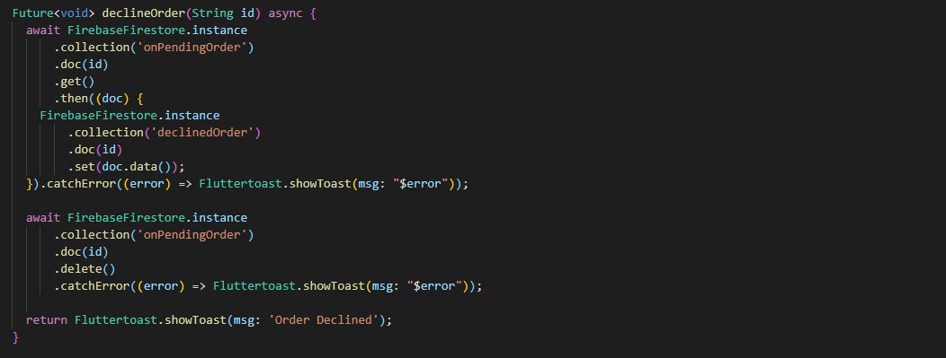

***Figure 4.2.15.1 Decline Order***

Figure 4.2.15.1 shown the coding for decline order function. Service provider clicks the Decline Order button and the system will remove the order from the pending order and refund the money to the buyer.

### 4.2.16 Navigate to Buyer’s Location

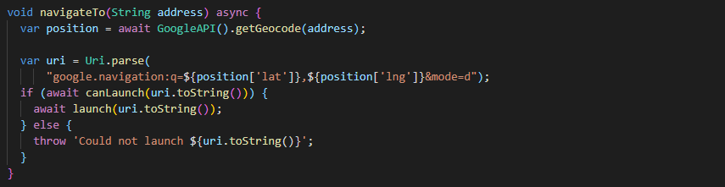

***Figure 4.2.16.1 Navigate to Buyer’s Location***

Figure 4.2.16.1 shows that the function used to navigate to buyer’s location. Service provider clicks the Open Maps button in the top right corner. The address of the buyer will be pass to the navigateTo() function. The function will convert the address to geocode and pass the location data into the position variable. After that, system will pass the variable to the Google Maps Apps to generate the route for the service provider. If Google Maps isn’t installed on the device, system will allow user to choose alternative map application to generate the route.

# System Implementation

## 5.1 Hardware Setup

### 5.1.1 PC Model

|  |  |
| --- | --- |
| System | Information |
| Operating system | Microsoft Windows 10 Pro |
| Processor | Intel(R) Core (TM) i5-10400 |
| Graphic Card | GTX 1660 Super |
| CPU | 6 Core(s), 12 Logical Processor(s) |
| Memory (RAM) | 16 GB |
| System Type | 64-bit operating system, x64-based PC |

***Table 5.1.1.1 Detail Information of the PC Model***

### 5.1.2 Mobile Phone

1. Mobile Phone Model: Huawei Nova 5T

|  |  |
| --- | --- |
| System | Information |
| Operating system | Android |
| Android Version | Android 10.0 |
| Resolution | 2340 x 1080 pixels |
| Processor | Huawei Kirin 980 |
| Memory (RAM) | 8 GB |
| Internal storage | 128 GB |

***Table 5.1.2.1 Detail Information of the Mobile Device***

1. Mobile Phone Model: Android Virtual Device

|  |  |
| --- | --- |
| System | Information |
| Operating system | Android |
| Android Version | Android 9.0 |
| Resolution | 2280 x 1080 pixels |
| Processor | Unknown |
| Memory (RAM) | 1536 MB |
| Internal storage | 2048 MB |

***Table 5.1.2.2 Detail Information of the Mobile Device***

## 5.2 Software Setup

### 5.2.1 Flutter SDK

1. Download and install the Flutter SDK from the link <https://docs.flutter.dev/get-started/install/windows> .
2. Extract the folder and put it in your root directory.
3. Open “Edit the System Environment Variables” in the Window.
4. Click “Environment Variables” under Advanced option.
5. Insert the “/source path/flutter/bin” into the Path variables.
6. Clicks Ok to confirm the modification.

### 5.2.2 Visual Studio Code

1. Download and install the Visual Studio Code from the link <https://code.visualstudio.com/download>.
2. Open the Visual Studio Code and install the Flutter and Dart extension in the extension panel.
3. Open the terminal and run “flutter create” command to initialize a new project.
4. Now, you can start to develop the project now.

### 5.2.3 Firebase

1. Go to <https://console.firebase.google.com/u/0/> and create a new project.
2. Enter the project name.
3. Press Continue to proceed.
4. Enter the Android project package name.
5. Download the configuration file.

## 5.3 Setting Configuration

### 5.3.1 Firebase Configuration

1. Move the downloaded configuration file into the project directory (.\android\app\src\google-services.json).
2. Add the required dependency to the project file as followed:

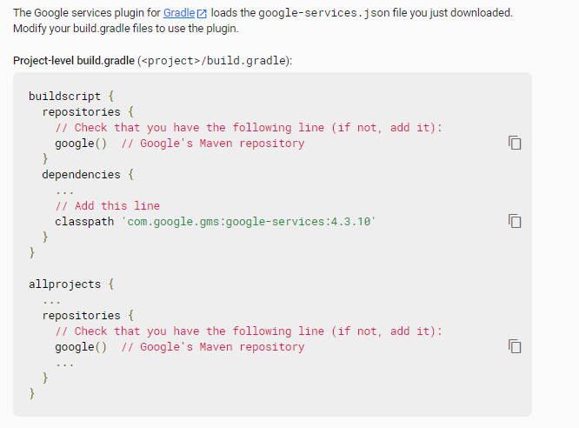

***Figure 5.3.1.1 Required Dependency for Firebase Integration (1)***

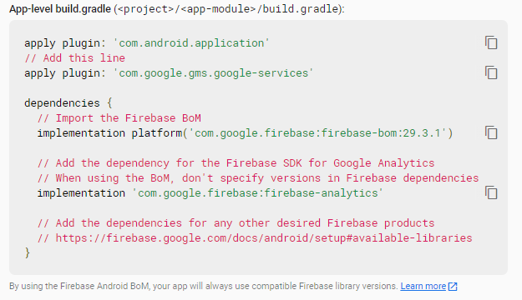

***Figure 5.3.1.1 Required Dependency for Firebase Integration (2)***

### 5.3.2 Project Configuration

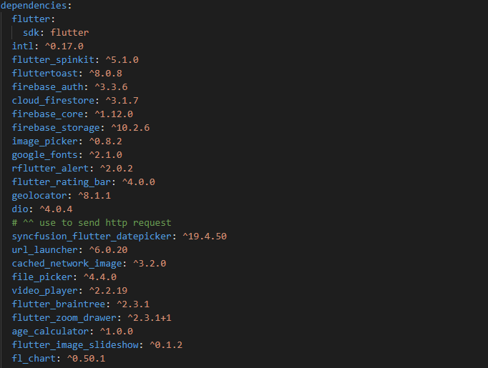

***Figure 5.3.2 Project Configuration***

Figure 5.3.2.1 shows the required packages needed install to the project in order to run the whole application.

## 5.4 System Operation

### 5.4.1 Start-up

 

***Figure 5.4.1.1 Splash Screen Figure 5.4.1.2 Welcome Page***

The splash screen is set up as the Figure 5.4.1.1 in the application to notify the users the users that they have successfully start-up the application. Since it is a splash screen to inform the users, it has been designed to have a timeout after one second. After one second, the screen will be direct to the welcome page which look like Figure 5.4.1.2 to notify user that they can proceed to the next step.

### 5.4.2 Sign In

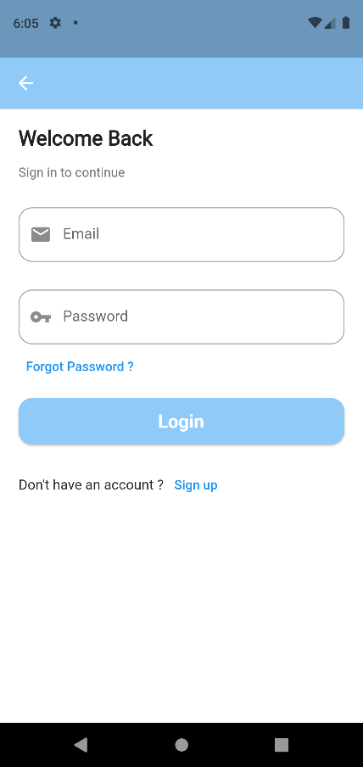

***Figure 5.4.2.1 Sign in***

Once the user presses the button at the welcome page, they will be direct to the sign in user interface. After the user key in the email and password, the Firebase will verify the existence of the email and the validation of the password before to let the user sign in. Once completed the verification, user will able to sign in to the system. System will verify the user type of user and direct to the homepage. If the user does not have an account, they can press the sign-up button at application and then will be direct to the sign-up user interface shown in Figure 5.4.3.1.

### 5.4.3 Sign Up

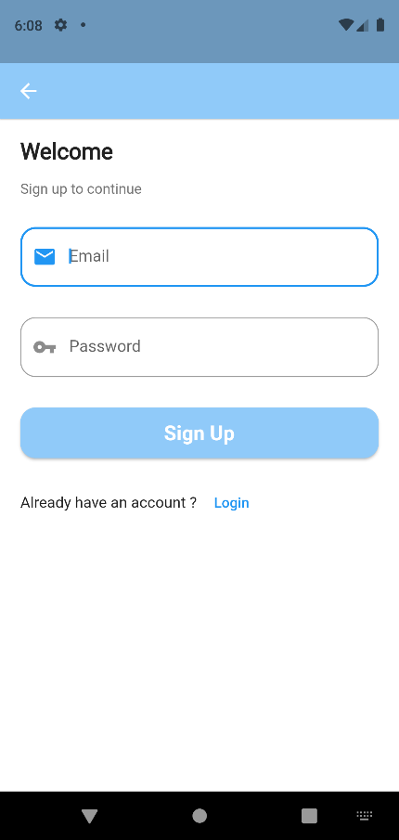

***Figure 5.4.3.1 Sign up***

The email and password field are required for the Firebase to register a new user. If the email is existed, the system will return the error to user and tell user to key in a new email. Once they successful sign up, user will be direct to the profile detail page shown in Figure 5.4.5.1.

### 5.4.4 Reset Password

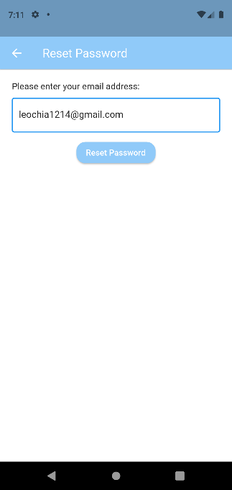 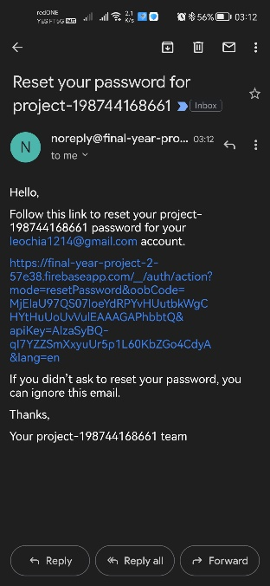 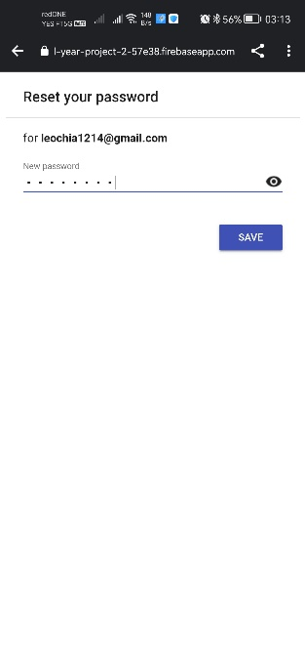 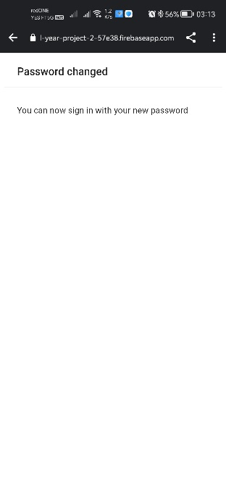

***Figure 5.4.4.1 Reset Password (1)***

***Figure 5.4.4.2 Email Confirmation***

***Figure 5.4.4.3 Reset Password (2)***

***Figure 5.4.4.4 Confirmation Message***

User can enter their email into the input field to reset the password. After click the button, system will send the email for the verification purpose as shown in the Figure 5.4.4.2. User can enter the new password after clicking the link provided in the email. A confirmation message will show to user upon they success changed the password.

### 5.4.5 Profile Detail

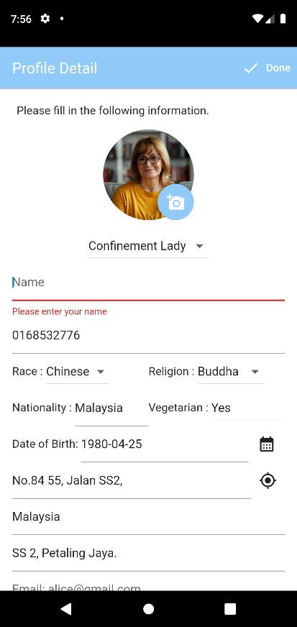 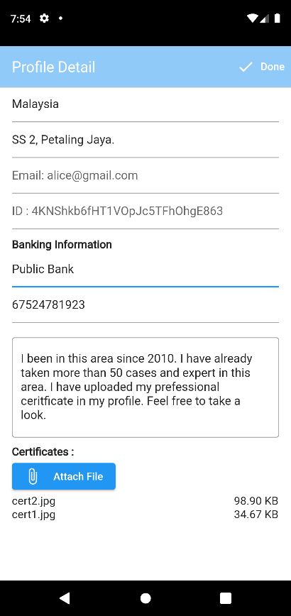 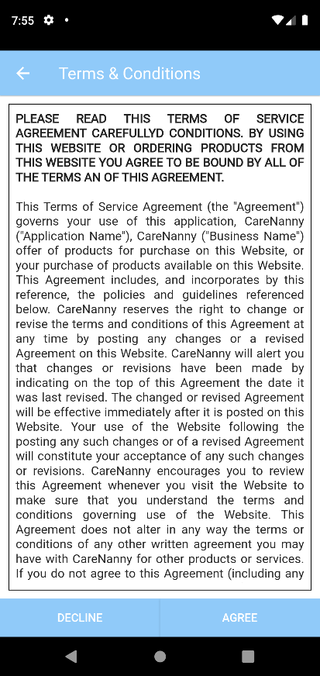

***Figure 5.4.5.1 Profile Detail (1)***

***Figure 5.4.5.2 Profile Detail (2)***

***Figure 5.4.5.3 Terms & Conditions***

The user is required to fill in the following profile information as shown in Figure 5.4.5.1 and Figure 5.4.5.2 before they can proceed to the next step. The user will be asked to select one of the user types which is: buyer or confinement lady before to start their journey in the application. After all the information have been filled, the user can click the done button and system will display the terms and conditions and ask the user to agree on it. If user decline, they can’t proceed to the next step. After user agree the terms and conditions, they will be direct to the homepage. The firebase will store all the information of the user in the database for further usage.

### 5.4.6 Service Provider Homepage

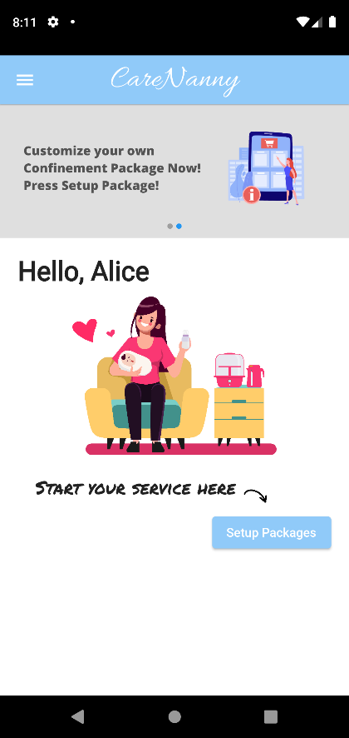 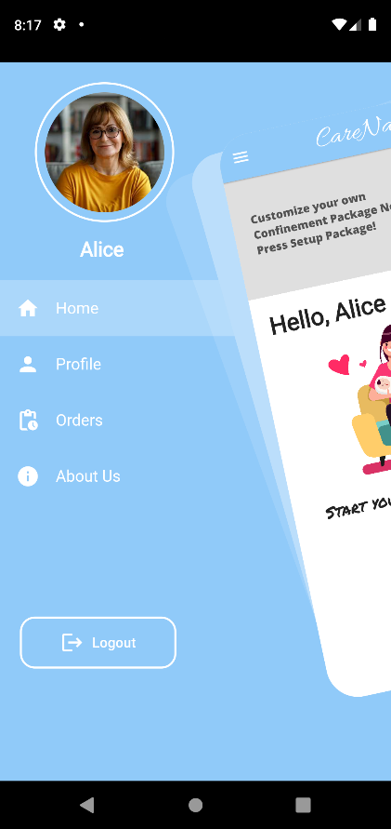 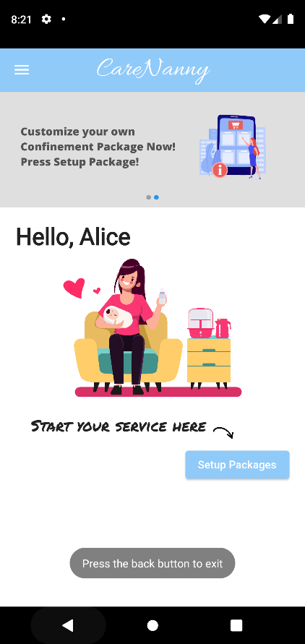

***Figure 5.4.6.1 Service Provider Homepage***

***Figure 5.4.6.2 Side Menu***

***Figure 5.4.6.3 Exit Message***

Service provider homepage is shown as Figure 5.4.6.1. The latest feature of the system is show as a banner on top of homepage. User can setup their packages by pressing the button at the homepage. A menu button is provided at the top left corner of the homepage. The side menu is popped out as Figure 5.4.6.2 when the user clicked the menu button. The side menu will display the profile image of the user on the top corner and followed by the user name. After that, a list of menu buttons will also be display below the name. Each button will navigate user to different pages. Lastly, the logout button will be placed at the bottom of the menu buttons. Besides, a pop out message will be displayed at the bottom layer of the homepage if the user accidentally clicked the back button.

### 5.4.7 Add service

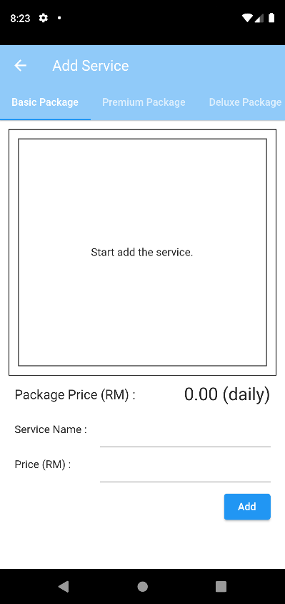 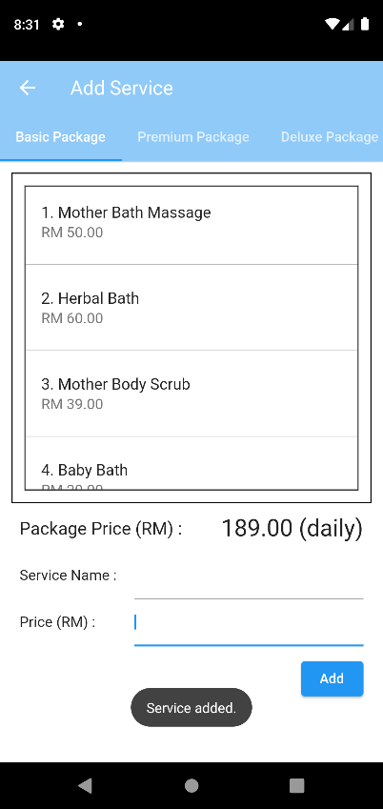 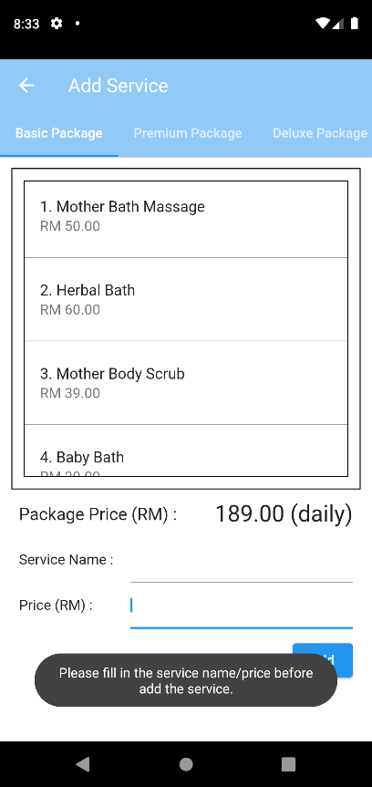

***Figure 5.4.7.1 Add Service (1)***

***Figure 5.4.7.2 Add Service (2)***

***Figure 5.4.7.2 Add Service (3)***

The user can customize their package by entering the services name and the service price in the provided field. When the service is successfully added to the service package, the system will display the message to inform user. If the user did not fill anything, and press the add button, the system will display message to inform user to fill up required field before adding a service.

### 5.4.8 Delete Service

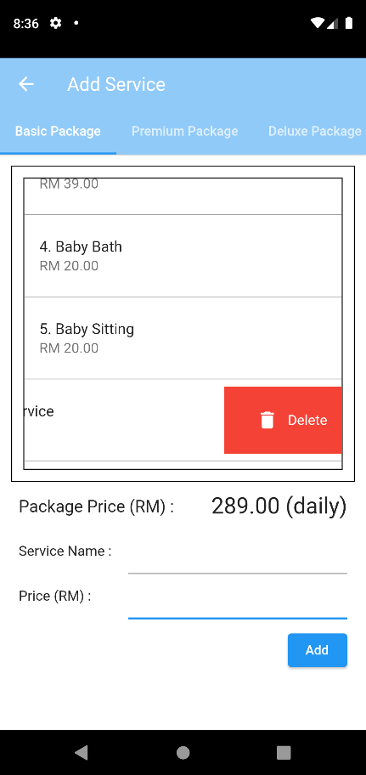 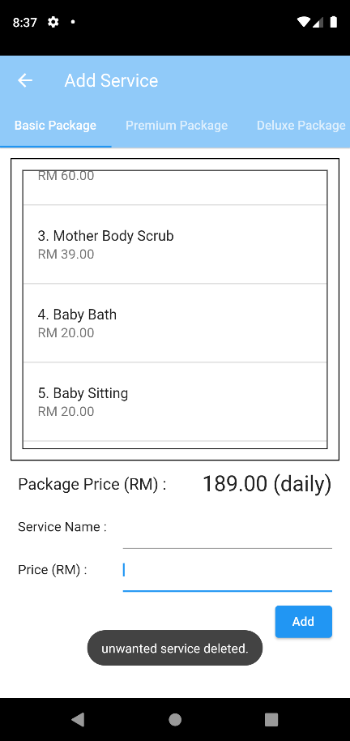

***Figure 5.4.8.1 Delete Service (1)***

***Figure 5.4.8.2 Delete Service (2)***

User can remove the service by swipe left on the unwanted service as shown in Figure 5.4.8.1. After remove the service, the system will display the message to inform user that they already successfully removed the service.

### 5.4.8 Profile

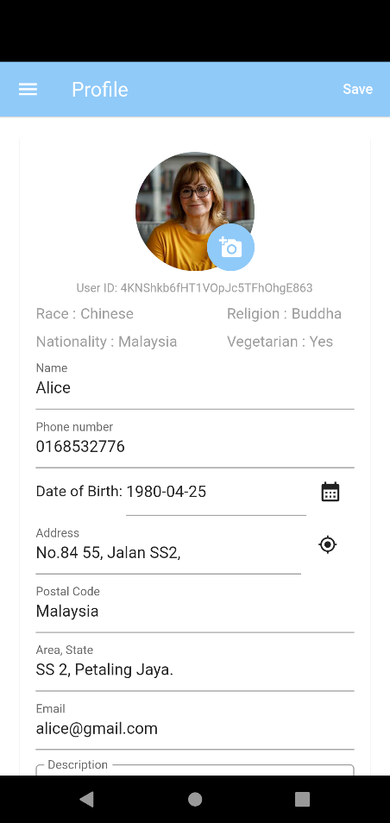 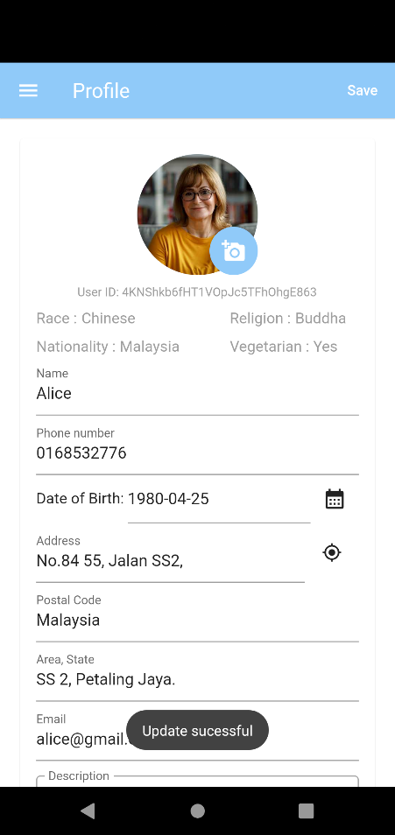

***Figure 5.4.8.1 Profile (1) Figure 5.4.8.2 Profile (2)***

User can check on their profile detail by clicking the profile button in the menu page. System will direct the user to the profile page as shown in Figure 5.4.8.1. User can edit the information and update the information by clicking the Save button after done edit the information. The message will be displayed as shown in Figure 5.4.8.2 to inform user that they already update the information.

### 5.4.9 View Orders

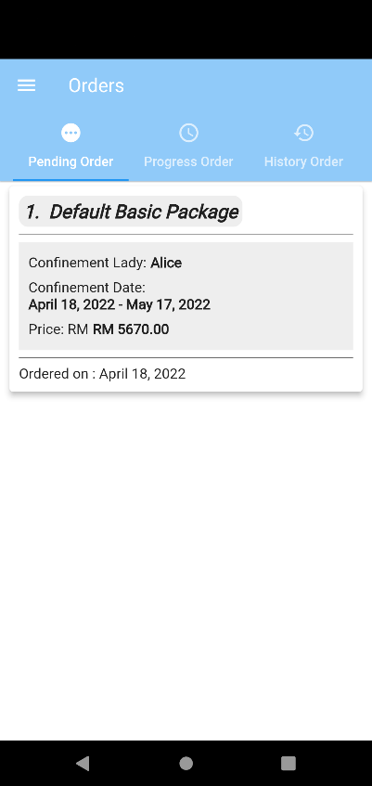 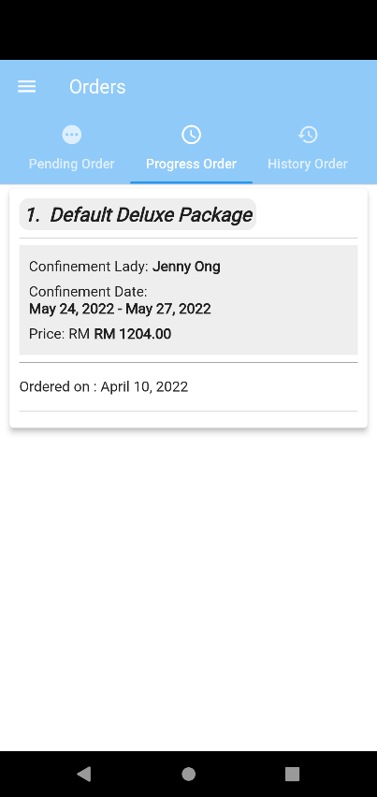 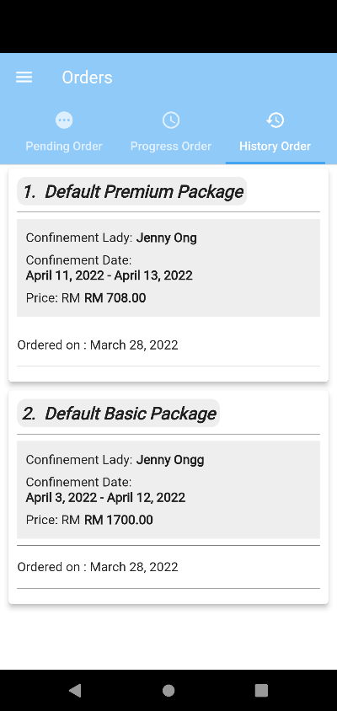

***Figure 5.4.9.1 Pending Order***

***Figure 5.4.9.2 Progress Order***

***Figure 5.4.9.3 History Order***

User can view their order on the order button in the menu. After user clicked the order button, system will direct user to orders page. In the order page, user can view the pending orders, progress order, and the history order. A general view of the orders will be displayed as a list on each tab. User can click on the order to check more details.

### 5.4.10 Accept/Decline Order

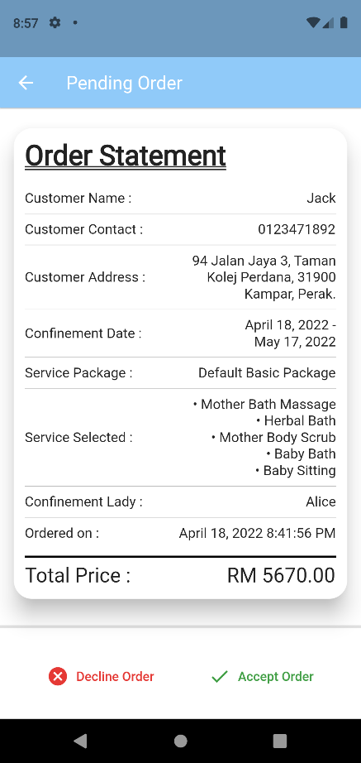 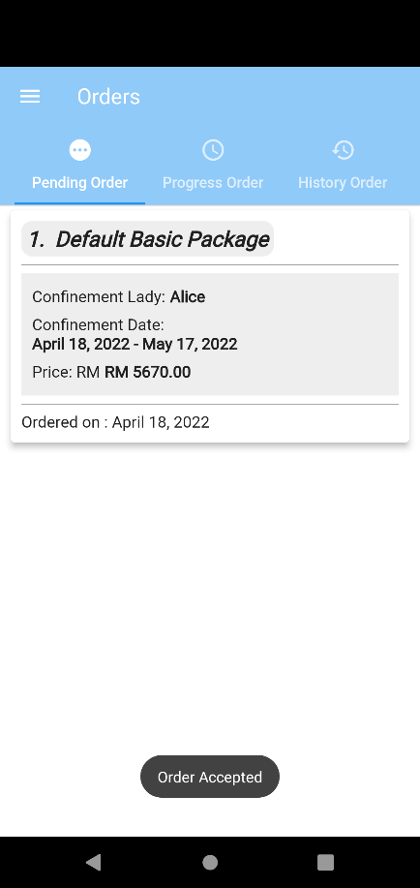

***Figure 5.4.10.1 Accept / Decline Order (1)***

***Figure 5.4.10.2 Accept / Decline Order (2)***

User can click the accept button to accept the order or decline button to decline the order. If the user clicks the accept button, the system will update the order to the progress order list which indicate the user already accepted the order and ready to go for work on the date of confinement. If user decline the order, system will refund the money to the buyer.

### 5.4.11 Navigate the Buyer’s Location

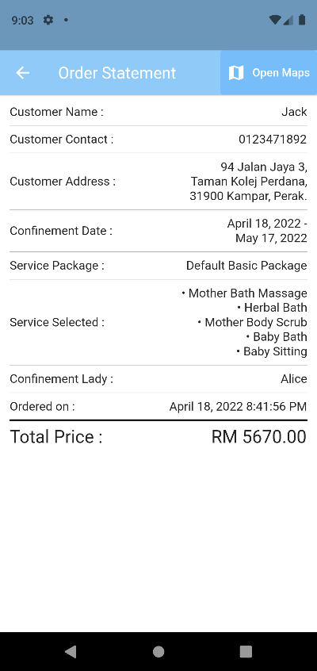 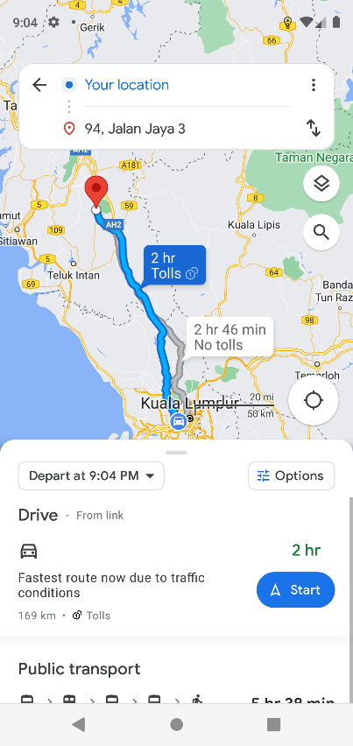

***Figure 5.4.11.1 Progress Order Detail Page***

***Figure 5.4.11.2 Google Maps App’s Route***

User can click the Open Maps button to generate the route from his current location to the buyer provider address. After the user clicked the button, the system will open the Google Maps automatically and help the user to generate the route as shown in Figure 5.4.11.2.

### 5.4.12 View History Order Detail

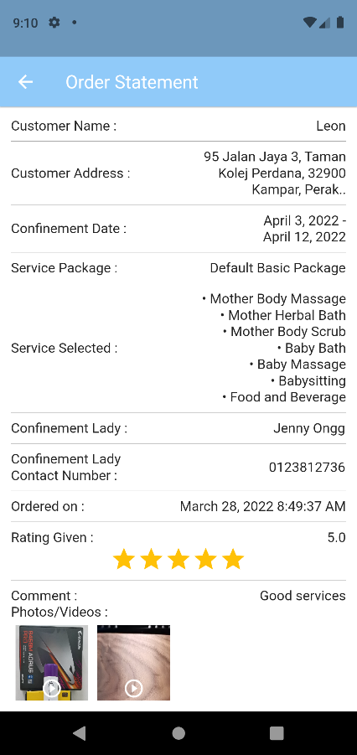 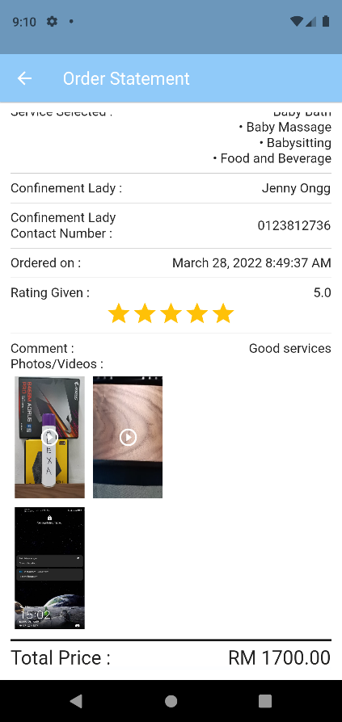

***Figure 5.4.12.1 History Order Detail (1) Figure 5.4.12.2 History Order Detail (2)***

User can check on the detail of the orders that done before by click the order on the history order page. The order detail will be displayed as shown in the Figure 5.4.12.1 and Figure 5.4.12.2. User can click on the photos and videos to view it.

### 5.4.13 About Us

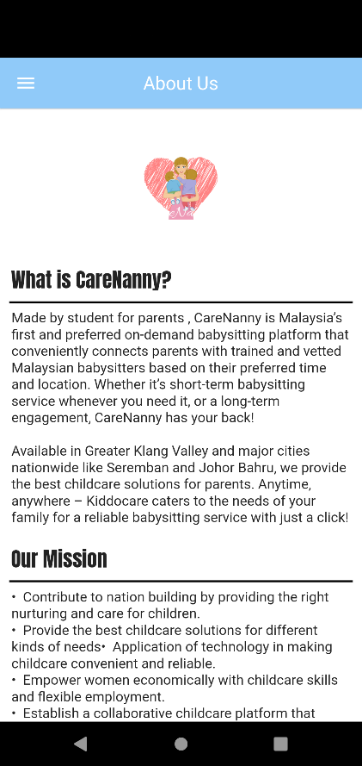

***Figure 5.4.13.1 About Us***

Figure 5.4.13.1 shows the page of about us. User can view the information of the application in this page.

### 5.4.14 Buyer Homepage

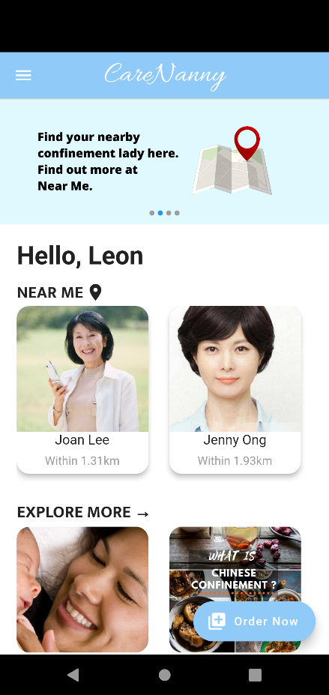 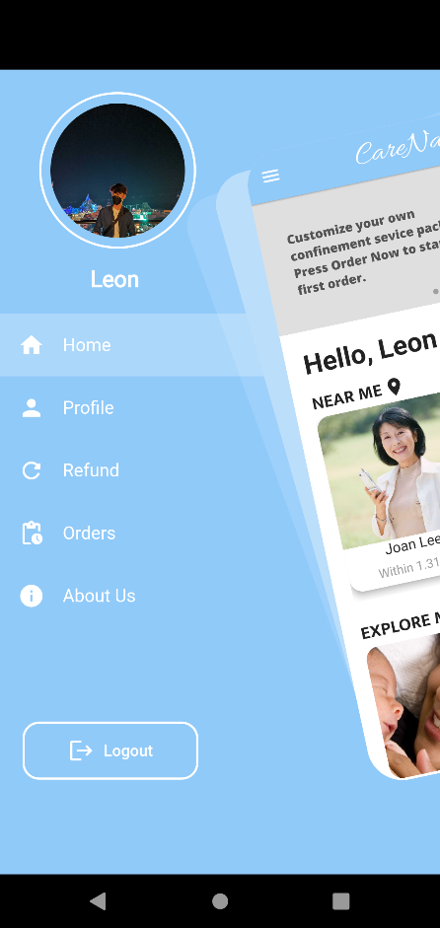

***Figure 5.4.14.1 Buyer Homepage Figure 5.4.14.2 Side Menu***

Figure 5.4.14.1 shows the homepage of the buyer. The features that can access by the buyer is shown as banner on top of the homepage. User can view the features by sliding through it. Besides, the near me feature is placed at the middle of the homepage. User can check the nearby service provider by sliding the listing horizontally. User can click on the service provider card to view more details. Besides, user also can click the images in the explore more section to view some confinement information on the website. Lastly, user can start to make a order by clicking the floating button at the bottom right corner.

### 5.4.15 Service Provider Detail

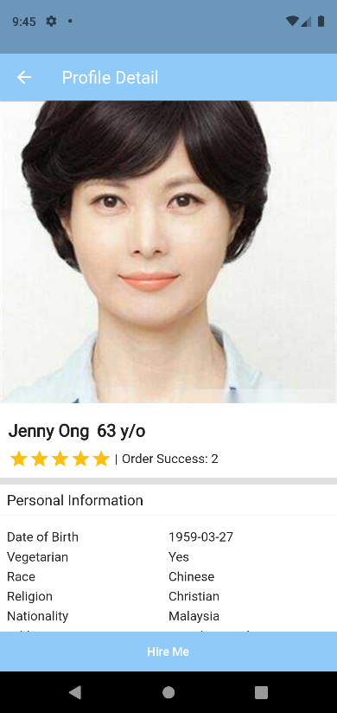 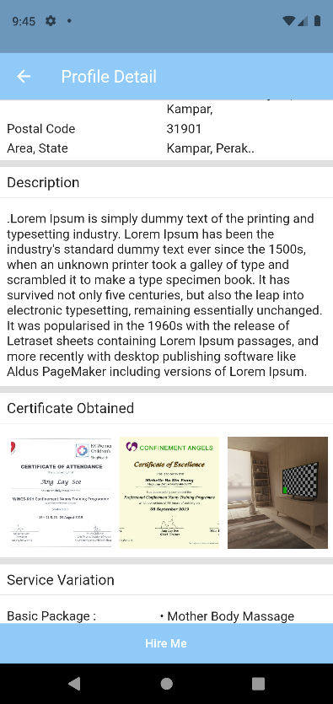

***Figure 5.4.15.1 Profile Detail (1)*** ***Figure 5.4.15.2 Profile Detail (2)***

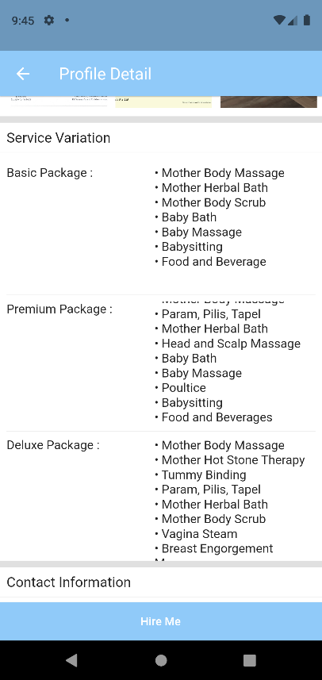 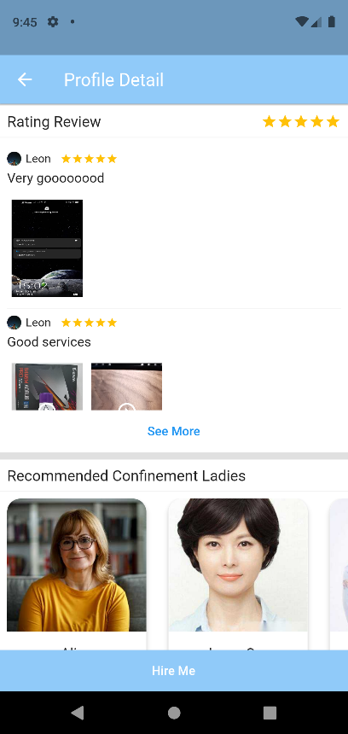

***Figure 5.4.15.3 Profile Detail (3) Figure 5.4.15.4 Profile Detail (4)***

User can view the service provider detail after clicked their image in the near me section. The detail information of the service provider is displayed as Figure 5.4.15.1 until Figure 5.4.15.4. User can view the information, like personal information, description, certificates obtained, service variation, contact information and the rating review of the service provider. User can click the see more button in the rating review section to view all the rating in a new page as shown in Figure 5.4.15.5. Besides, the system will also recommend other similar confinement ladies at the recommended confinement ladies’ section.

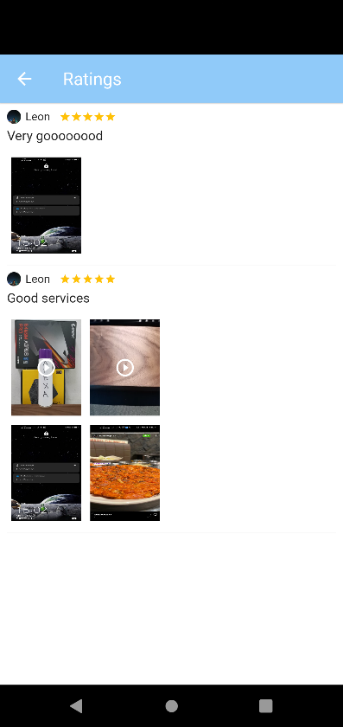

***Figure 5.4.15.5 Rating Reviews***

### 5.4.16 Place Order

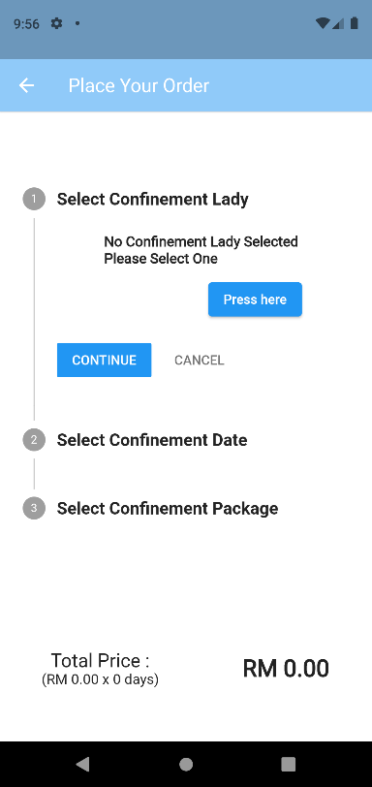 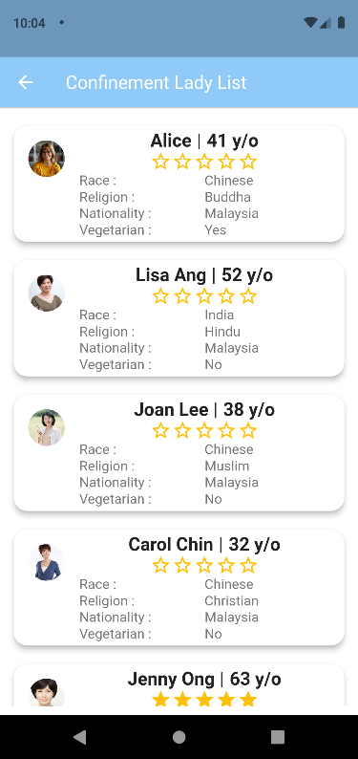

***Figure 5.4.16.1 Place Order*** (1) ***Figure 5.4.16.2 Confinement Lady List***

After user clicked the Order Now button in the homepage or Hire Me button in the service provider detail page, system will be directed to place order page as shown in Figure 5.4.16.1. User are required to choose the service provider a.k.a. confinement lady, confinement date and the confinement package.

After user clicked the Press Here button, system will show the list of available confinement lady will be displayed as shown in Figure 5.4.16.2, user can click the confinement lady and then system will be directed to the service provider detail page as shown in Figure 5.4.15.1. After user clicked the Hire Me button, data will be updated and the place order place will be shown as Figure 5.4.16.3.

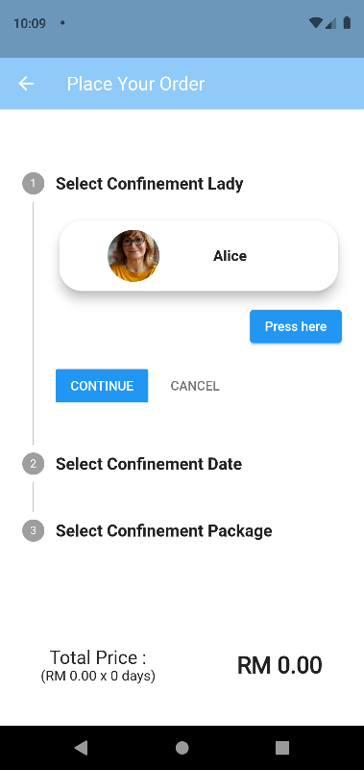 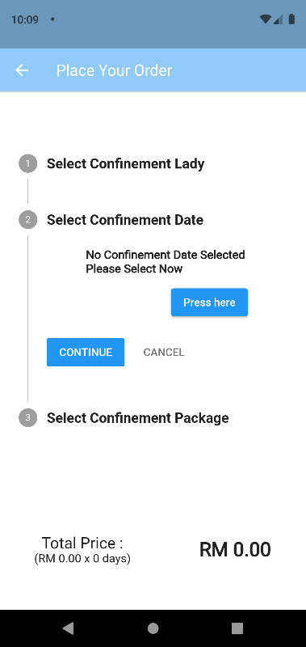 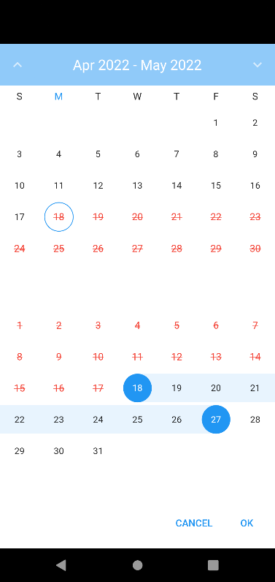

***Figure 5.4.16.3 Place Order (2)***

***Figure 5.4.16.4 Place Order (3)***

***Figure 5.4.16.5 Confinement Date Calendar***

User are then required to choose the confinement date. A calendar will be displayed as shown in Figure 5.4.16.5 after user click the Press Here button. The red outlined date indicated the unavailable day for the service provider. User can select the date that haven’t been outlined. After clicked OK button in the calendar, the confinement date will be updated on the place order page as shown in Figure 5.4.16.6.

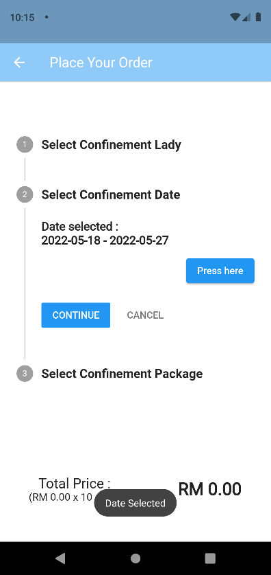 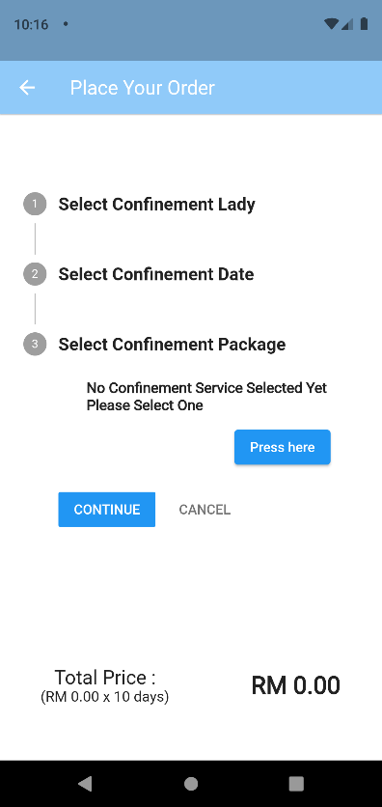

***Figure 5.4.16.6 Place Order (4) Figure 5.4.16.7 Place Order (5)***

User are then continuing choose the confinement service package. User will be directed to the page as shown in Figure 5.4.16.8 to choose for the confinement service package after clicking the Press Here button in step 3.

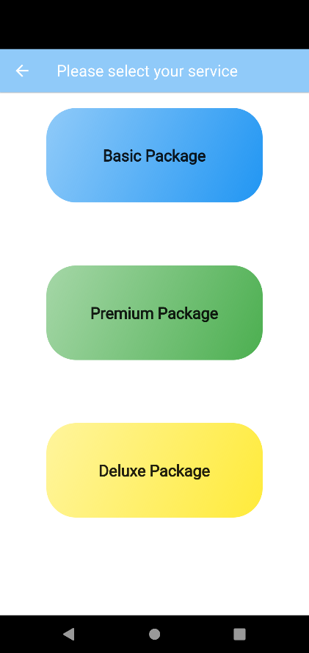 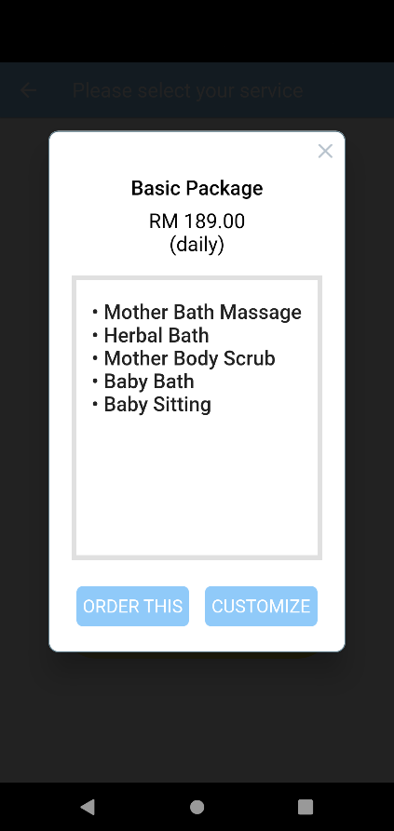

***Figure 5.4.16.8 Service Package Select Figure 5.4.16.9 Content of Service Package (1)***

User can view the service available in the package by clicking the service package. The service included in the service package will be shown in a dialog box like the Figure 5.4.16.9.

User can either click Order This button to select this package or click Customize button if they wish to remove some unnecessary service in the package.

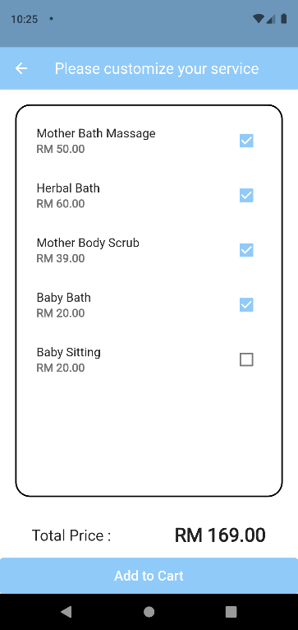 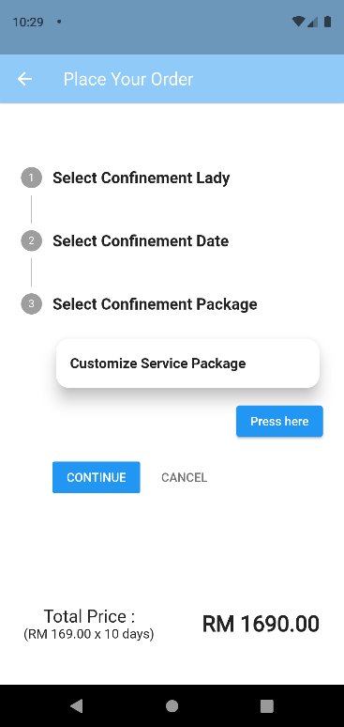 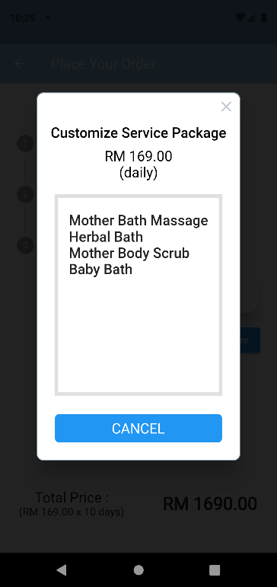

***Figure 5.4.16.10 Customize Order***

***Figure 5.4.16.11 Place Order (6)***

***Figure 5.4.16.12 Content of Service Package (2)***

User can select the service they wanted include in the package and unselect the service they wish to remove from the package. The system will calculate the price and update simultaneously when the user unselects the service. The total price will be calculated and shown at the bottom part of the list of services. User clicks the Add to Cart button once they done customize the button. The service package data will be updated to the order process once the user click to add to cart button.

The total price will be calculated once the user done selecting the package and the confinement date. The total price is calculated based on the total days of confinement service multiply the daily price of the confinement service package selected. Once the user clicked the Continue button, system will pop out two option to let the user make payment as shown in Figure 5.4.16.13.

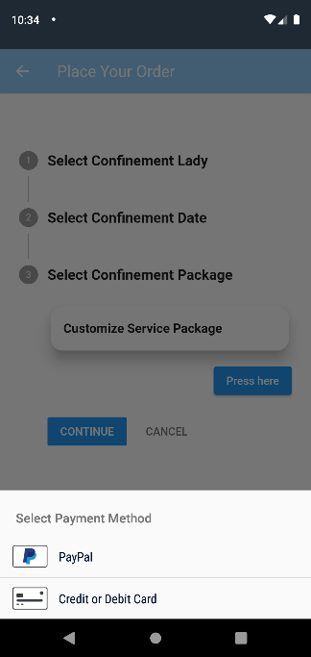 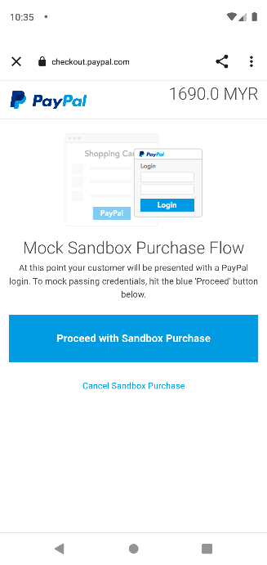 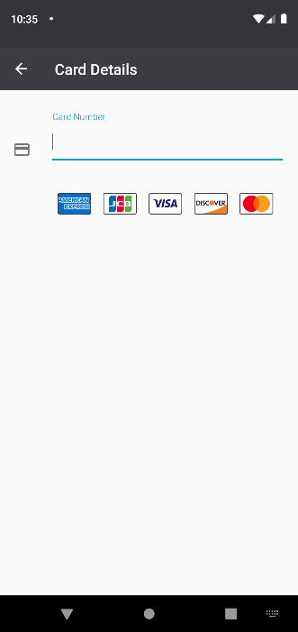

***Figure 5.4.16.13 Payment Method***

***Figure 5.4.16.14 PayPal Method***

***Figure 5.4.16.15 Credit/Debit Card Method***

User can choose either one method to make the payment. After the payment made, system will display a message to notify that user already success made the payment as shown in Figure 5.4.16.16.

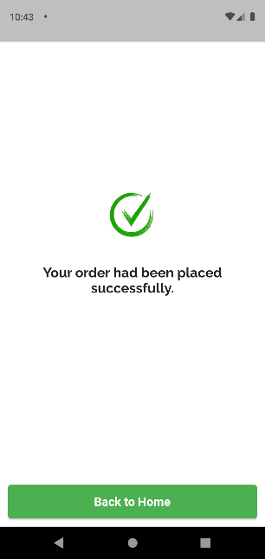

***Figure 5.4.16.16 Complete Place Order Message***

# Conclusion

In a conclusion, in order to help to solve the problem that the current existing market does not have a mobile-based confinement service application, a e-confinement service application has been developed in this project to provide the users a platform to searching for the confinement lady that providing the confinement service. The objectives of this project are providing the users several features like customizing confinement service package, provide a better navigation system for the confinement lady to search for the user’s location, and implementing the rating system which intended to let the confinement service become better. This project will be developed using Dart programming language associated with the Flutter framework and using the Firebase as the database. It will feature a graphical user interface, 3 main modules which has been mentioned above and miscellaneous modules that will help to improve the user experiences when they using the mobile application. This project is expected to take around two semesters to complete and deliver.

# BIBLIOGRAPHY

1. Fok, D., Aris, I., Ho, J., Lim, S., Chua, M., Pang, W., Saw, S., Kwek, K., Godfrey, K., Kramer, M. and Chong, Y., 2016. A Comparison of Practices During the Confinement Period among Chinese, Malay, and Indian Mothers in Singapore. *Birth*, 43(3), pp.247-254.
2. Vow, T. and Vow, T., 2021. 8 Best Confinement Nanny in Singapore You Should Hire (2020). *The Wedding Vow*. Available at: <https://www.theweddingvowsg.com/confinement-nanny-singapore/> [Accessed 8 March 2021].
3. Confinementcaremalaysia.com. 2021. *Confinement Lady Malaysia | Your One-stop Confinement Care Provider*. Available at: <https://www.confinementcaremalaysia.com/> [Accessed 10 March 2021].
4. First Online Confinement Care Services Platform in Malaysia| 28Days. 2021. *28days-Home*. Available at: <https://28days.my/> [Accessed 10 March 2021].
5. Confinement Angels. 2021*. Confinement Nanny Singapore | Hospital Certified | Confinement Lady*. Available at: <https://confinementangels.com.sg/> [Accessed 10 March 2021].
6. Star Confinement Nanny Agency. 2021*. Star Confinement Nanny Agency - Singapore Confinement Nannies*. Available at: <https://starconfinementnanny.com.sg/> [Accessed 11 March 2021].
7. PEM Confinement Nanny Agency. 2021*. Confinement Nanny Singapore | MOM Licensed Confinement Lady*. Available at: <https://pemconfinement.com/> [Accessed 11 March 2021].
8. Confinement Nanny Singapore. 2021. *The leading confinement nanny agency providing confinement nanny, daytime nanny and babysitter in Singapore.* Available at: <https://www.nannysos.com.sg/> [Accessed 11 March 2021].
9. Balaji, S. & Murugaiyan, M.S., 2012. Waterfall vs. V-Model vs. Agile: A comparative study on SDLC. *International Journal of Information Technology and Business Management*, 2(1), pp.26-30.
10. CherCherTech. 2021. *Introduction To Agile Methodology*. Available at: <https://chercher.tech/jira/agile-methodology> [Accessed 20 March 2021].
11. SDLC, A., 2021*. Agile in SDLC* | Characteristics and Functionality of Agile in SDLC. EDUCBA. Available at: <https://www.educba.com/agile-in-sdlc/> [Accessed 21 March 2021].
12. Visual-paradigm.com. 2021. *Visual Paradigm Product Overview*. Available at: <https://www.visual-paradigm.com/support/documents/vpuserguide/12/13/5963_visualparadi.html> [Accessed 23 March 2021].
13. SearchMobileComputing. 2021. *What is Android Studio?* - Definition from WhatIs.com. Available at: <https://searchmobilecomputing.techtarget.com/definition/Android-Studio> [Accessed 23 March 2021].
14. Code, V. 2021*. Why Visual Studio Code? Code.visualstudio.com*. Available at: <https://code.visualstudio.com/docs/editor/whyvscode> [Accessed 23 March 2021].
15. O’Reilly Online Learning. 2021*. Software Architecture Patterns*. Available at: <https://www.oreilly.com/library/view/software-architecture-patterns/9781491971437/ch01.html> [Accessed 29 March 2021].
16. O'Neill, A., 2021. Malaysia - unemployment rate 1999-2020 | Statista. [online] Statista. Available at: <https://www.statista.com/statistics/319019/unemployment-rate-in-malaysia> [Accessed 12 June 2021]
17. Surve, V. and Here, Y., 2022. Haversine Vs Vincenty: Which is the best?| Neova Tech Solutions. [online] Neova Tech Solutions : We are startup specialists. Available at: <https://www.neovasolutions.com/2019/10/04/haversine-vs-vincenty-which-is-the-best/> [Accessed 6 April 2022].
18. Kettle, S., 2022. Distance on an ellipsoid: Vincenty's Formulae. [online] Distance on an ellipsoid: Vincenty's Formulae. Available at: <https://community.esri.com/t5/coordinate-reference-systems-blog/distance-on-an-ellipsoid-vincenty-s-formulae/ba-p/902053> [Accessed 7 April 2022].
19. GitHub. 2022. GitHub - microsoft/vscode: Visual Studio Code. [online] Available at: <https://github.com/microsoft/vscode> [Accessed 7 April 2022].
20. Android Developers. 2022. Download Android Studio and SDK tools | Android Developers. [online] Available at: <https://developer.android.com/studio?gclid=Cj0KCQjwl7qSBhD-ARIsACvV1X0HA6kDGmJJ8T9Sn23FcF-DCVUaZuIhSONgx4CptIg4lvmHL5VC93EaAhQvEALw_wcB&gclsrc=aw.ds> [Accessed 7 April 2022].
21. Firebase. 2022. Firebase. [online] Available at: <https://firebase.google.com/?gclid=Cj0KCQjwl7qSBhD-ARIsACvV1X1wcXux6jAwirjVQlA8dae8q7ZbgdV5XvW34E90tUZbVzOdCnolh_EaAnlGEALw_wcB&gclsrc=aw.ds> [Accessed 7 April 2022].

# Appendix A Biweekly Report

**FINAL YEAR PROJECT WEEKLY REPORT**

*(Project I / ~~Project II~~)*

|  |  |
| --- | --- |
| **Trimester, Year: Y3S1** | **Study week no.:2** |
| **Student Name & ID: Chia Kai Yi 18ACB01343** | |
| **Supervisor:Ts. Yeck Yin Ping** | |
| **Project Title: E-Confinement Service System** | |

|  |
| --- |
| **1. WORK DONE**  [Please write the details of the work done in the last fortnight.]  Reevaluate the problem, scope, objectives and background information of chapter 1.  Draw the system Framework, use case diagram, activity diagram. |
| **2. WORK TO BE DONE**  Draw the sequences diagram.  Study the dart coding language. |
| **3. PROBLEMS ENCOUNTERED**  No problem encountered. |
| **4. SELF EVALUATION OF THE PROGRESS**  -Expected to complete all the diagram at week 3. |



_________________________

Supervisor’s signature Student’s signature

**FINAL YEAR PROJECT WEEKLY REPORT**

*(Project I / ~~Project II~~)*

|  |  |
| --- | --- |
| **Trimester, Year: Y3S1** | **Study week no.: 4** |
| **Student Name & ID: Chia Kai Yi 18ACB01343** | |
| **Supervisor:Ts. Yeck Yin Ping** | |
| **Project Title: E-Confinement Service System** | |

|  |
| --- |
| **1. WORK DONE**  [Please write the details of the work done in the last fortnight.]  Complete the sequence diagram. |
| **2. WORK TO BE DONE**  Display the screen of customer choose the confinement service i.e. Select the default and customize confinement service package.  Study the way of implement firebase into the system. |
| **3. PROBLEMS ENCOUNTERED**  No problem encountered. |
| **4. SELF EVALUATION OF THE PROGRESS**  -Expected to complete the WORK TO BE DONE before week 6. |



_________________________

Supervisor’s signature Student’s signature

**FINAL YEAR PROJECT WEEKLY REPORT**

*(Project I / ~~Project II~~)*

|  |  |
| --- | --- |
| **Trimester, Year: Y3S1** | **Study week no.:6** |
| **Student Name & ID: Chia Kai Yi 18ACB01343** | |
| **Supervisor:Ts. Yeck Yin Ping** | |
| **Project Title: E-Confinement Service System** | |

|  |
| --- |
| **1. WORK DONE**  [Please write the details of the work done in the last fortnight.]   * Study the way of implement firebase into the system. * Display the screen of customer choose the confinement service i.e. Select the default and customize confinement service package. * Login authentication and signup authentication * Partial database done implement |
| **2. WORK TO BE DONE**  **-** Complete the database of the system  - implementing the form to let the user fill in the personal info. |
| **3. PROBLEMS ENCOUNTERED**  No problem encountered. |
| **4. SELF EVALUATION OF THE PROGRESS** |



_________________________

Supervisor’s signature Student’s signature

**FINAL YEAR PROJECT WEEKLY REPORT**

*(Project I / ~~Project II~~)*

|  |  |
| --- | --- |
| **Trimester, Year: Y3S1** | **Study week no.:8** |
| **Student Name & ID: Chia Kai Yi 18ACB01343** | |
| **Supervisor:Ts. Yeck Yin Ping** | |
| **Project Title: E-Confinement Service System** | |

|  |
| --- |
| **1. WORK DONE**  [Please write the details of the work done in the last fortnight.]   * Completed first objective. * Complete the form to receive user information. * Completed the profile of both confinement lady and customer. * Done setting up database of the application. |
| **2. WORK TO BE DONE**   * Implement the rating system of the confinement lady. |
| **3. PROBLEMS ENCOUNTERED**  No problem encountered. |
| **4. SELF EVALUATION OF THE PROGRESS** |



_________________________

Supervisor’s signature Student’s signature

**FINAL YEAR PROJECT WEEKLY REPORT**

*(Project I / ~~Project II~~)*

|  |  |
| --- | --- |
| **Trimester, Year: Y3S1** | **Study week no.: 10** |
| **Student Name & ID: Chia Kai Yi 18ACB01343** | |
| **Supervisor:Ts. Yeck Yin Ping** | |
| **Project Title: E-Confinement Service System** | |

|  |
| --- |
| **1. WORK DONE**  [Please write the details of the work done in the last fortnight.]   * Implemented rating system of the confinement lady. |
| **2. WORK TO BE DONE**   * Completing the documentation of the report. * Design the poster |
| **3. PROBLEMS ENCOUNTERED**  No problem encountered. |
| **4. SELF EVALUATION OF THE PROGRESS** |



_________________________

Supervisor’s signature Student’s signature

# Appendix B Poster

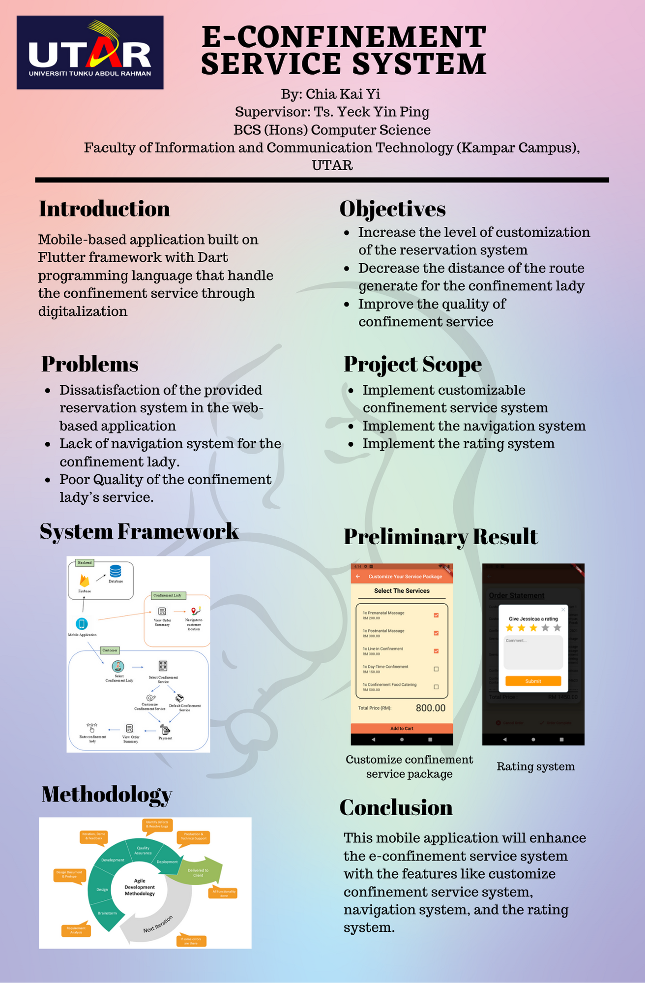

# Appendix C Plagiarism Check Result

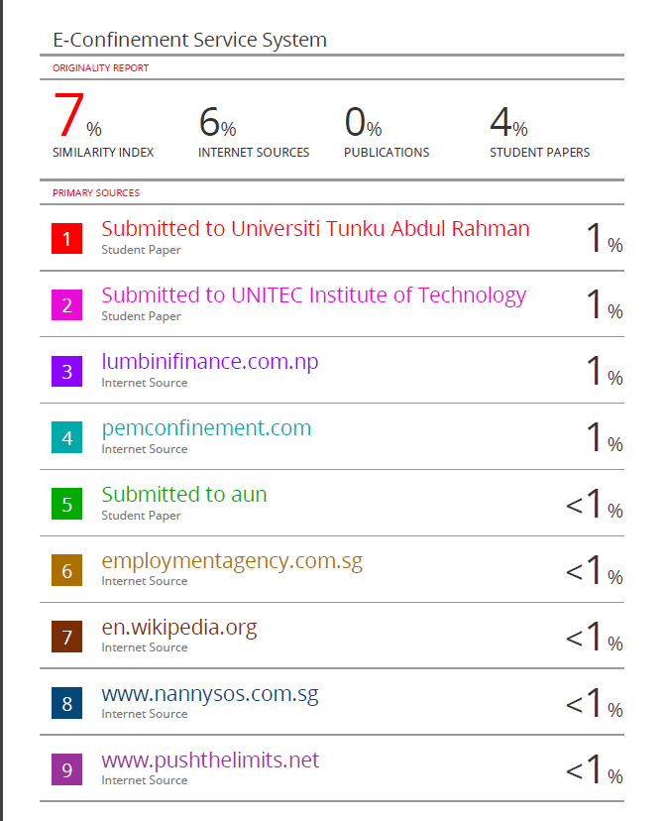

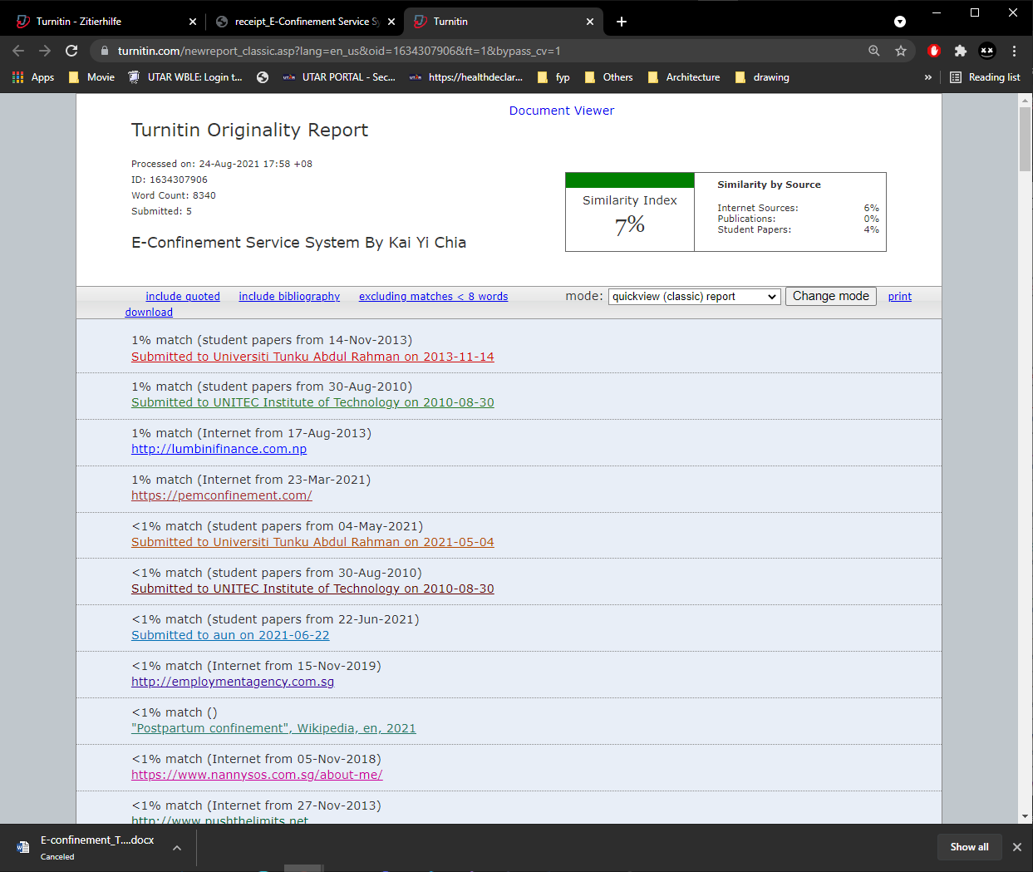

|  |  |  |  |
| --- | --- | --- | --- |
| **Universiti Tunku Abdul Rahman** | | | |
| **Form Title : Supervisor’s Comments on Originality Report Generated by Turnitin for Submission of Final Year Project Report (for Undergraduate Programmes)** | | | |
| Form Number: FM-IAD-005 | Rev No.: 0 | Effective Date: 01/10/2013 | Page No.: 1of 1 |



|  |  |
| --- | --- |
| **Full Name(s) of Candidate(s)** | Chia Kai Yi |
| **ID Number(s)** | 18ACB01343 |
| **Programme / Course** | Bachelor of Computer Science |
| **Title of Final Year Project** | E-Confinement Service System |

**FACULTY OF INFORMATION AND COMMUNICATION TECHNOLOGY**

|  |  |
| --- | --- |
| **Similarity** | **Supervisor’s Comments (Compulsory if parameters of originality exceeds the limits approved by UTAR)** |
| **Overall similarity index: 7 %**  **Similarity by source** Internet Sources: _______6________%  Publications: _____0____ %  Student Papers: _____4____ % |  |
| **Number of individual sources listed** of more than 3% similarity: 0 |  |
| **Parameters of originality required and limits approved by UTAR are as Follows:**  **(i) Overall similarity index is 20% and below, and**  **(ii) Matching of individual sources listed must be less than 3% each, and**  **(iii) Matching texts in continuous block must not exceed 8 words**  ***Note: Parameters (i) – (ii) shall exclude quotes, bibliography and text matches which are less than 8 words.*** | |

Note Supervisor/Candidate(s) is/are required to provide softcopy of full set of the originality report to Faculty/Institute

***Based on the above results, I hereby declare that I am satisfied with the originality of the Final Year Project Report submitted by my student(s) as named above.***

______________________________ ______________________________

|  |  |  |
| --- | --- | --- |
| Signature of Supervisor |  | Signature of Co-Supervisor |
| Name: __________________________ |  | Name: __________________________ |
| Date: ___________________________ |  | Date: ___________________________ |

# Appendix D FYP 1 Checklist



**UNIVERSITI TUNKU ABDUL RAHMAN**

FACULTY OF INFORMATION & COMMUNICATION TECHNOLOGY (KAMPAR CAMPUS)

**CHECKLIST FOR FYP1 THESIS SUBMISSION**

|  |  |
| --- | --- |
| Student Id | 18ACB01343 |
| Student Name | CHIA KAI YI |
| Supervisor Name | Ts. Yeck Yin Ping |

|  |  |
| --- | --- |
| **TICK (√)** | **DOCUMENT ITEMS**  Your report must include all the items below. Put a tick on the left column after you have checked your report with respect to the corresponding item. |
| √ | Title Page |
| √ | Signed form of the Declaration of Originality |
| √ | Abstract |
| √ | Table of Contents |
| √ | List of Figures (if applicable) |
| √ | List of Tables (if applicable) |
|  | List of Symbols (if applicable) |
| √ | List of Abbreviations (if applicable) |
| √ | Chapters / Content |
| √ | Bibliography (or References) |
| √ | All references in bibliography are cited in the thesis, especially in the chapter of literature review |
| √ | Appendices (if applicable) |
| √ | Poster |
| √ | Signed Turnitin Report (Plagiarism Check Result – Form Number: FM-IAD-005) |

*Include this form (checklist) in the thesis (Bind together as the last page)

|  |  |
| --- | --- |
| I, the author, have checked and confirmed all the items listed in the table are included in my report.    (Signature of Student)  Date:25/8/2021 | Supervisor verification. Report with incorrect format can get 5 mark (1 grade) reduction.  ______________________  (Signature of Supervisor)  Date: |